Original Star Wars Lightsaber Sells at Auction for
$450,000 to Ripley’s Believe It or Not!
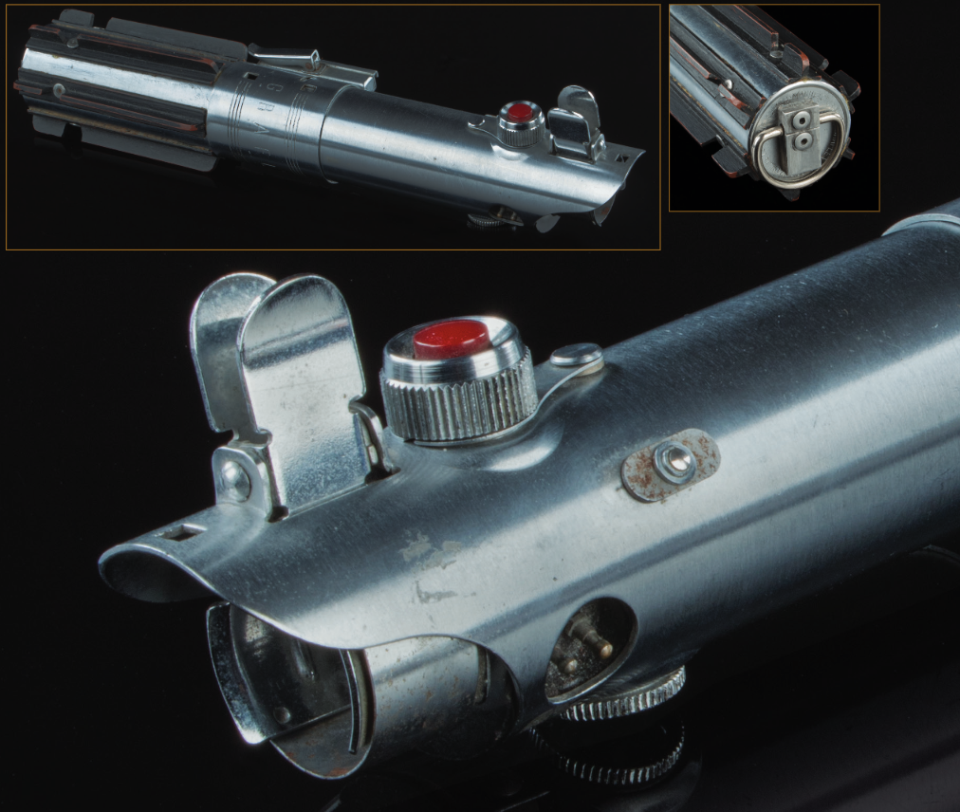
For Immediate Release
Orlando, FL (June 29, 2017) – Ripley’s Believe It or Not! has purchased an original Star Wars lightsaber used by Luke Skywalker himself, Mark Hamill, in Star Wars: A New Hope and Star Wars: The Empire Strikes Back.
Believe it or not, this lightsaber was constructed from an existing Graflex flashgun camera from the 1930s. It comes from the archives of Gary Kurtz, a producer on both Star Wars: A New Hope and Star Wars: Return of the Jedi.
Edward Meyer, VP of Archives and Exhibits for Ripley’s Believe It or Not! acquired the piece at the Profiles in History Hollywood Auction on June 28th.
The lightsaber will make a great addition to their Star Wars collection, which includes hair from a Chewbacca suit, Michelangelo’s “Pieta” reinterpreted with Chewbacca cradling Han Solo made from duct tape, and portraits of Star Wars characters made from staples.
Another auction piece sci-fi lovers will covet is a bridge engineering console used in Star Trek: First Contact, Star Trek IX: Insurrection, and Star Trek X: Nemesis. The console was typically manned by “Lt. Cmdr. Geordi La Forge” (LeVar Burton) and “Lt. Cmdr. Worf” (Michael Dorn). Very few consoles from the U.S.S. Enterprise Bridge come to auction.
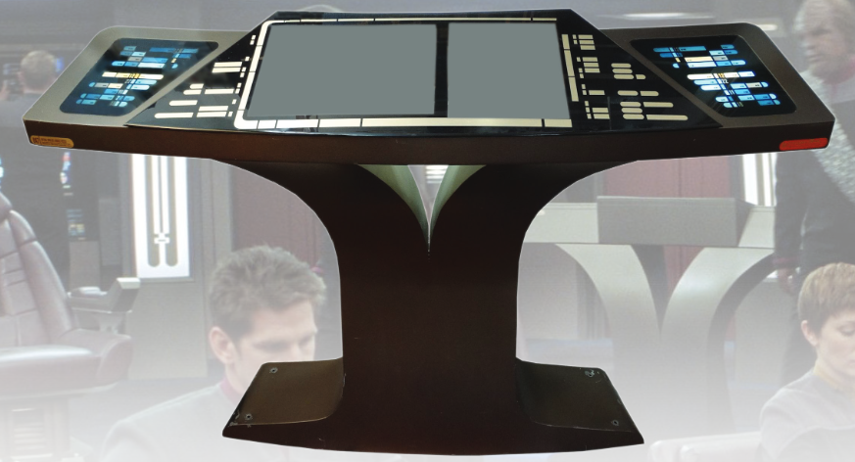

It's a Bird...It's a Plane...It's Superman! The original Superman costume, worn by actor George Reeves, which includes a red fabric cape, belt buckle, and muscled under suit, will feel right at home joining Ripley’s Superman collection which includes a Superman cape worn by Christopher Reeve during filming of Superman: The Movie and Superman II and a costume Dean Cain wore on Lois & Clark: The New Adventures of Superman.
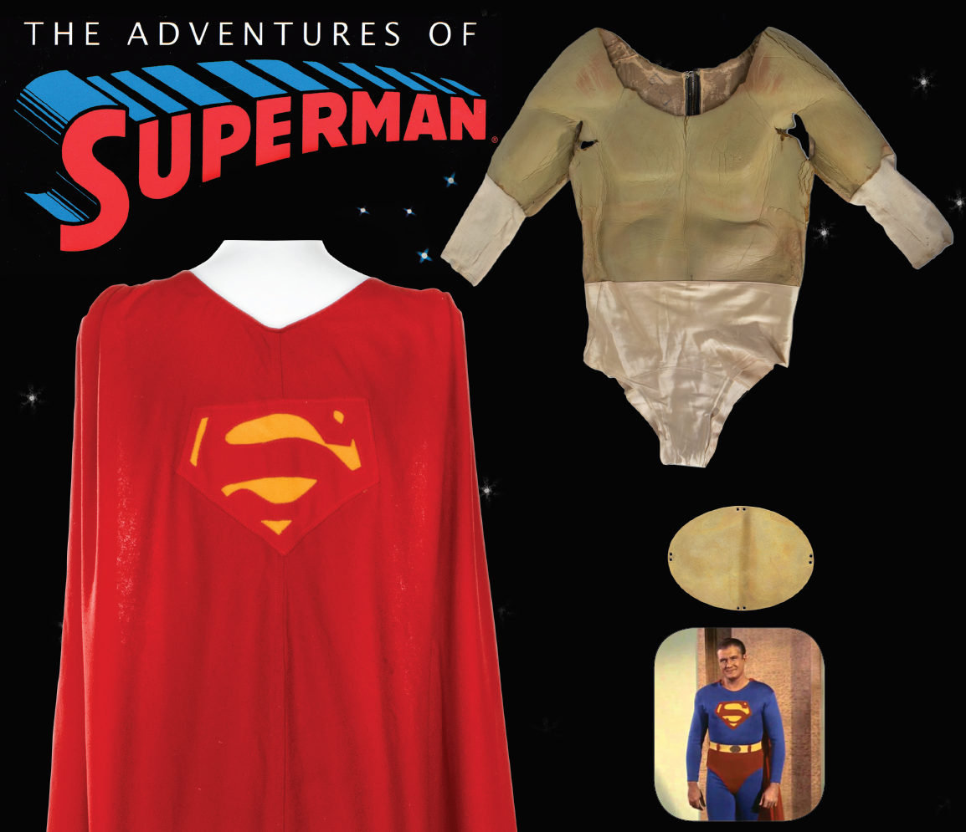
Other Notable Items Purchased at the Auction
- Donald Trump’s 50th birthday invitation sent to Loni Anderson
- The Walking Dead jacket and “zombie” facial appliance
- Set of Bob Hope novelty golf clubs
- All My Children Daytime Emmy Award (1978-88) for Best Writing to Mary K. Wells
Star Wars Extras
Also traveling to Ripley’s Believe It or Not! is a replica of the Millennium Falcon made up of almost one million matchsticks! The piece was created by matchstick artist, Patrick Acton, who has made other pieces for Ripley’s, including a steam punk train, the International Space Station, Notre Dame Cathedral, and a dragon that actually moves.
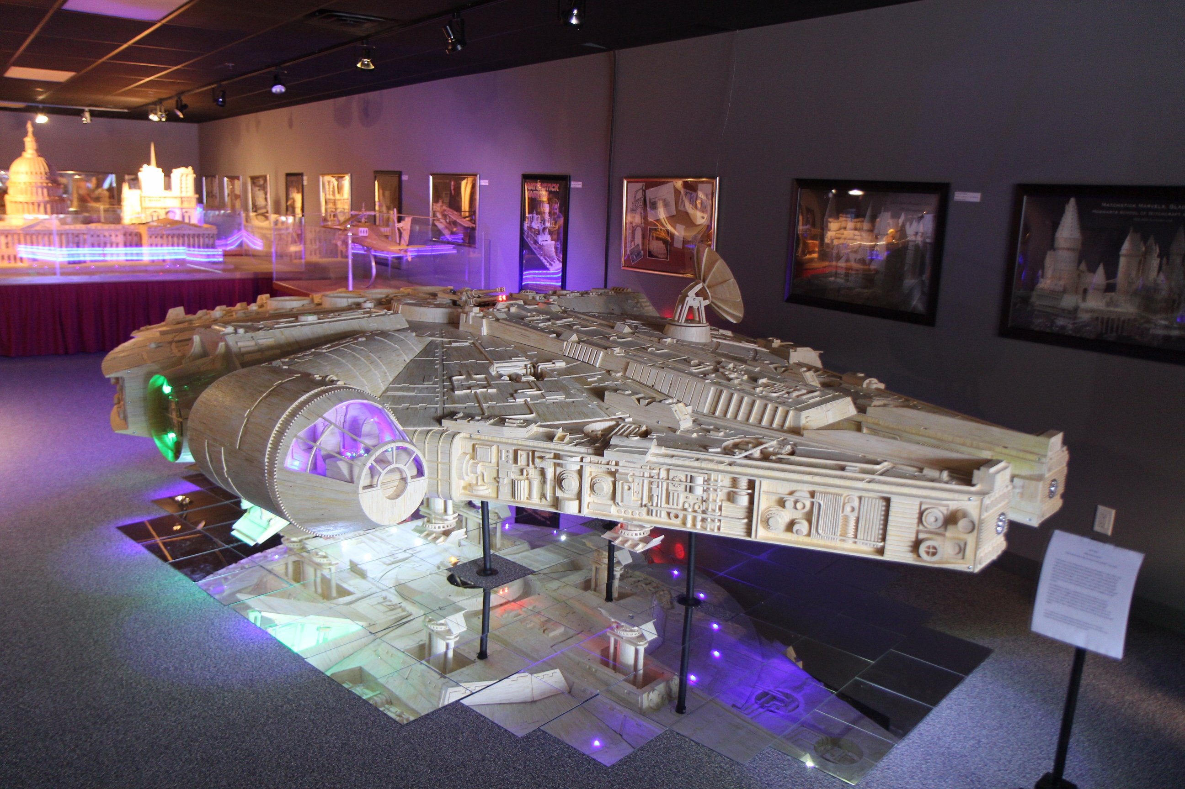
Edward Meyer, VP of Exhibits & Archives is available for interviews. Please contact pr@ripleys.com to schedule.
For media images, including additional photos of exhibits mentioned but not pictured, click here.
MEDIA CONTACTS
Suzanne Smagala-Potts
Public Relations Manager
Ripley Entertainment
smagala@ripleys.com
Office: 407-345-8010 Cell: 727-439-0136
About Ripley Entertainment
Ripley’s Believe It or Not! is part of the Ripley Entertainment Inc. (www.ripleys.com) family of worldwide attractions, the global leader in location-based entertainment. More than 14 million people visit its 100-plus attractions in 11 countries each year. In addition to its 31 Believe It or Not! Odditoriums, the Orlando, Florida-based company has publishing, licensing and broadcast divisions that oversee projects including the syndicated Believe It or Not! television show, best-selling books and the popular syndicated cartoon strip, Ripley’s Believe It or Not!, that still runs daily in countries around the world. Ripley Entertainment is a Jim Pattison Company, the second-largest privately held company in Canada.

