Press Release

January 24, 2025
Recall of La Fiesta Brand Bread Crumbs (Unseasoned and Seasoned) for Undeclared Sesame

La Fiesta Food Products, LLC, La Mirada, CA is recalling 8 oz packages of La Fiesta brand Unseasoned Bread Crumbs (Pan Rayado) and Seasoned Bread Crumbs (Pan Rayado Sazonado). The products contain sesame as an undeclared allergen. Additionally, the labels do not include the allergen declaration in Spanish.
People who have an allergy or severe sensitivity to sesame run the risk of serious or life-threatening allergic reaction if they consume these products. No illnesses have been reported to date in connection with this issue.
The impacted products are identified below:
La Fiesta brand Bread Crumbs (Pan Rayado) 8oz UPC#032327000886
- Lot codes 26032; 26073; 26082; 26092; 26094; 26,400 sold nationwide through distributors to retail stores from April 10, 2024 through January 22, 2025.
La Fiesta brand Bread Crumbs Seasoned (Pan Rayado Sazonado) 8oz UPC#032327000887
- Lot codes 26094; 26123; 6,240 sold nationwide through distributors to retail stores from August 29, 2024 through January 22, 2025.
The lot code can be found stamped on the front of the package.
The product is packaged in 8 oz transparent plastic bags with an attached printed label.
The recall was initiated after discovering that the product contained undeclared sesame. Further investigation revealed that the issue was caused by errors on the product labeling.
Consumers who have purchased the products are urged to return them to the place of purchase for a full refund.
Consumers with questions may contact the company at 408-326-0487, Monday to Friday from 8:00am – 5:00pm Pacific Time or at QualityAssurance@lffp.com.

Product Photos
La Fiesta brand Bread Crumbs (Pan Rayado) 8oz UPC#032327000886
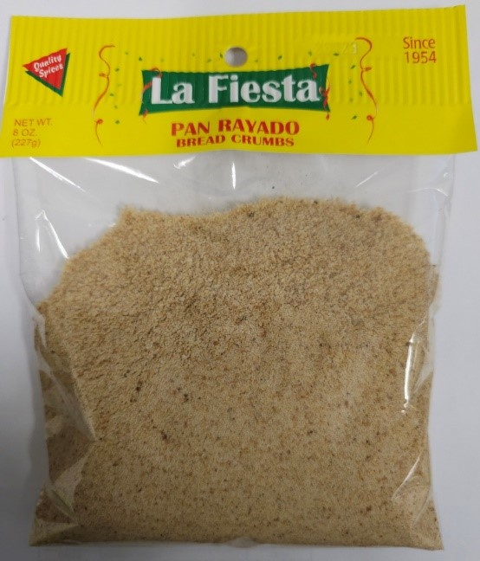 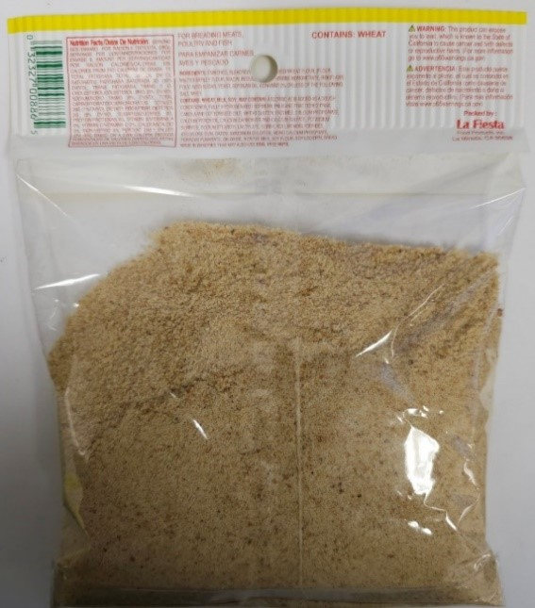

La Fiesta brand Bread Crumbs Seasoned (Pan Rayado Sazonado) 8oz UPC#032327000887
