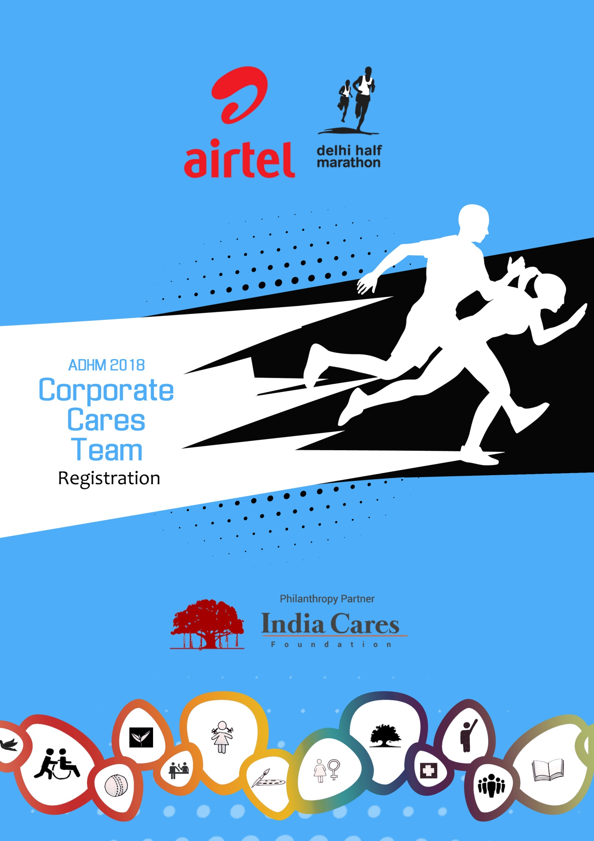
Corporate Cares Team

The CORPORATE CARES category lends companies an unique opportunity to combine Health & Fitness, Employee Engagement and CSR by supporting a Civil Society Organisation (CSO/ NGO) through Airtel Delhi Half Marathon 2018.

Companies can choose from any of the CSOs listed with India Cares for the Event, to donate the amount contributed by them. If the company’s preferred CSO is not registered with India Cares Foundation, India Cares Foundation will assist the CSO in completing its registration formalities and thereby stand to benefit through its association with the Event.
At Airtel Delhi Half Marathon 2018, companies can choose to field Corporate Cares teams of following team strengths:
- Team 12: A company makes an upfront non-refundable contribution of Rs 1,75,000 in favour of chosen CSO and fields a team of upto 12 employees.
- Team 25: A company makes an upfront non-refundable contribution of Rs 2,75,000 in favour of chosen CSO and fields a team of upto 25 employees.
- Team 40: A company makes an upfront non-refundable contribution of Rs 3,75,000 in favour of chosen CSO and fields a team of upto 40 employees.
- Team 60: A company makes an upfront non-refundable contribution of Rs 5,00,000 in favour of the chosen CSO and fields a team of upto 60 employees.

The amounts above do not include the applicable event entry fees for individual team members (given below in this document). These need to be paid additionally depending upon the race category chosen by individual team members to the event promoters (vide cheque/ DD/ Bank Transfer) ‘Procam International Pvt. Ltd’ before 10th October 2018 for Bibs to be collected in the Get Active Expo between 18-20 October 2018.
India Cares gets Rs 15,000; Rs 25,000; Rs 35,000 & Rs 45,000 respectively of the donated amount to the CSO as mentioned above as a donation for the support provided to the participating CSO and the Company.

Privileges for Corporate Cares teams:
- Regular pre-race day communication from India Cares Foundation.
- Meetings with team leaders to give Event updates, pledge raising tips, standardized presentations which they can use to motivate their team members.
- Acknowledgement on India Cares Foundation’s website.
- Companies who complete the process of registering, making donations and run registration payments by 15th September 2018 will have their name printed on their Team’s running bibs (only Great Delhi Run bibs).
- Team members participating in the Great Delhi Run race category will be hosted in a special Corporate Cares holding area at the event venue on race day.
- Visibility for company and supporting CSO within the Corporate Cares holding area and at a designated section on the race route as decided by the event Promoter Procam International.
- MD or CEO of top 2 contributing companies of ADHM 2017 will be hosted at the Grand Stand on race day to cheer their participating team.
- Race day photographs for top 2 fund raising members in a Corporate Cares team (where captured by event’s official photographers, www.marathon-photos.com). To be eligible for this, the team member must have raised a minimum of INR 25,000 for his/her chosen cause and such funds must have been submitted and reported to India Cares Foundation on or before 30th September 2018.
- Team acknowledgement in the docket published post race day.
- Invitation to 2 representatives, for the post Event function, to company’s top management whose employees have raised a minimum of INR 1,00,000 funds through the ADHM 2018.

REGISTRATION PROCESS FOR CORPORATE CARES
- Fill the Corporate Cares registration form
- Choose the CSO/s the team wishes to support
- Issue a cheque of upfront contribution of INR 1.75 Lakh; INR 2.75 lakh; INR 3.75 lakh or INR 5 lakh as the case may be, drawn in favour of the chosen CSO or India Cares Foundation. Where cheque is drawn in favour of India Cares, India Cares shall disburse the amount to the beneficiary CSO after deducting applicable donations for support.
- Email the filled form to India Cares
- India Cares will share the process of getting the team’s individual runners registrations done.
- Along with the team registrations, the company will be required to submit a separate cheque in favour of “Procam International Pvt. Ltd.” for the event participation fee of its team members. This will be one single cheque, consolidating entry fees of all team members, depending upon the race category chosen by each member.**
- Last date of the runners’ registrations will be no later than 15th September 2018 and run registration fees to be paid to Procam International no later than 10th October 2018.

Important Points for acceptance of runner’s registration:
Mandatory fields including photographs, date of birth, emergency contact number, etc. are essential details of individual team members to be accepted and confirmed.
Once the registrations are submitted to India Cares, no changes will be entertained.
All Half Marathon & Timed 10K runners will be required to collect their running numbers personally or authorize an individual to collect the running number on their behalf, from the Get Active Expo. In all circumstances, only one running number will be handed over to an individual.
The employees of a Corporate Cares team can download the fundraising kit free of cost from the philanthropy partner’s website http://icfn.in/ADHM/

** Note: Running Bibs will not be handed over to the Corporate Cares team if complete Payment of Run registration fees have not been cleared at Procam International’s end.

EVENT ENTRY FEES
Race Categories | Application Fee*
21K – Half Marathon Run | Rs. 1900
10K - Timed Race (New) | Rs. 1400
Great Delhi Run | Rs. 650
Senior Citizens' Run | Rs. 300
Champions with Disability | Rs. 300
*The amounts are inclusive of GST

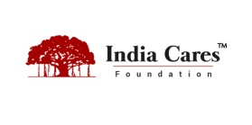
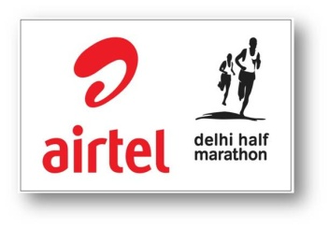

Corporate Cares Team
Registration Form

Company Details:
Category | Rs in lakh | No. of Team/s |  | Total Amt donated Rs. | Amount India Cares will receive per team and the balance is for the chosen CSO
Team 60 | 5.00 |  |  |  | Rs 45,000/-
Team 40 | 3.75 |  |  |  | Rs 35,000/-
Team 25 | 2.75 |  |  |  | Rs 25,000/-
Team 12 | 1.75 |  |  |  | Rs 15,000/-
Company Name

Address for Invoice

GSTN Number

Primary Contact
Email Id
Mobile Number
Your chosen CSO*
*Choose a CSO from the list of participating charities on http://icfn.in/ADHM/
Terms and Conditions:
- All terms and conditions that apply to participation in the Airtel Delhi Half Marathon 2018, as indicated in the run application form for the event, shall apply to each participant from your company.
- Terms and conditions governing various aspects of the Corporate Cares category shall apply as stated on each service/ product provided.
- Your company will:
- Make an up-front, non-refundable contribution as per Payment Details to the CSO or India Cares.
- If the total amount is made out to India Cares Foundation, you will get an 80G receipt from us for the same.
- A separate cheque for Runners registrations - applicable entry fees will be given by you in favour of "Procam International Private Ltd". before 10th October 2018.
- Companies may register as many teams as they like, by paying for each team in Corporate Cares registration in support of any participating CSO.

As a Corporate Cares participant you are entitled to the following benefits:
- Regular pre-race day communication from India Cares Foundation.
- Meetings with team leaders to give Event updates, pledge raising tips, standardized presentations which they can use to motivate their team members.
- Acknowledgement on India Cares Foundation’s website.
- Companies who complete the process of registering, making donations and run registration payments by 15th September 2018 will have their name printed on their Team’s running bibs (only Great Delhi Run bibs).
- Team members participating in the Great Delhi Run race category will be hosted in a special Corporate Cares holding area at the event venue on race day.
- Visibility for company and supporting CSO within the Corporate Cares holding area and at a designated section on the race route as decided by the event Promoter Procam International.
- MD or CEO of top 2 contributing companies of ADHM 2017 will be hosted at the Grand Stand on race day to cheer their participating team.
- Race day photographs for top 2 fund raising members in a Corporate Cares team (where captured by event’s official photographers, www.marathon-photos.com). To be eligible for this, the team member must have raised a minimum of INR 25,000 for his/her chosen cause and such funds must have been submitted and reported to India Cares Foundation on or before 30th September 2018.
- Team acknowledgement in the docket published post race day.
- Invitation to 2 representatives, for the post Event function, to company’s top management whose employees have raised a minimum of INR 1,00,000 funds through the ADHM 2018.
.
If you have any queries, please contact us at kaushal@icfn.in/ 8607938463 or meena@icfn.in / 9740083121
We have read through and understood the terms and conditions governing our participation in the Corporate Cares program of the Airtel Delhi Half Marathon 2018 and we agree to abide by them.
For (Company Name)
Authorized Signatory Name
Signature | Date
Soft copy of this Form filled along should reach India Cares at the above mentioned email ids. You can reach us at our office too:
India Cares Foundation: No 227A, 1st Floor, Sant Nagar, East of Kailash, New Delhi 110065. 011-41096623
FREQUENTLY ASKED QUESTIONS

1. What does my company need to do in order to register for Corporate Cares?  In order to register for Corporate Cares you must send the following to India Cares:  - The completed Corporate Cares Registration Form signed by an authorised signatory from your company.  - The donation cheque as per team size made out to your chosen CSO or ‘India Cares Foundation.’ Receipt will be given by those whose name the cheque is made out to | 6. What recognition will my company receive for participating as Corporate Cares Team?  Your company will get special mention in all relevant reports related to the Run, a special page on India Cares website if details are provided. Your team will have a special holding area on race day for the Great Delhi Run category. During expo and event day, the company name is featured in India Cares holding area.
2. Which CSOs are eligible to receive funds through the Corporate Cares programme?  Only CSOs registered as ‘Participating CSOs’ with India Cares are eligible to receive funds through the Corporate Cares programme. Please refer to the ‘Participating CSOs’ list available at http://icfn.in/ADHM/  You can connect any CSO to India Cares to get their participation if their want to. | 7. How can I get my employees excited about participating in the event?  India Cares is happy to come and do a one hour training session for your employees. We can also provide motivational tools such as a short video for your use upon request. Finally, we suggest that you connect with the CSO participant that you have chosen - they may be able to provide you with additional information about how your support will impact their work which can also serve as a motivational tool.
3. How do I register the employees running in my Corporate Cares team?  India Cares will guide you once you confirm participation. All employees have to fill up run registrations forms individual through an online link | 8. Can we carry/display branded material at the event?  Yes. Your employees are welcome to wear company T-shirts and carry signs and banners celebrating your company’s participation. You may also want to encourage the team to connect with your chosen CSO on this and wear costumes that reflect the CSO cause.
4. How many employees can run as part of our corporate team?  Depending on the number of employees choosing to run, your company is welcome to enter as many teams as you would like as part of Corporate Cares Team, at the donation set per team for any CSO | 11. Can employees raise funds too?  Absolutely! They can take a Fundraising guide from India Cares, with tips on raising funds, submit details of their collected funds. For either the same CSO the company supports or for any participating CSO of their choice.
5. Can more employees participate in the run apart from the numbers in the Corporate Cares team?  Yes, they definitely can. The employees in your Corporate Cares team are guaranteed participation. Thereafter, participation will be on First Come First Served basis subject to availability and applicants will have to register directly with Procam as per the process given in the Entry Form. | 10. What are CSO Awards :  The following awards of recognition will be given at the post event Press Conference which will be held 6-8 weeks after the Run:  - Highest Contributing Corporate in Corporate Cares Category. (threshold of Rs 25 lakh and above)  - 2nd highest Contributing Corporate in Corporate Cares Category. . (threshold of Rs 20 lakh and above)  - Highest Corporate Cares Team Fund Raising. . (threshold of Rs 5 lakh and above)

