For Immediate Release

Basis Industrial Completes another Multi-Tenanted Industrial Acquisition in South Florida.
Rapidly growing real estate owner and operator picks up another 100,000 square feet of well-located, multi-tenant industrial and retail space in Deerfield Beach.

Deerfield, FL – (March 14, 2023) – Basis Industrial, a privately held and vertically integrated real estate owner and operator, continued its acquisition spree with the $24 million purchase of a multi-tenanted industrial and retail property in Broward County, Florida. The newly acquired asset totals 100,000 square feet of existing retail and industrial tenancy.

The latest acquisition closed Tuesday March 14th, 2023. Following the closing, Basis now owns and manages more than 1.75million square feet of multi-tenant industrial, retail and mixed use real estate. Basis self-manages these assets through their in-house management company BaySpace.

“We continue to be extremely interested in South and Central Florida.” said Basis Industrial COO & President Anthony Scavo. “We believe this region continues to grow and there is still opportunities to grow our footprint in South Florida. The lack of industrial assets, the extremely low vacancy in this asset class and the barriers to entry for new industrial development make this sub-sector of the industrial asset class very attractive. We look forward to implementing our business plan and continuing to expand in this region.”

In only twelve months since its initial launch, Basis has amassed a vast portfolio of existing multi-tenant industrial and self-storage space and development sites – with a focus on Florida, the Sun Belt & Northeast. Basis has active developments in 12 states.

“Basis is aggressively buying and expanding its holdings while most of the industry is hiding. We see opportunities in this market while others have doubts, we plan to expand and capitalize on the opportunities in this market,” said Scavo. “Our disciplined strategy and ability to seamlessly execute on acquisitions is resonating with sellers, investors, and lenders. We are well-positioned to come out of a broader economic downturn even stronger.”

About Basis Industrial
Basis Industrial is a vertically integrated real estate owner and operator formed by industry veterans and sponsors Jay Massirman, Stephen Garchik and Daniel Weinstein. Basis brought Anthony Scavo on as C.O.O./President to run day to day activities of the company. It has deep roots in the self-storage and industrial sectors. Basis currently owns over 2 million square feet of self-storage and industrial real estate and is scheduled to close another 1 million square feet in 2022. Active markets for Basis include South Florida, Pennsylvania, New Jersey, New York, Boston, Los Angeles and select urban markets nationwide. In total, the sponsors have developed and managed over 13.5 million square feet of real estate assets including self-storage, industrial, retail, office and residential. BaySpace is the property management arm of Basis. For more information, visit www.basisindustrial.com/ or www.bayspace.com.

Media Contact: Zoe Daniel and Adam Halem
zoe@basisindustrial.com
adam@basisindustrial.com

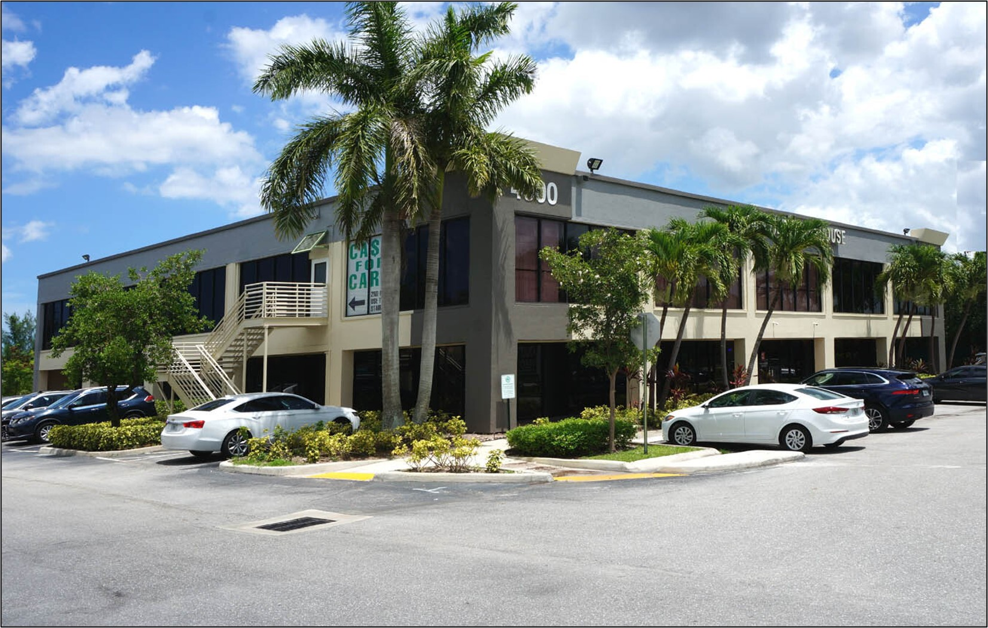


Dan Weinstein Anthony Scavo

