Catchings-Smith Installed as Chair of NPHC Council of Presidents
FOR IMMEDIATE RELEASE
September 18, 2018 Contact: Cheryl Procter-Rogers, 847-454-7400
Cheryl@AStepAheadPR.com

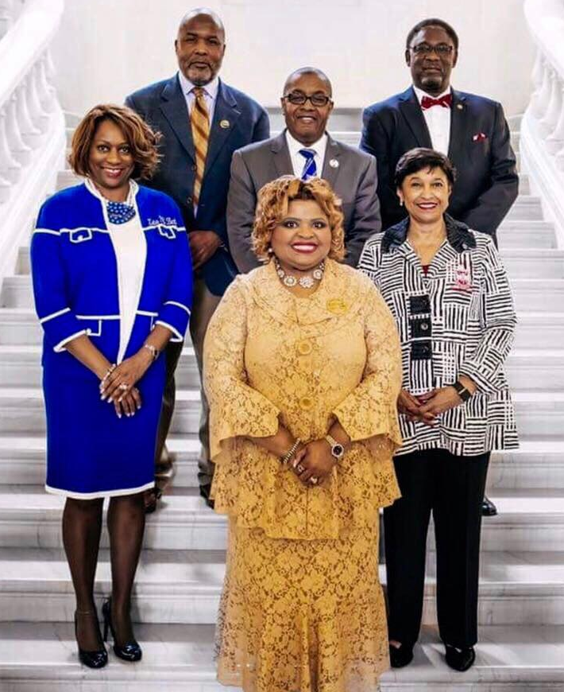
Divine Nine Presidents Convene During Congressional Black Caucus
Pictured top left to right: David Marion, grand basileus, Omega Psi Phi Fraternity; Micheal E. Cristal, international president, Phi Beta Sigma Fraternity; Thomas L. Battles, Jr., grand polemarch, Kappa Alpha Psi Fraternity. Second row left to right: Valerie Hollingsworth-Baker, international president, Zeta Phi Beta Sorority; Beverly E. Smith, national president and CEO, Delta Sigma Theta Sorority. Front center: Deborah Catchings-Smith, international president, Sigma Gamma Rho Sorority. Not pictured: Everett B. Ward, general president, Alpha Phi Alpha Fraternity; Glenda Baskin Glover, international president, Alpha Kappa Alpha Sorority; Andre R. Manson, international grand polaris, Iota Phi Theta Fraternity.

