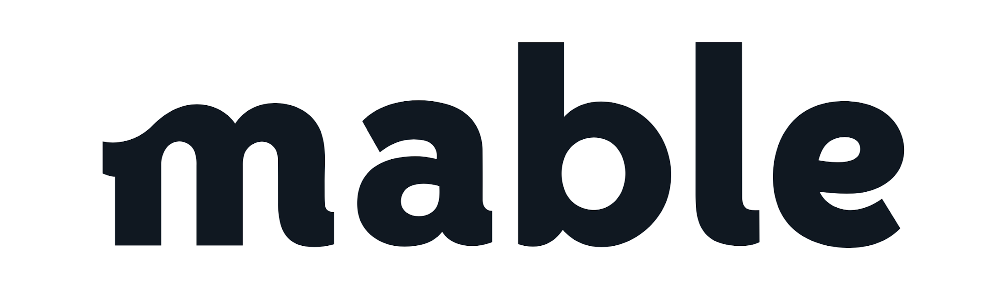

Arik Keller Bio
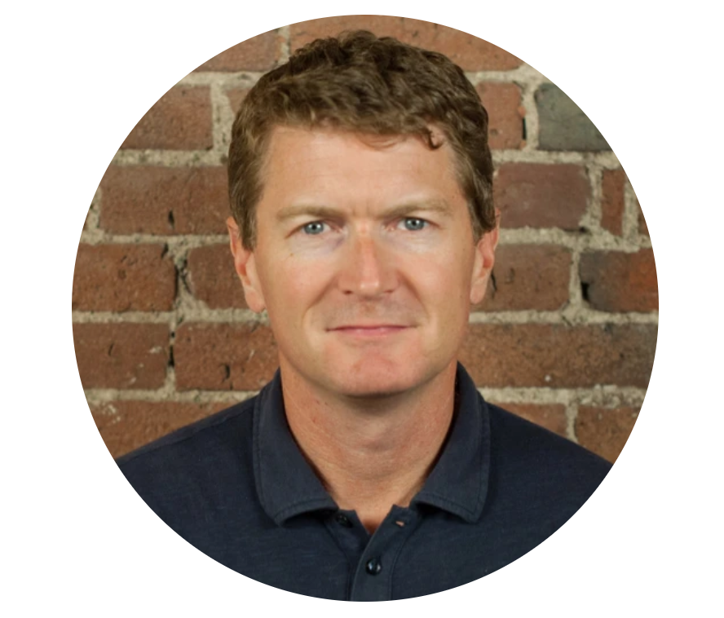
Arik Keller, founder & CEO of Mable, has spent the last 20 years in technology start-ups. Most recently, Keller was Chief Product Officer of Confirm, a mobile identity company acquired by Facebook in 2018. Prior to Confirm, Keller spent 4 years running PayPal’s Global Demand Generation team.
Keller’s passion for small business and retail started when he founded a mobile advertising platform in 2009 designed to help small businesses drive local demand through targeted ads and coupons. The company was acquired by WHERE in 2010, which was acquired by PayPal in 2011. Prior to that, Keller was COO of DNSstuff, a platform for IT administration, that was acquired by Solarwinds.
After Facebook’s acquisition of Confirm, Arik Keller took a break from technology bought a small grocery store. Keller discovered what his customers wanted, which involved a great deal of buying direct from emerging brands.
At the same time, Keller discovered all the inefficiencies of the purchase and restocking process, but with his tech background, quickly saw the solution: an on-line, centralized, ordering platform that would allow retailers to learn about and purchase from individual brands or distributors at wholesale. He also knew this would help distributors streamline their commerce and logistics. Thus, Mable was born, to help small businesses more easily buy from one another to put better quality products on retail shelves and online.

