

Media Contacts
Lucille Ogura
Voiz
908-272-1329 lucille@voiz.link

Retro-futuristic AiRadio from Voiz - Perfect compact audio system for Hi-Fi streaming music

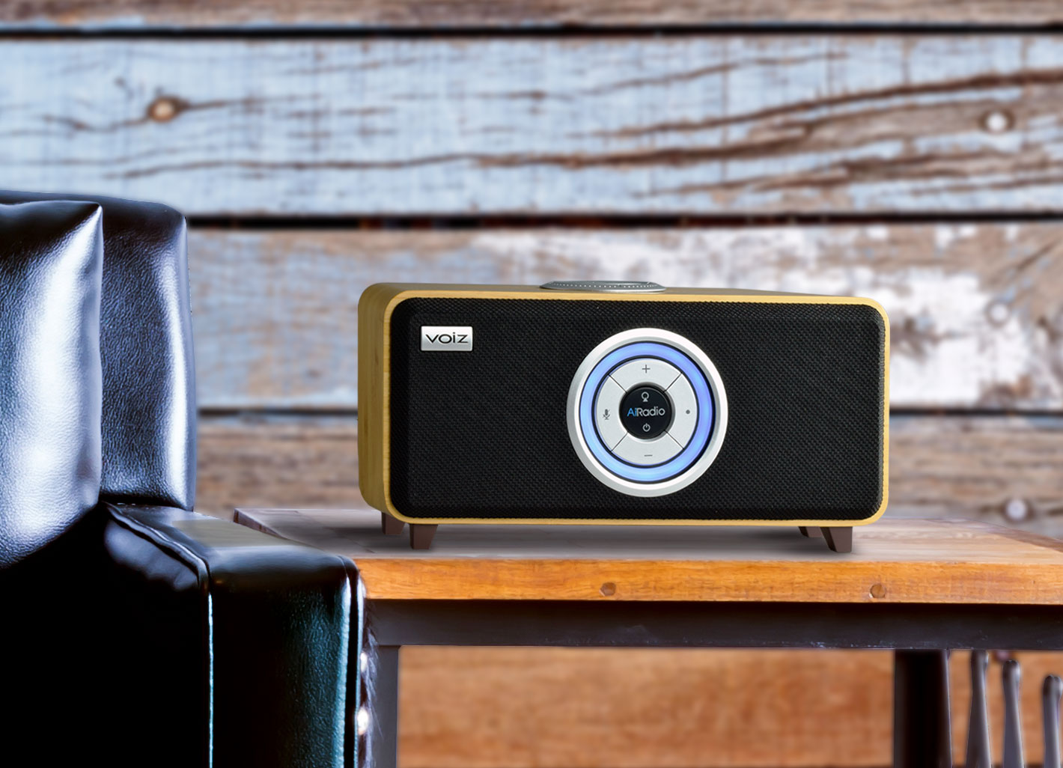

Cranford, NJ - January 30, 2020 - As on-demand streaming music services continue to grow, consumers are looking for quality sound options to enjoy every nuance of their music choices. Voiz, a New Jersey based company, will soon ship its exciting Amazon Alexa enabled AiRadio designed to deliver impressive audiophile sound quality in a handcrafted, sustainable bamboo cabinet that fits into any lifestyle.

The Voiz AiRadio line is comprised of two models that will be available in mid-February 2020. Prior to the shipping, Voiz kicks off a pre-order campaign via their web site www.voiz.link where consumers can purchase the AiRadio Duo VR-80 (Natural speaker grill) or VR-80B (Black speaker grill) for $199 ($100 off retail) and free shipping. According to CEO Hiro Ogura, “We are so excited to deliver our dream product that has received rave reviews from the actual users who purchased from the crowdfunding site IndieGoGo.”

To pre-order, visit: www.voiz.link.

About Voiz
Voiz was founded in 2018 by entrepreneur Hiro Ogura who holds the position of CEO and his wife Lucille joined as a President in 2019.
Ogura started Voiz because he believed consumers deserved better from their audio products. Voiz envisioned a line of audio products with not only superior sound quality, but also attractive designs that would incorporate the latest trends in consumer technology.
# # # # #

