BLUETTI Offers Solar Generators to Gear Up for Halloween
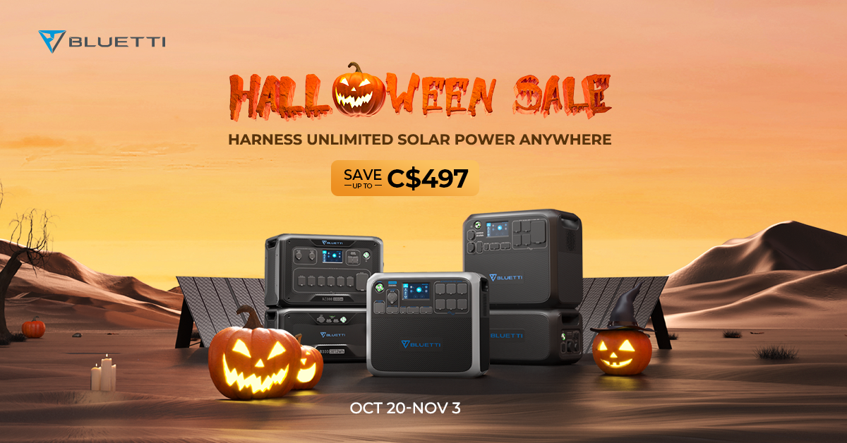
This Halloween, trick-or-treaters can fill their bags with more than free candy. BLUETTI, a portable power station leader, decides to give them a "Boo" before they become power-starved or their houses are haunted by blackouts. It offers a slew of special deals for power generators, batteries and solar panels from this October 20 to November 3.

“Whether people are looking to upgrade gears for camping or secure their houses with stable power supply, this is the most affordable time in recent history.“ BLUETTI’s spokesman James Ray said.

Huge Discounts to Date
From the portable solar generator-- the 10-pound EB3A to the 3072Wh power giant AC300 series, BLUETTI slashes the prices generously. The AC300 series, BLUETTI’s first modular model, is largely discounted. The AC300+B300 combo with three PV350 solar panels is regarded as the best bargain(C$497 off) compared to the AC200P and AC200MAX.

New Bundles to Step Up
BLUETTI also rolls out new battery & solar panel bundles for those who already own a power station and simply wish to beef up their solar system for power independence.

The company claims its expansion LFP battery, B230 and B300, have wide compatibility with mutiple unites. As for its panels, PV200 and PV350 are built up with monocrystalline cells that boast 23.4% efficiency.

"We team up them to give off-grid power system a kick. Convert more free sunlight, store more clean power, a sustainable life with abundant energy is there." James Ray explained in an address to media.

Buy One and Get a Freebie
In addition to hefty discounts, BLUETTI also gives away various useful accessories.
Like a XT90-P090D connection cable will be sent for free to those who buy AC200P+B230 or B230+PV350 or other bundles.

Halloween heralds not only spine-chilling fun but also the coming of winter. It is wise to get prepared before the Knight of Darkness knocks at the door.

About BLUETTI
With over 10 years of industry experience, BLUETTI has tried to stay true to a sustainable future through green energy storage solutions for both indoor and outdoor use while delivering an exceptional eco-friendly experience for everyone and the world. BLUETTI is making its presence in 70+ countries and is trusted by millions of customers across the globe. For more information, please visit BLUETTI online at https://www.bluettipower.ca/.

