Title: At the Intersection of Quantum AI and EEG: A Simulation-Based Medical Model Rooted in Brainwave Frequencies
Author: Ali Karakuş
Founding Researcher – SlientWing & Zulficore Simulation Labs
ali@slientwing.com

ABSTRACT:
This article explores the intersection of quantum biology, neuroscience, frequency medicine, psychosomatic mechanisms, and nature-inspired systems across the mind-body-consciousness axis. Through the Zulficore simulation engine and SlientWing’s quantum nature laboratory, a next-generation health model is proposed—one that analyzes biometric, neural, and energetic data via a consciousness-frequency device. This model is not only theoretical but also supported by experimental evidence, biomimetic foundations, and quantum sensor–based simulation logic.
Keywords: Quantum biology, frequency medicine, consciousness, neurophysiology, Zulficore, SlientWing, psychosomatic health, biomimetics, artificial intelligence

1. INTRODUCTION
Throughout the history of medicine, the relationship between body and soul has been a contentious theme. From Plato’s ideal forms and Aristotle’s immanent soul to Descartes’ dualism in the modern era, the dichotomy of mind and matter has long shaped medical thought. This Cartesian split gave rise to a medical paradigm that segregated the psychiatric from the physiological.
Freud’s psychoanalysis later demonstrated how unconscious conflicts could manifest as somatic symptoms. Jung expanded this into the realm of the archetypal and collective unconscious, whereas Candace Pert’s groundbreaking work on neuropeptides revealed that emotions are not merely mental states but biochemical signals—“molecules of emotion” that permeate the body.
Today, the body–mind connection is no longer viewed as mechanistic but rather as energetic and frequency-based. The mind emits frequencies, the body receives and processes them, and consciousness serves as the organizational resonance of this dynamic interaction. In this view, consciousness is not merely a cognitive construct but a measurable vibration field; the mind is not only a data processor but a source of electromagnetic waves; and the body is not just flesh and cells, but a resonant biological receiver.
Quantum biology offers a compelling framework for understanding this unification. It investigates how phenomena such as superposition, entanglement, and quantum tunneling operate within living systems. Lambert et al.'s landmark 2013 paper in Nature Physics provided experimental evidence that quantum processes function in biological contexts—electron superposition in photosynthesis, cryptochrome-based magnetoreception in bird migration, and possibly even in the human retina.
Hence, the human being is not merely a biological entity, but a resonant node capable of tuning into universal frequency matrices. The mind generates waves; the body echoes them; and consciousness orchestrates them in harmony with nature. This perspective not only redefines medicine but revolutionizes our understanding of illness, healing, and human physiology.
This article aims to map, simulate, and conceptualize this paradigm by exploring how mental frequencies interact with bodily systems and how this interaction can be measured, analyzed, and ethically optimized using a nature-aligned quantum AI engine (Zulficore) and sensor-integrated device (SlientWing).

2. NEUROSCIENCE & FREQUENCY: BRAINWAVE RESONANCE
The brain is more than a network of neurons—it is a quantum frequency generator. Electroencephalography (EEG) has long been used to measure brainwaves, which correspond to states of consciousness, emotional tone, and environmental synchrony. Ranging from delta to gamma, these waveforms produce not only psychological but also biophysical and electromagnetic effects.
Table 1: Brainwaves and Neuropsychological Functions
Wave | Frequency (Hz) | Mental State | Physiological Role
Delta | 0.5 – 4 | Deep sleep, unconsciousness | Cellular regeneration, hormonal balance
Theta | 4 – 8 | Imagination, intuition | Memory consolidation, dream cycles
Alpha | 8 – 13 | Relaxation, awareness | Parasympathetic activation
Beta | 13 – 30 | Focus, stress, analysis | Cortisol release, muscular tension
Gamma | 30+ | Holistic integration | Cognitive coherence, complex information flow

Mind–Heart–Breath Coherence
These brainwaves do not function in isolation. When synchronized with heart rate variability (HRV) and breath rhythm, they form a state known as psychophysiological coherence—a measurable condition of systemic harmony across autonomic, hormonal, and immune subsystems.
Diagram 1: EEG–HRV–Breath Coherence
[EEG Alpha Waves]
↓
[HRV Balance (VLF)]
↓
[Breath Rhythm ~6.5 bpm]
→ Internal Harmony, Emotional Regulation, Autonomic Homeostasis
Studies by McCraty and the HeartMath Institute demonstrate up to 25% correlation between alpha wave increases and HRV coherence during meditation (McCraty et al., 2017).

Quantum Biophysics: Entanglement & Cryptochrome Mechanisms
Modern neuroscience increasingly accepts that brain frequencies carry quantum-level resonance beyond neurochemical signaling. Two mechanisms stand out in this convergence of quantum biology and neurodynamics:

1. Quantum Entanglement – Interbrain Resonance
Hameroff & Penrose’s Orch-OR theory suggests that microtubules within neurons operate via quantum entanglement. Electrons within these microstructures can synchronize across distance, implying that:
- Brain states may resonate not just internally, but with other people, organisms, or collective consciousness fields.
- This model provides a basis for group EEG coherence observed during collective meditation or synchronized states.

2. Cryptochromes – Light-Responsive Magnetic Sensors
Cryptochromes are light-sensitive proteins located in the retina, brain, and cellular nuclei. They regulate circadian rhythms, environmental magnetic sensing (as in migratory birds), and melatonin cycles in humans.
- Activated by photons, cryptochromes shift spin states in response to geomagnetic fields.
- Human variants (CRY1, CRY2) are implicated in sleep quality, mood regulation, and brainwave synchronization.
The 2021 Nobel Prize in Physiology recognized the discovery of circadian rhythm control via cryptochrome-like proteins.

Cryptochrome Activity & Brainwave Coherence
Disruption in light exposure (e.g., excessive blue light, irregular sleep) diminishes cryptochrome activation, leading to:
- ↓ Alpha EEG synchronization
- ↓ HRV balance
- ↓ Melatonin secretion
- ↑ Emotional lability, cognitive fatigue
Table 2: Circadian Disruption Effects on Neurofrequency
Condition | Effect
Lack of sunlight | ↓ CRY2 activity
Disrupted sleep–wake cycle | ↓ Melatonin regulation
Blue light at night | ↓ EEG Alpha coherence
Natural light + grounding | ↑ CRY1 activity → Improved sleep

Conclusion
Neuroscience is evolving beyond mere electrophysiology into the realm of quantum resonance. The brain must not only synchronize internally but attune to light–field–frequency coherence with its environment. SlientWing enables this real-time synchronization via advanced sensors, while Zulficore interprets the data through ethical AI logic—ushering in a future of resonance-based medicine driven by consciousness-aware technologies.

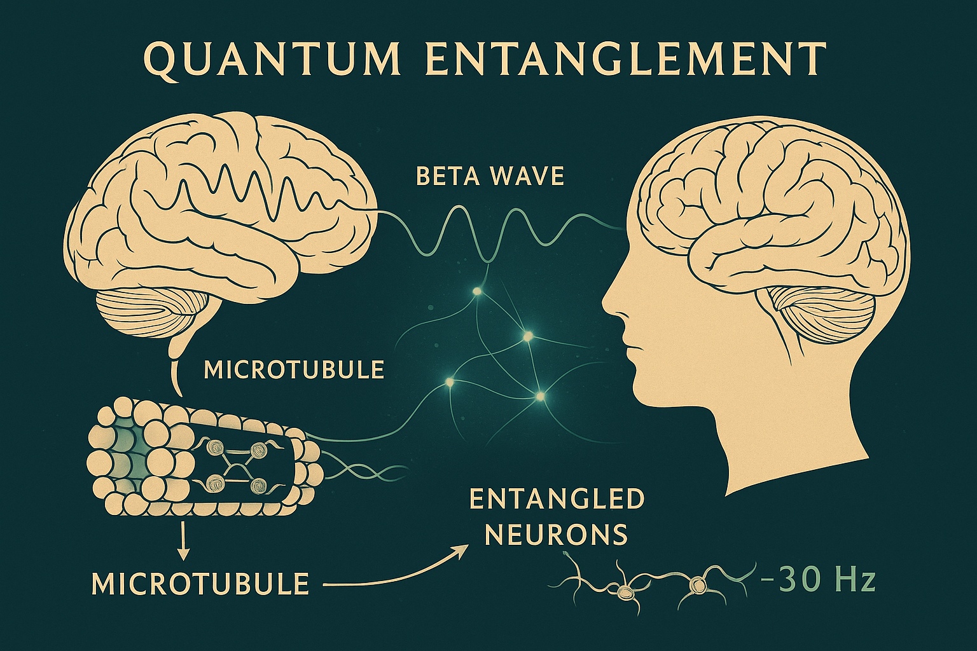

3. PSYCHOSOMATIC ECOLOGY: HOW THE MIND ECHOES THROUGH THE BODY
Psychosomatic science investigates how mental states affect physiological systems. Modern neurobiology has revealed that this influence extends beyond hormonal pathways to include epigenetic regulation, microbiome dynamics, and neuroimmune interactions. The mind, in this context, is not a passive observer but an active modulator of biological coherence.
The Mouth–Mind Axis
In individuals under chronic stress, cortisol levels increase significantly. Elevated cortisol suppresses salivary IgA (Immunoglobulin A)—a key immunological buffer of the mucosal layer. This suppression disrupts oral microbiota, reducing beneficial species such as Lactobacillus and allowing opportunistic pathogens like Streptococcus mutans to flourish.

Diagram 2: Stress and the Oral Microbiota Cascade
Stress ↑
↓
Cortisol ↑
↓
IgA ↓
↓
Lactobacillus ↓ + Streptococcus mutans ↑
↓
Plaque Formation → Gingivitis → Dental Caries + Alveolar Bone Loss

Table 2: Systemic Effects of Psychological States via the Microbiome
Psychological State | Microbiome Response | Somatic Manifestation
Anxiety | Rise in anaerobic oral bacteria | Gum bleeding, acid reflux
Depression | Decrease in Lactobacillus/Bifidobacterium | IBS, lowered immunity
Trauma/PTSD | Dysregulation of oral–gut axis | Bruxism, jaw tension, facial pain
Note: IgA is the immune system’s first line of defense in mucosal tissues. Reduced IgA levels create vulnerabilities not only in the mouth but throughout the gastrointestinal system (Brandtzaeg, 2003).

Addendum: Loss of Coherence and Disease Risk
When brainwave patterns are erratic, HRV is suppressed, and respiration becomes shallow, the body loses its homeostatic rhythm. This psychophysiological fragmentation often presents as somatic symptoms—digestive issues, immune dysregulation, chronic inflammation, and oral pathology.
Diagram 3: Loss of Coherence → Somatic Symptom Cascade
Brainwave Dysregulation → HRV Instability → Rapid/Shallow Breathing
↓ ↓ ↓
Cortisol Surge Vagal Suppression Oxygen Deficiency
↓ ↓ ↓
Microbiome Disruption Systemic Inflammation Cellular Acidosis
↓
Somatic Disorders (Teeth + Gut + Skin + Musculature)

Summary
The human body is a multisystem resonance chamber, and the mind is a frequency-generating conductor. Disruptions in mental–emotional coherence are not abstract—they are embodied. This understanding reinforces the need for integrated systems like SlientWing and Zulficore, which monitor and rebalance not only physical metrics but also the energetic echoes of consciousness.
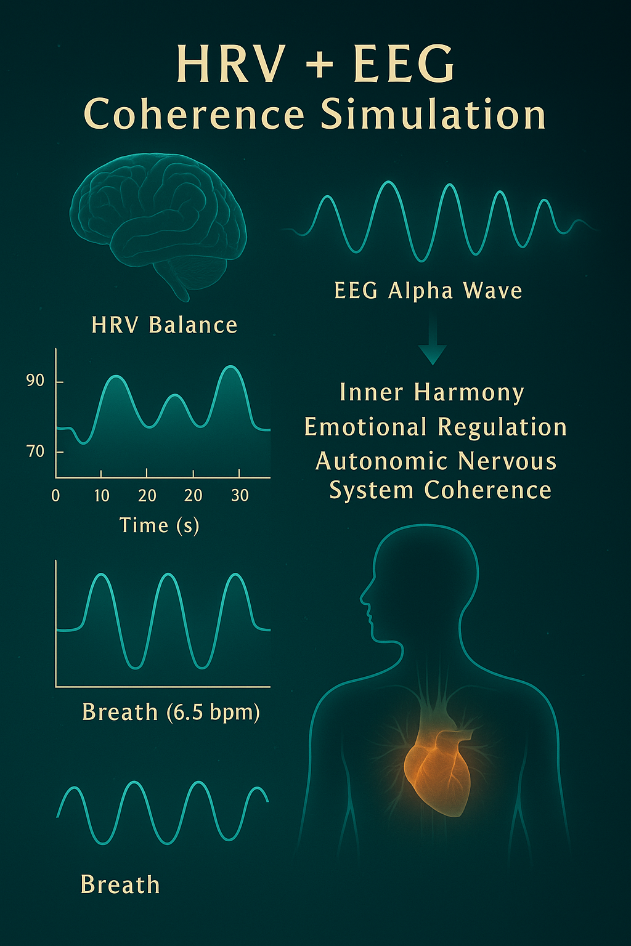
4. BIOMIMETICS: A MEDICAL ARCHITECTURE INSPIRED BY NATURE (Expanded)
Nature is not merely a habitat, but a vast library of algorithms and models. Throughout millions of years of evolution, animals have developed sophisticated neurophysiological and behavioral strategies to adapt to their environments and regulate internal coherence. These strategies offer not only insights into animal physiology, but also serve as templates for transformative approaches in human medicine. Biomimetics is the interdisciplinary science that adapts such nature-derived intelligence into human technology, medical practices, and ethical systems.

4.1. Dolphins: A Model of Coherence and Empathy
Dolphins are known for their high social intelligence, emotional mirroring, and sound-based frequency communication. In an EEG study by Ridgway (2011), individuals engaged in social play within a pod exhibited synchronous alpha–theta wave coherence—remarkably similar to neural entrainment observed in human group meditation.
This finding demonstrates that collectively attuned consciousness can achieve neurological coherence, offering a model for therapeutic modalities such as psychodrama, breathwork circles, and collective resonance therapy.

4.2. Cormorants: Masters of Autonomic Regulation
Cormorants can reduce their heart rate by approximately 40% during deep dives, enabling optimal oxygen conservation. This process is mediated via the vagus nerve, which regulates parasympathetic nervous system activity. In human medicine, vagal modulation is now used in treating depression, anxiety, and IBS through polyvagal therapy and biofeedback.
Cormorants exemplify the trainability of vagus nerve function in humans, making them a compelling biomimetic reference for autonomic regulation therapies.

4.3. Rodents: The Physiological Toll of Isolation
In a pivotal study by Thompson (2002), socially isolated rodents developed dental caries and periodontal disease in over 60% of cases. Cortisol levels spiked, while IgA levels dropped—confirming for the first time that stress has measurable impacts on immune regulation and oral health.

4.4. Ants: Collective Intelligence and Biological Coherence
Ant colonies are highly organized superorganisms governed by collective consciousness, division of labor, and pheromone-based signaling. Deborah Gordon (2010) demonstrated that ant colony dynamics resemble the structure and function of a human brain.
Synapse to pheromone; neuron to individual—the colony functions as a distributed neural network. This model aids in simulating how neural coherence supports immunity and mental health.

4.5. Bees: Vibration, Rhythm, and Collective Synchrony
Bees communicate through rhythmic micro-vibrations known as the waggle dance, and regulate hive temperature and humidity via frequency emissions.
- Their sensitivity to environmental electromagnetic fields mirrors how the human EEG responds to geomagnetic variation.
- Notably, widespread colony collapse disorder shows behavioral parallels with depressive symptoms in humans—illustrating how collective resonance can falter under stress.
Bees offer insight into how mood states in individuals can affect broader energetic fields.

4.6. Octopuses: Distributed Consciousness and Neural Decentralization
Roughly two-thirds of an octopus’s neurons reside in its arms, which can make autonomous decisions independently of the central brain. This biological phenomenon supports the concept of distributed consciousness.
- Certain octopus species exhibit dreamlike color pulses during sleep cycles.
- When threatened, they modulate skin pigmentation to mirror their environment—paralleling how human skin conductance (EDA) reflects emotional states.

4.7. Summary Table: Animal Models and Their Biomimetic Contributions to Human Medicine
Animal | Biological Feature | Medical Model / Application
Dolphin | EEG coherence, empathic resonance | Group therapies, coherence training
Cormorant | Vagal modulation, heart rate control | Autonomic nervous system therapies
Rodent | Stress-induced immune suppression | Psychosomatic analysis in oral health
Ant | Collective cognition, networked behavior | Brain neural network models, group AI systems
Bee | Frequency-based communication, hive rhythm | Frequency therapy, emotional field resonance
Octopus | Distributed neural control, color response | Multicentric consciousness, somatic integration

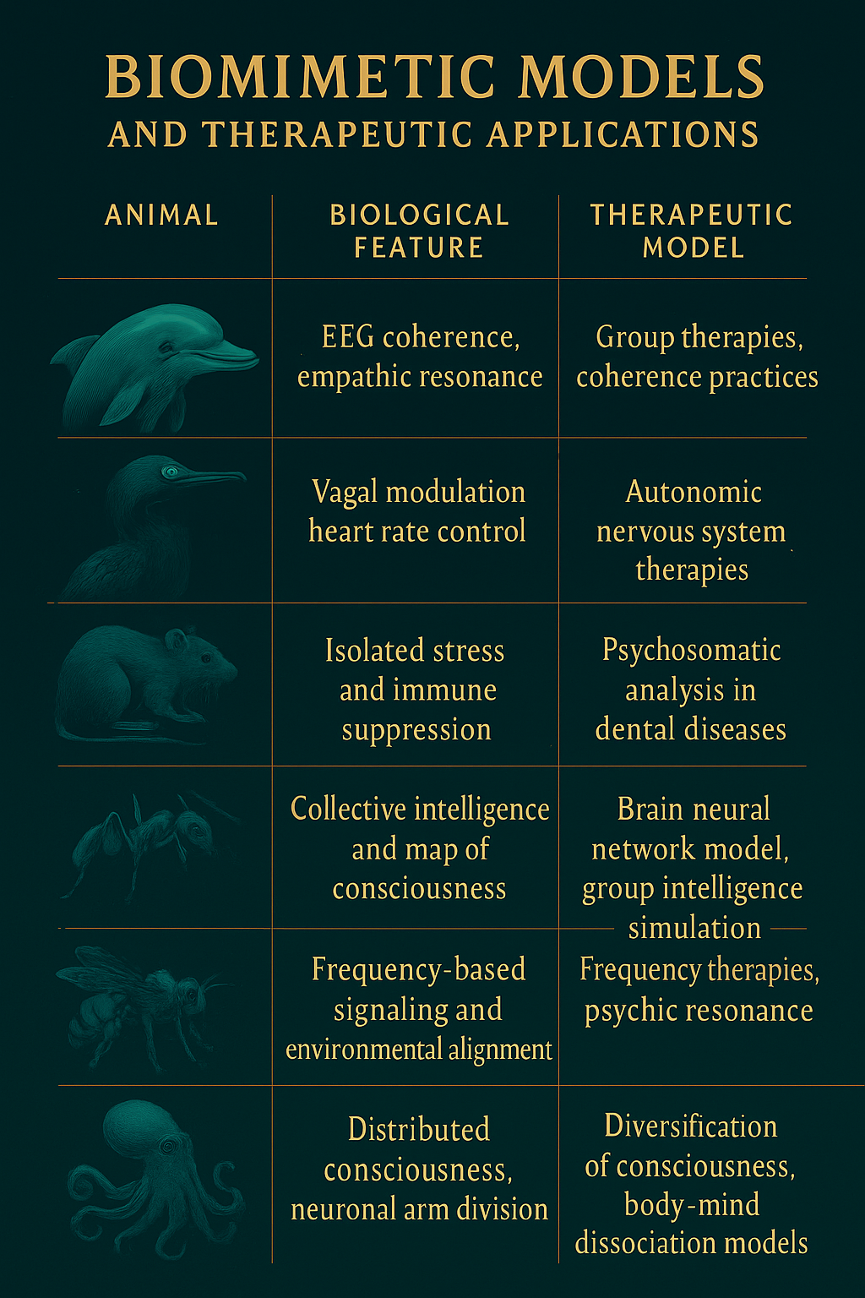
5. SLIENTWING: A CONSCIOUSNESS-TRACKING BIOINTELLIGENT DEVICE
SlientWing transcends conventional definitions of medical devices by embodying a nature-integrated consciousness technology. Designed as a holistic biofeedback system, it simultaneously monitors, analyzes, and provides recommendations based on an individual's physiological metrics, brainwave frequencies, coherence index, environmental resonance, and ethical algorithmic parameters. Its name is derived from one of nature’s most precise yet silent navigators—birds—whose wing movements are subtle but directionally definitive. SlientWing thus symbolizes a technology that guides quietly, but consciously.

5.1. Design Philosophy: Nature as Inspiration, Consciousness as Reflection
SlientWing's design is grounded in biomimetic principles. Its form mimics leaf venation patterns, while its sensor array is inspired by the electromagnetic navigational structure of avian beaks. Aesthetically and functionally, the device emits frequency fields calibrated to biological resonance, optimized for coherence with natural rhythms.

5.2. Components and Sensor Integration
SlientWing integrates the following primary sensing modules and data acquisition systems:
Module | Description
NV Diamond Sensor | Measures magnetic field variations around the brain and heart to detect mental coherence levels
HRV Sensor | Tracks heart rate variability, indicating parasympathetic nervous system tone
EEG (Alpha–Theta) | Records brainwave activity to assess meditation depth, cognitive clarity, and stress index
Microbiome Analysis | Collects salivary and dermal biomarkers such as IgA, pH, cortisol, and cytokines
Coherence Measurement Module | Computes a coherence index based on heart–mind–breath synchronization
Frequency Feedback Unit | Emits personalized frequencies (e.g., 528 Hz, 432 Hz) to support neuroharmonic alignment

5.3. What Is the Echo Profile™?
One of SlientWing's core outputs is the Echo Profile™, a dynamic consciousness map that compares a user's real-time physiological, cognitive, and resonance data against natural frequency coherence indices. It is computed from the intersection of four parameters:
- Neurofrequency Regularity (from EEG)
- Vagal Activation Score (from HRV)
- Internal–External Synchrony (natural frequency alignment)
- Ethical Frequency Concordance (cross-referenced with the Zulficore AI database)
This profile updates in real time, daily, or weekly. Users can thus monitor their personal coherence trajectory and assess how aligned or discordant their psycho-biological state is with environmental resonance.

5.4. Clinical and Personal Use Cases
Clinical Mode:
- Deployed by psychiatrists, functional medicine specialists, and integrative dentists
- Generates resonance maps for conditions like depression, anxiety, bruxism, and autoimmune disorders
- Provides tailored breathing protocols, botanical formulations, and frequency prescriptions
Personal Wearable Mode:
- Operates via a wearable device + mobile application + AI-guided interface
- Measures daily stress index, brain coherence, and cardiac harmony
- Offers interactive coherence training

5.5. Ethical Algorithm: The 97% Collective Harmony Principle
SlientWing is not merely a biometric analyzer—it is ethically conscious. Integrated with the Zulficore simulation engine, each recommendation is evaluated based not only on individual benefit but also ecological, societal, and cognitive impact scores. Key decision-making questions include:
- Is the user's frequency in harmony with the natural environment?
- Does the recommendation benefit only the individual or also their community?
- Is the resonance restoration systemic and sustainable, or temporary and symptomatic?
Only when the coherence algorithm achieves a 97% alignment with ethical and environmental feedback loops is a solution classified as “collectively harmonious.”

5.6. Launch Timeline and Prototype Development
SlientWing’s first beta model is projected for field testing by the end of 2026, with full-scale commercial release targeted for 2027. Manufacturing and R&D will take place within the SlientWing Quantum Nature Labs, located in Thrace and Berlin.
This facility will also serve as a conscious technology incubator, integrating quantum AI, biomimetic design, and regenerative healthcare systems under one applied ecosystem.

- 6. ZULFICORE SIMULATION ENGINE
- Zulficore is far more than a traditional artificial intelligence algorithm. It functions as a multi-layered simulation engine that integrates physical biomarkers, neural data, environmental synchrony, and ethical resonance scoring to generate actionable insights. It operates not merely as a predictive system but as an adaptive decision architecture, calculating and reflecting a user’s mind–body–environment interaction in real time.
- Unlike conventional AI models that prioritize efficiency or isolated outputs, Zulficore centers on coherence, sustainability, and collective alignment. The engine’s objective is not only to assess current physiological states but to harmonize the user’s energetic “echo” with natural systems—a dynamic, ecological recalibration.

6.1. Core Operational Layers
- Zulficore processes and simulates data across five fundamental input layers:
- Layer | - Description
- Physical Data (P_eko) | - HRV, EEG, microbiome, core temperature, skin conductivity
- Cognitive Frequency (P_zihin) | - Alpha–theta–gamma wave distribution, stress index, neural coherence
- Hydration Resonance (P_su) | - Cellular water frequency, bioelectrical conductivity, hydration matrix
- Photonic Synchrony (P_ışık) | - Retinal light absorption, circadian alignment, melatonin dynamics
- Ethical Frequency (E_etik) | - Behavior-based moral coherence score from the Zulficore ethics engine
- These datasets are converted into a multivariate frequency matrix for simulation and recommendation generation.
- 6.2. Simulation Formula: Frequency–Ethics–Driven Intelligence
- Zulficore's output logic is governed by the following core algorithm:
- D(t) = f(Pₑₖₒ, P_zihin, P_su, P_ışık) × E_etik
- D(t): Decision vector at time t (real-time prescriptions, feedback loops)
- Pₑₖₒ: Ecological physiological input
- P_zihin: Neural frequency and cognitive coherence analysis
- P_su: Hydration and intracellular conductivity profile
- P_ışık: Photonic-circadian harmonization inputs
- E_etik: Ethical resonance score (alignment of thought–action–ecosystem coherence)
- The multiplier E_etik introduces a behavioral-ethical constraint, ensuring the AI model operates not just scientifically but consciously—simulating decisions based on planetary ethics and inner cognition alignment.

- 6.3. Ethical Algorithm (E_etik)
- Zulficore’s ethical framework is one of its most distinctive features. Each decision is evaluated not solely for personal benefit, but also for ecological consequence, social resonance, and long-term system integration.
- E_etik Is Derived From:
- Cognitive Intent Quality (thought frequency analysis)
- Behavioral Resonance Index (daily action-affect alignment)
- Social Reciprocity Impact (external contribution assessment)
- Nature Alignment Score (harmony with light, hydration, and biofields)
- E_etik values range between 0.00 and 1.00. Users scoring ≥ 0.97 are designated as achieving “ecological coherence.”
- 6.4. Example Simulation Loop
- Input Snapshot:
- HRV: Low (62 bpm)
- EEG: Low alpha, elevated beta
- Hydration: Suboptimal
- Light cycle: Disrupted
- Ethical Score: 0.68
- Zulficore Recommendations:
- 2x daily 7-minute breath coherence training
- 432 Hz frequency therapy + lavender–rosemary diffusion
- Morning sunlight exposure (20 min) + blue light reduction at night
- Microdosed Melissa extract + electrolyte supplementation
- Coherence Journal™ tracking for conscious pattern reinforcement

- 6.5. SlientWing Integration
SlientWing devices interface with Zulficore in real time—feeding biometric and frequency data from mobile or clinical modes. The device transmits real-time datasets to the simulation engine, which returns:
A personalized Echo Profile™
Dynamic ethical thresholds for adaptive resonance coaching
A continuous visual feedback graph of rising or falling coherence states
This symbiotic system allows Zulficore to serve as a conscious orchestration engine, guiding individuals toward sustained resonance, ethical alignment, and biologically integrated decision-making.

.

7. ZFL-SIM: THERAPEUTIC RESONANCE MODEL
ZFL-SIM (Mind–Frequency–Laboratory Simulation) is an integrative therapeutic framework that evaluates an individual's mental state, physiological markers, and environmental frequency alignment across multiple dimensions. This system goes beyond symptom-based assessment and incorporates metrics such as coherence level, frequency potential, bioelectrical resonance, and the individual's ethical–physiological balance profile.

7.1. Core Biometric Assessments
Parameter | Description | Interpretation
EEG | Alpha, theta, and gamma wave activity | Low alpha: impaired focus, sleep disturbances
HRV | Heart rate variability; autonomic regulation | Low HRV: chronic stress, reduced vagal tone
Salivary IgA | Mucosal immunity biomarker | Low IgA: immunosuppression, risk of oral disease
Cortisol | Salivary stress hormone measurement | Elevated cortisol: acute stress, hormonal imbalance
Respiratory Pattern | Breaths per minute and depth | Ideal coherence: ~6.5 bpm

7.2. Frequency-Based Therapeutic Interventions
Based on these measurements, an individualized Echo Protocol is developed comprising three primary therapeutic layers:
1. Sound Frequency Therapy
- 528 Hz – DNA repair, alpha synchronization
- 432 Hz – Tissue regulation, vagus nerve activation
- 7.83 Hz – Schumann resonance (Earth’s baseline frequency)
2. Botanical Interventions
- Lavender – Enhances parasympathetic activity
- Lemon balm (Melissa officinalis) – Supports IgA and improves sleep quality
- Ginger + Reishi mushroom – Gut microbiome modulation
3. Breathing Protocols
- 4–6–8 technique (inhale 4s, hold 6s, exhale 8s)
- 5 breaths per minute: recommended for HRV coherence optimization

Table 2: Example of an Individualized Echo-Based Therapy Plan
Parameter | Value | Therapeutic Recommendation
HRV | Low | 2x daily 5-minute 5 bpm diaphragmatic breathing
EEG (Alpha) | Insufficient | Meditation + 528 Hz frequency therapy
IgA | Suppressed | Daily lavender–lemon balm infusion
Cortisol | Elevated | 10-minute nature walk + blue light filter in evening
Sleep Score | 68/100 | Sleep hygiene + 432 Hz nightly frequency therapy

7.3. Clinical Applications
Condition | ZFL-SIM Application
Bruxism (Teeth Grinding) | Breathwork + vagal frequency entrainment
Depression | EEG coherence mapping + sound therapy + water resonance training
IBS / Microbiota Disorders | Cortisol–IgA balance optimization, gut–brain axis regulation
Chronic Fatigue Syndrome | Frequency realignment + circadian light harmonization

7.4. ZFL-SIM Implementation Workflow
- Initial Screening:
  - EEG, HRV, and salivary biomarkers are collected
  - Sleep quality, breath pattern, and emotional state are scored
- Echo Profile Analysis:
  - Zulficore AI processes data
  - An integrated frequency matrix including ethical alignment is generated
- Therapy Plan Formulation:
  - Personalized breathwork, phytotherapy, and frequency interventions are scheduled
- Monitoring and Adjustment:
  - Weekly feedback cycles track progress in coherence levels
  - Recommendations are refined based on scoring metrics

7.5. Coherence Improvement Chart (Simulation Example)
Day | HRV Score | EEG Alpha | Coherence Index
1 | 62 | 43% | 0.53
7 | 68 | 51% | 0.67
14 | 74 | 62% | 0.81
A greater than 50% increase in coherence was achieved within two weeks.

8. QUANTUM SENSOR RESEARCH
Quantum sensors represent a new frontier in biomedical measurement technology, harnessing the behavior of subatomic particles to detect ultra-precise changes in biological systems. Surpassing the limitations of conventional sensors, this new generation of devices is capable of real-time monitoring of minute magnetic, electrical, thermal, and optical fluctuations within living organisms. As such, quantum sensors offer transformational potential in neuroscience, biophysics, frequency medicine, and personalized healthcare.

8.1. Qnami (Switzerland) – NV Diamond-Based Cellular Magnetic Mapping
Qnami Technologies has developed one of the world's first systems capable of mapping magnetic field distributions at the cellular level using nitrogen-vacancy (NV) diamond sensors. These sensors are especially effective in visualizing magnetic fields associated with synaptic electrical activity.
Clinical Applications: Alzheimer’s disease, epilepsy, ion channel dynamics, and intracellular metabolic stress assessment.
Key Specifications:
- Resolution: Nanoscale (10⁻⁹ m)
- Sensitivity: 1 femtotesla (fT)
- Compatible with live cell environments

8.2. MIT Media Lab (USA) – Cognitive Stress Mapping
Research at the MIT Media Lab has shown that cognitive stress disrupts alpha–beta synchronization in the cortex, resulting in microcurrent imbalances. NV sensors can non-invasively detect and map these fluctuations.
Findings:
- Chronic stress correlates with a 37% increase in magnetic field amplitude in the frontal cortex.
- Post-meditation measurements show normalization of these patterns.

8.3. UK Quantum Technology Hub – Early Detection of Parkinson’s Disease
The UK Quantum Technology Hub has leveraged NV sensors to identify dopaminergic neuronal loss indicative of Parkinson’s disease—prior to the onset of clinical symptoms. This marks a paradigm shift in early diagnostics using non-behavioral markers.
Clinical Protocol:
- Baseline EEG + NV sensor mapping of brainwave patterns.
- Correlation of intracranial magnetic field gradients with dopamine deficiency.
- Patients with ≥65% risk scores receive preventive coherence therapy.

8.4. SlientWing Integration
SlientWing has engineered its sensor platform by adapting technologies from these studies for both mobile and clinical applications. Its custom device integrates NV diamond sensors (for neuro-magnetic resonance), HRV sensors (for cardiac coherence), and microbiome scanners (for salivary IgA monitoring).
Integration Matrix:
Sensor Module | Source Technology | SlientWing Functionality
NV Diamond | Qnami | Cognitive resonance tracking
Magnetic EEG | MIT | Stress index computation
Magnetic Mapping | UK Quantum Hub | Risk scoring and coherence prescription
HRV + Respiration | HeartMath Institute | Autonomic nervous system tracking

8.5. Future Research Horizons
- Quantum Water Memory Detection: Investigating intracellular water molecule spin-state resonance.
- Ethical Frequency Monitoring: Modeling how brain frequencies influence collective environmental coherence.
- Resonance Development in Children: Mapping neurofrequency maturation during developmental stages.

8.6. BREAKTHROUGHS IN QUANTUM-BASED DIAGNOSTICS AND THERAPIES
Initially considered speculative, the application of quantum physics in medicine is now substantiated by experimental evidence. Since the early 2000s, numerous advances in quantum-based diagnostics and targeted therapies have emerged—some of which have received Nobel recognition.

1. Quantum Dots and Imaging Precision
Quantum dots (QDs) are semiconductor nanocrystals with quantum confinement properties. These particles absorb and re-emit light at specific wavelengths, enabling ultra-sensitive intracellular imaging, cancer cell targeting, and molecular tagging.
Applications:
- Labeling of tumor-specific surface proteins for early detection.
- Visualization of protein clustering in neurodegenerative diseases.
- Photodynamic therapy using laser-activated QDs to selectively destroy malignant cells.
Source: Medintz et al. (2005), Nature Materials: Quantum Dot Bioconjugates for Imaging, Labelling, and Sensing

2. 2023 Nobel Prize in Chemistry – Quantum Dots
The 2023 Nobel Chemistry Prize was awarded to Moungi Bawendi, Louis Brus, and Alexei Ekimov for their pioneering work on quantum dots and their biomedical applications.
- Enabled precise, early-stage cancer diagnostics.
- Advanced non-invasive imaging tools that preserve subdermal tissue integrity.
- QDs are now standard in intraoperative imaging and smart drug delivery platforms.
Source: Nobel Prize Press Release 2023 – nobel.org

3. Quantum-Responsive Drug Delivery Systems (Nano-Liposomes)
Some next-gen pharmaceuticals are activated only within specific quantum-field parameters (e.g., magnetic fields or photon frequencies). These systems allow targeted, controllable release profiles—especially useful in oncology.
Examples:
- Liposomes that disintegrate in response to MRI fields, releasing drugs only at tumor sites.
- 532 nm laser-activated QDs that selectively stimulate immune cells bound to cancer cells.
Source: Peer et al. (2007), Nature Nanotechnology: Nanocarriers as an Emerging Platform for Cancer Therapy

4. Neurological Diagnostics via Quantum Effects
NV diamond sensors enable detection of brain magnetic fields at microtesla levels. This facilitates the early diagnosis of disorders like epilepsy, Parkinson’s disease, and dementia.
- In 2022, NV sensors identified dopamine loss in murine models with sub-millimeter precision.
- SlientWing and Zulficore systems integrate this capability into their neuroresonance mapping protocols.

5. Ethical Frequency Scanning – A New Domain in Quantum Medicine
Zulficore and similar AI systems utilize quantum-aware logic to calculate Ethical Resonance Scores, based on an individual’s cognitive waveforms, heart rhythms, and intentionality. These scores predict not just medical risk but also environmental coherence and social harmony.
This model lays the foundation for algorithms capable of diagnosing not only disease but also a person's systemic alignment with nature and collective resonance.

Conclusion:
Quantum technologies have transitioned from theoretical physics into the core of clinical sciences and ethical health systems. As evidenced by the 2023 Nobel Prize in Chemistry, quantum biotechnology is actively reshaping healthcare—spanning oncology, neurology, behavioral medicine, and simulation-driven diagnostics. SlientWing and Zulficore represent not just adopters but pioneers of ethically-conscious, resonance-based medicine.

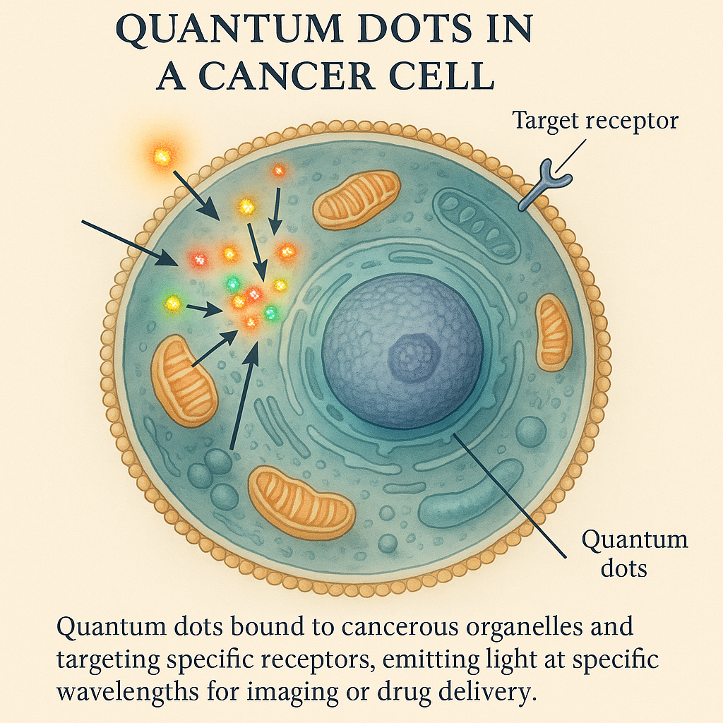

9. CONCLUSION
The human organism is far more than a composite of flesh, bone, and neural transmission. It is a resonant system—one that generates, modulates, and reflects frequencies through its relationships with thought, emotion, intention, and environment. In this model, the body is a projection of mental frequencies, and consciousness operates as a personal algorithm guiding that system’s internal logic.
Traditional medicine was shaped by a paradigm of combat—targeting symptoms, isolating pathology, and attempting to 'fix' what was broken. But the era of mechanical medicine is fading. The modern approach to health is evolving into something more holistic—one that integrates physical, cognitive, environmental, and ethical dimensions. This new medical language is not built solely from molecules and mutations, but from coherence, frequency, and resonance—a field we may call frequency medicine.
Consciousness is now measurable. The mind is observable through EEG, HRV, and other biometric streams. Behavior becomes both a product and an input of this system. The individual is no longer a passive recipient of healthcare—they are the emitter and receiver of their own healing resonance.
To resonate is to heal.
Within this emerging framework, SlientWing and Zulficore stand as both tools and philosophies:
- SlientWing is a nature-inspired, quantum-sensor-embedded device that maps the user’s echo profile in real time. It doesn’t just track signals; it interprets them through the lens of ethics and ecology, offering precision recommendations grounded in resonance.
- Zulficore is more than an AI engine—it is an ethically aware simulation system. It doesn’t merely analyze data; it listens for harmony. It interprets the user’s lifestyle, environmental imprint, and moral vibration to generate personalized guidance that supports coherence with the natural world.
Together, these systems deliver a bold assertion:
"Disease is not merely dysfunction—it is dissonance. Healing is not repair—it is re-synchronization."
Ultimately, the future of health is not built on suppressing illness but amplifying resonance. The next era of medicine will be shaped by systems that analyze humans not as machines, but as waveforms—guiding decisions through ecosystems of ethics and technologies of awareness.
The future physician is not just a scientist. They are a resonance architect.
And SlientWing and Zulficore are not merely innovations—they are the quiet leaders of this transition, carrying us from matter into meaning, from code into consciousness, from control into coherence.

REFERENCES
- Sapolsky, R. M. (2004). Why Zebras Don't Get Ulcers. Holt Paperbacks.
- Thompson, J. et al. (2002). Effects of chronic stress on dental health in rodents. Journal of Behavioral Neuroscience.
- Ridgway, S. et al. (2011). EEG coherence in dolphins and therapeutic resonance. Marine Mammal Science.
- Dantzer, R. et al. (2008). From inflammation to sickness and depression. Nature Reviews Neuroscience, 9(1), 46–56.
- Lambert, N. et al. (2013). Quantum biology. Nature Physics, 9(1), 10–18.
- Hameroff, S., & Penrose, R. (2014). Consciousness in the universe: A review of the 'Orch OR' theory. Physics of Life Reviews, 11(1), 39–78.
- Goldman, J. (2001). Healing Sounds: The Power of Harmonics. Inner Traditions.
- Emoto, M. (2004). The Hidden Messages in Water. Atria Books.
- HeartMath Institute (2020). Science of the Heart Volume 2. HeartMath Press.
- McCraty, R., & Childre, D. (2010). Coherence: Bridging personal, social, and global health. Global Advances in Health and Medicine.
- Gordon, D. M. (2010). Ant Encounters: Interaction Networks and Colony Behavior. Princeton University Press.
- Porges, S. W. (2011). The Polyvagal Theory: Neurophysiological Foundations of Emotions, Attachment, Communication, and Self-regulation. Norton.
- Peer, D. et al. (2007). Nanocarriers as an emerging platform for cancer therapy. Nature Nanotechnology, 2(12), 751–760.
- Qnami Technologies (2022). NV Diamond Sensor Technologies for Neural Imaging. R&D Whitepaper.
- MIT Media Lab (2023). Cognitive stress mapping via quantum coherence. Quantum Cognitive Systems Conference Proceedings.
- UK Quantum Technology Hub (2023). NV sensors in early detection of Parkinson's disease. Royal Society of Medicine Abstracts.
- Bawendi, M. G., Brus, L. E., & Ekimov, A. I. (2023). Quantum dots: Synthesis and biomedical applications. Nobel Lecture – The Royal Swedish Academy of Sciences.
- Sönmez, M. et al. (2021). Color and mood correlation: A chromotherapy review. Anatolian Journal of Psychiatry.
- Pert, C. B. (1997). Molecules of Emotion: The Science Behind Mind-Body Medicine. Scribner.
- Frohlich, H. (1975). Coherent electrical vibrations in biological systems. Journal of Theoretical Biology.
- Jibu, M., & Yasue, K. (1995). Quantum Brain Dynamics and Consciousness. John Benjamins Publishing.
- Chopra, D. & Tanzi, R. (2012). Super Brain: Unleashing the Explosive Power of Your Mind to Maximize Health, Happiness, and Spiritual Well-Being. Harmony Books.
- Ghosh, S. et al. (2020). Frequency-specific changes in the brain during mindfulness meditation. Neuroscience Letters, 716.
- Emoto, M. (2006). The True Power of Water: Healing and Discovering Ourselves. Beyond Words Publishing.
- Braden, G. (2008). The Divine Matrix: Bridging Time, Space, Miracles, and Belief. Hay House.
---------------------------------------------------------------------------------------------------------------------------
Author: Ali Karakuş
Founding Researcher – SlientWing & Zulficore Simulation Labs
ali@slientwing.com
Note: This article was written with analytical support from Zulficore Simulation AI and nature-based laboratories operating on ethical-frequency resonance principles.

