FOR IMMEDIATE RELEASE

Stavis Seafoods Continues Its Growth with An Historic Move To New Facilities

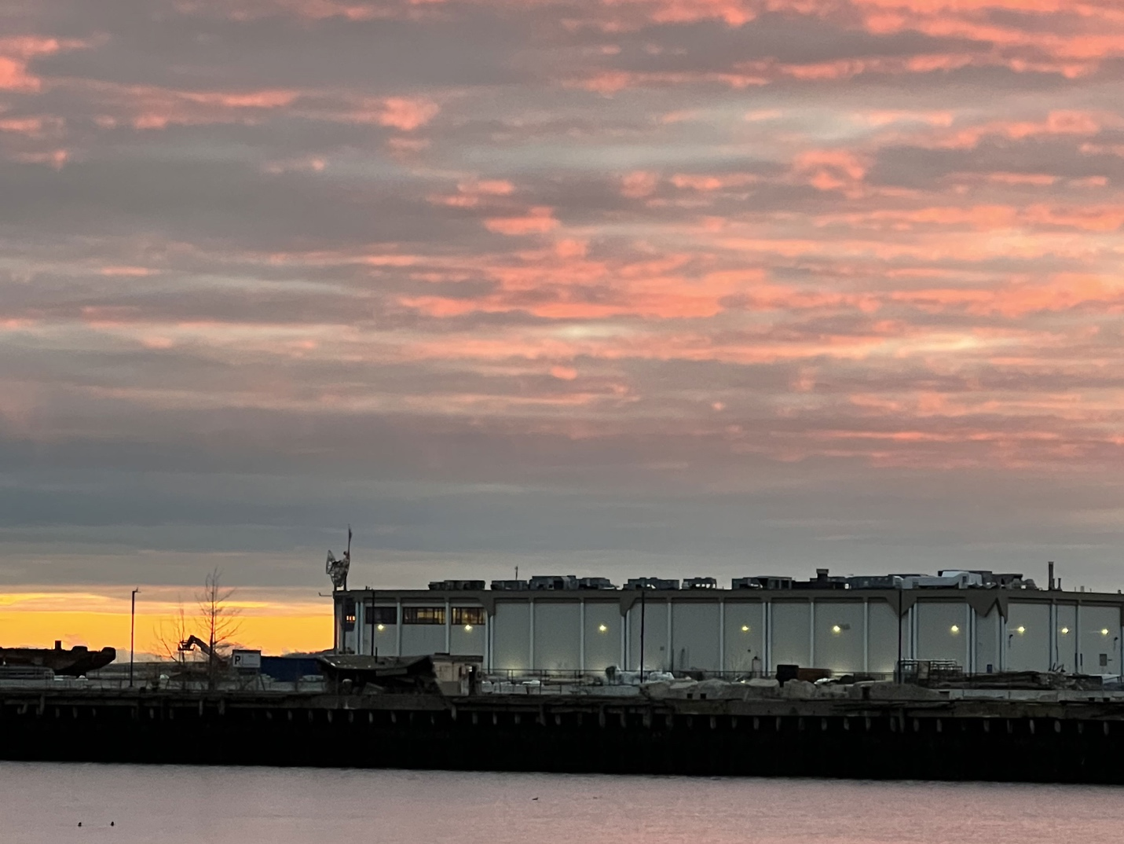
A New Dawn: 1 Seafood Way Facility on the Boston Harbor

[Boston, June 21, 2023] — Stavis Seafoods, a renowned name in the seafood industry, moves to a new facility with its own significant history. Located at 1 Seafood Way in the Boston Seaport, this new facility and move marks a significant milestone in Stavis' journey, solidifying its position as a true industry leader and pioneer in the global seafood market.

The relocation is a further step in Stavis' continued growth and commitment to innovation and providing customers with the highest quality seafood products. The new space will see a significant expansion and redevelopment to house a state-of-the-art facility, incorporating the latest technological advancements that will revolutionize seafood production, with the assistance of the expert engineering team of parent company, Profand Group.

"We are thrilled to embark on this exciting new chapter in Stavis Seafoods' storied history," stated CEO David Lancaster. "Our relocation to 1 Seafood Way represents a significant investment in our future and underscores our commitment to excellence in every aspect of our business. This new facility will empower us to expand our operations, maintain rigorous quality standards, and reinforce our position as a trailblazer within the seafood industry."

Stavis contributes to the preservation of our oceans for future generations through its sustainable practices and responsible sourcing, while consistently supplying seafood products that go beyond its customers' expectations. The cutting-edge technologies to be implemented in the processing facility will prioritize environmental conservation and adhere to the highest industry standards.

“I would also like to extend my gratitude to Massport for working diligently with us to find a solution that keeps Stavis Seafoods in the Boston Waterfront Seaport district; our home for nearly 100 years,” Lancaster added. “Massport’s continued commitment to the Seafood Industry is a tremendous support.”

About Stavis Seafoods:

Stavis Seafoods is a premier provider of seafood products in the New England seafood industry since 1929. Stavis’ rich heritage and global reach has positioned the company as a leader in the seafood industry, offering an extensive range of fresh and frozen seafood products sourced from the world's finest fisheries. The company's dedication to reliability, innovation, and environmental responsibility has established Stavis Seafoods as a trusted leader and preferred partner worldwide.

Stavis Seafoods LLC is owned by Profand Group, a multinational fishing and seafood company based in Spain with more than 3,000 employees and business operations in Europe, USA, Asia, South America, and Africa. Profand markets around 120,000 tons of fish per year, owns 13 processing plants, 11 aquaculture facilities and 24 fishing vessels operating globally.

Committed to quality and innovation, Profand Group takes care of the entire value chain from the origin, from integrating fishing and aquaculture, to the processing and distribution of fish, cephalopods, and crustaceans. This relationship provides Stavis with a direct connection to harvesters throughout the world, giving the company true vertical integration and a simple, traceable sourcing solution.

Profand also has a strong commitment to sustainability. Through its strategy Profand 4 Future, Profand develops its green visions for a blue future: contributions to community development, conservation and ecosystems, protection and respect of human labor rights, compliance, and good governance.

Profand Group’s North America branch, Profand USA manages all US based subsidiary companies including Stavis Seafoods LLC., Seafreeze Ltd., and Worldwide Perishables Enterprises, LLC.

Contact: Martha Williams
Marketing Director, Stavis Seafoods
mwilliams@stavis.com

