BIO: Founder and CEO of Sōmrus, Mr. Pankaj K. (“PK”) Garg
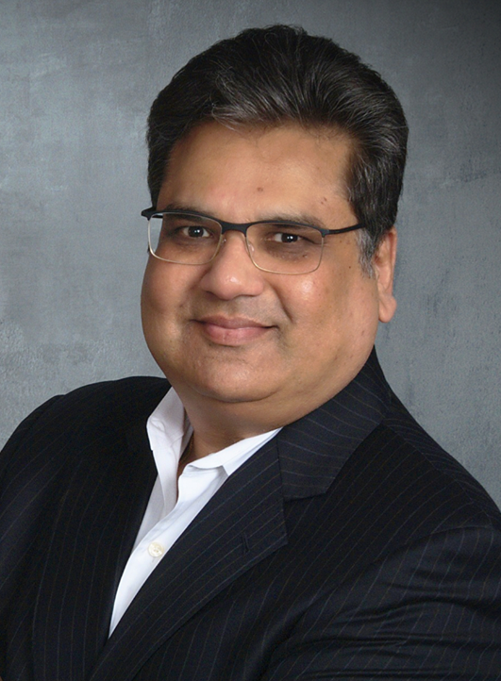
Happenstance is how entrepreneur PK describes his entry into the food and beverage industry. “It was an epiphany that came to me 35,000 feet in the air,” says Mr. Pankaj K. (“PK”) Garg, Founder and CEO of Sōmrus, a premium spirits company founded in 2012. “I had just enjoyed an Eastern-inspired meal while traveling from India to the U.S. It was followed by a delectable Indian dessert called Ras Malai. I still needed my nightcap, so I asked for Bailey’s, except its flavor couldn’t have been farther from the Eastern flavors of cardamom and saffron, and a light bulb went off: How come there is not a cream liqueur representing a region known for spices, flavors, and aromas, constituting about one-fifth of the world’s population?”
With this idea in mind, PK embarked on creating the Indian answer to Bailey’s, Kahlúa, Jägermeister, and other geographically-defined liqueurs. “We wanted to develop a line of liqueurs which are ‘India inspired, but universally appealing,’” he explains. After considerable research, experimentation, and a number of global focus groups, Sōmrus was born.
Prior to founding Sōmrus, PK was a Partner and Industry Director at Bridge Strategy Group, a Chicago based boutique strategy consulting firm. PK’s areas of specialization included Strategic Business Planning, Business Program Management, Business Transformation, Cost Optimization, Organizational Change Management and Enterprise Benefits Realization, among others. Formerly, PK served as the Corporate Vice President of Strategy and Business Consulting for a major global professional services firm; PK had been the founding team member of this firm’s US-based business consulting profit center. Before that, PK spent 14 years with EDS and A.T. Kearney in management consulting services, corporate strategy, and client partner roles. In another global first (other than India-inspired liqueurs!), PK was instrumental in helping Detroit based General Motors Corporation bring the world’s first commercial electric vehicle, “EV1,” to the market in 1994. PK is a patent holder on concept and processes for a global delivery model based on the native capability strands (“DNA”) of an enterprise. PK started his career with a major Asian conglomerate as a Management Trainee for the Office of Chairman and CEO.
PK received a Bachelors Degree in Mechanical Engineering with Honors from Birla Institute of Technology & Science (BITS), Pilani, India; a Masters in Corporate Finance & Marketing from The University of Illinois at Chicago; and an MBA from Kellogg School of Business in Evanston, Illinois.

