PRESS RELEASE:

An Intimate Evening Under The Hampton Stars With Michael Bolton
to benefit
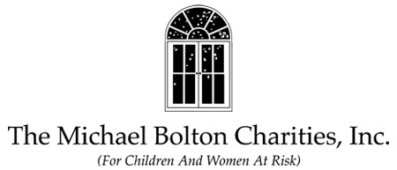

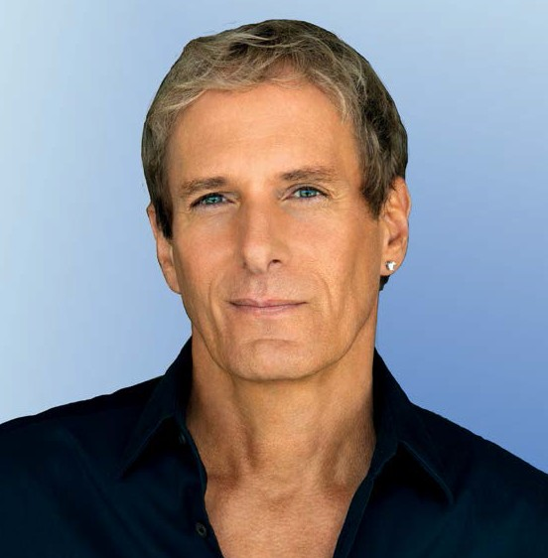Event: The Michael Bolton Charities Benefit Where: Private Residence - Sagaponack, New York Date: Saturday, August 29, 2015
6:30-7:30 pm ~ Private Sponsor Reception
7:30 pm ~ Dinner, Dancing, Silent & Live Auctions 9:30 pm ~ Performance

Sponsorships & Ticket Pricing:
http://michaelboltoncharities.com/index.php/events

To Order Tickets/Contact:
Andrena at The Michael Bolton Charities (203) 483-6463

Interview Contact:
Joyce Logan (203) 671-8403
Email: joyce@joyceloganmarketing.com

The Michael Bolton Charities was formed 23 years ago and has been a consistent advocate and supporter of initiatives and organizations committed to responding to the needs of children and women at risk from domestic violence, physical and mental abuse, poverty, homelessness and human trafficking. The Charities is devoting its attention to focus grant-giving
around one-service delivery design, in particular, The Family Justice Center model (FJC). The FJC is a one stop center of support services for domestic violence victims and their children, providing a holistic approach, its ability to improve communications among providers and its success in assessing victims to engage with a broad array of life-saving services. The Charities is working on such a pilot in New Haven, Connecticut, based on the successful Brooklyn FJC.
The event takes place on Saturday, August 29th, 2015 in Sagaponack, NY, at the “Dream Home” of Sammi & Scott Seltzer; a story about their home was recently featured in the New York Times. The evening will feature Dinner, Dancing, Silent & Live Auctions and a performance by Michael Bolton.

Sponsorships and individual tickets are available @
http://michaelboltoncharities.com/index.php/events

Michael Bolton is a multiple Grammy Award-winning Singer, Songwriter and Social Activist, who has sold more than 55 million records worldwide. Bolton remains committed to humanitarian causes, especially through The Michael Bolton Charities, now in its 23rd year.
In recognition of his artistic achievements, Michael won 2 Grammys for Best Pop Male Vocal Performance (nominated four times), 6 American Music Awards, and a Star on the Hollywood Walk of Fame. As a songwriter, he has earned over 24 BMI & ASCAP Awards, including Songwriter of the Year, 9 Million-Air awards, and the Hitmakers Award from the Songwriters Hall of Fame.
Continuing to tour the world each year, Michael has performed with such legends as Ray Charles, Luciano Pavarotti, Placido Domingo, Jose Carreras, Renee Fleming and BB King.
Recently, Michael became a viral sensation in The Lonely Island’s Emmy nominated video, “Captain Jack Sparrow” that launched on Saturday Night Live and has racked up nearly 140 million views on YouTube. Bolton has continued his comedic appearances in several episodes of CBS’s hit series Two and a half Men as well as the hit Fox network show Glee, HBO’s hit series Last Week Tonight with John Oliver, and ABC’s brand new series Repeat After Me, executive produced by Ellen Degeneres. He has also featured in TV campaigns for Honda, Starburst and Optimum and has ongoing campaigns with American Greetings.
Michael has been honored with several Humanitarian awards - including the Martin Luther King Award granted by the Congress of Racial Equality (C.O.R.E.), the Lewis Hine Award from the National Child Labor Committee, the Ellis Island Medal of Honor from the National Ethnic
Coalition of Organizations, and the Frances Preston Lifetime Achievement Award. Michael has testified before Congress for reauthorization of the Violence Against Women Act.

Sponsorships and individual tickets are available @

http://michaelboltoncharities.com/index.php/events

EVENT PRODUCED BY LAWRENCE SCOTT EVENTS

The following sponsors have generously given their support:

PRESENTING SPONSORS:

Paula & Robert Butler Stuart Rahr
Lawrence Scott Events

Event Co-Chairs Sammi & Scott Seltzer Gale & Ken Sitomer

Platinum Sponsors:

Sammi & Scott Seltzer Ravi & Raj Seltzer

Diamond Sponsor:

Sabrina & Jahn Levin

Gold Sponsors:

Digital Check Lisa Loeffel
Scott Seltzer, Wealth Advisor, Morgan Stanley

Bespoke Real Estate

Silver Sponsors:

Sandler & Mara, P.C.

Dawn & Frank Bodenchak Laura Cahill
Caterina DeMarco Gary DePersia
Elle & Herman Gans
Law Office of Sabrina N. Hannam, LLC Mindy & Larry Richenstein
Elizabeth Papadopolous & John Sills Anna & Joe Simone
Gale & Ken Sitomer Nadia & Raj Vasirhani Webster Private Bank Linda & Larry Weiss

Rose Sponsor:

Nevado Roses

Media Sponsor:

Hamptons Magazine

The Michael Bolton Charities is pleased to support The Southampton Animal Shelter.

For complete details please visit:
http://michaelboltoncharities.com/

