
Positively Arts Presents: The Get Launched Vegas Showcase at Myron’s on March 9
Tickets Now on Sale for the 2024 Get Launched Vegas Showcase at The Smith Center, Featuring the “Best of the Best” Vegas Youth Performers

February 6, 2025 - Las Vegas, NV – Positively Arts, a Las Vegas-based 501(c)(3) nonprofit organization dedicated to providing performing arts training to children across the Las Vegas Valley regardless of their ability to pay, announces the 2024 Get Launched Vegas Winners Showcase at Myron’s at The Smith Center, Sunday, March 9th, from 3 PM to 5 PM (doors open at 2 PM). This highly anticipated event spotlights Las Vegas’ most promising young talent – the winners and finalists of Positively Arts’ annual Get Launched Vegas singing competition and mentorship program. Tickets are priced from $40 to $58 and are available at The Smith Center Box Office or online at thesmithcenter.com/tickets.

Hosted by Grammy®-nominated recording artist Clint Holmes and renowned entertainer Kelly Clinton Holmes, the showcase will also feature performances by Lily Arce, lead singer of the Las Vegas Raiders house band, and Christine Shebeck, Vegas headliner and regular Myron’s performer. The musical accompaniment will be led by Angela Chan, a Las Vegas-based pianist and musical director who has performed with multiple Broadway national tours and Las Vegas productions, along with former Le Rêve band members.

This year’s Get Launched Vegas Winners will each perform a featured set as well as a duet with one of the headliners:
- Winner: Rylin Kohl (15), freshman at Bishop Gorman High School
- 1st Runner-Up: Khloe Judd (16), sophomore at Las Vegas Academy of the Arts
- 2nd Runner-Up: Jennifer Rangel (18), senior at Las Vegas Academy of the Arts
- 3rd Runner-Up: Nick Katopodis (14), 8th grader at K.O. Knudson Academy of the Arts Middle School
Additionally, finalists Ava Gloria (12), Lily Trujillo (16), and Mauricio Hernandez (14) will perform at the event.

“Mentorship and performance opportunities like Get Launched Vegas are crucial in helping young performers realize their potential,” said Clint Holmes, Positively Arts’ Director of Artist Development. “It’s been a privilege to work with these talented artists, and I’m excited for audiences to see the magic they each create on stage.”

“This showcase is a celebration of hard work, passion, and the transformative power of the arts,” said Pilita Simpson, founder of Positively Arts. “We couldn’t be prouder of these incredible young performers and what they’ve achieved.”

Event Details:
- Date: Sunday, March 9, 2025
- Time: Doors open at 2 PM. Show begins at 3 PM.
- Location: Myron’s at The Smith Center, 361 Symphony Park Ave, Las Vegas, NV 89106
- Tickets: $40.30–$57.5, available at The Smith Center Box Office or online at thesmithcenter.com/tickets.

For those interested in supporting Positively Arts and its mission to empower the next generation through the performing arts, donations can be made at www.positivelyarts.org/donate. Event sponsorship opportunities are available. Inquiries can be made by emailing Matt@PositivelyArts.org.

About Positively Arts
Positively Arts is a 501 (c)(3) nonprofit that uses the transformational power of the arts as a vehicle to empower youth with essential life skills through performance, creative exploration, and artistic discovery. Positively Arts fortifies Las Vegas youth's social and emotional development by providing the tools, positive outlets, and community support to develop the confidence and resilience they need to excel in every aspect of their lives. Since 2014, Positively Arts has served over 20,000 children through our training and mentorship programs and is proud to be building a safe and accepting community for children in Southern Nevada. For more information visit www.PositivelyArts.org.
###
Media Contact:
Alana Kohl
Alana@AlanaKohl.com
702-323-4561
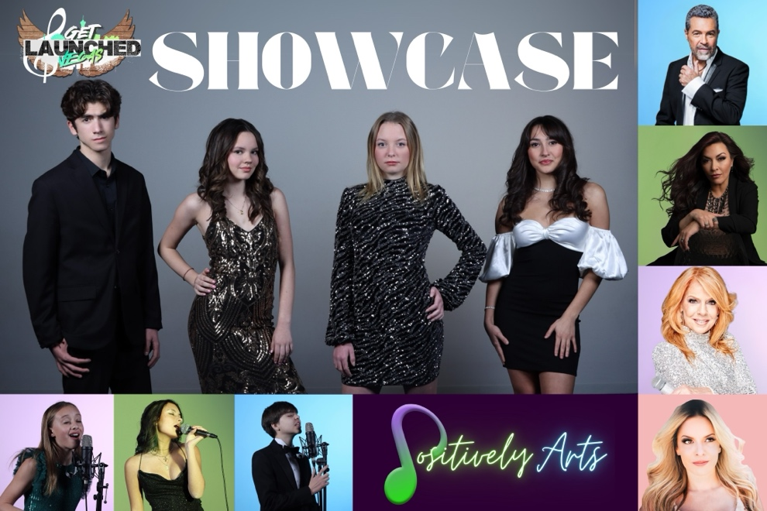
Photo Attributions
Right Column (from top to bottom): Clint Holmes, Christine Shebeck, Kelly Clinton-Holmes, Lily Arce

Group Photo (from left to right): Nick Katopodis, Khloe Judd, Rylin Kohl, Jennifer Rangel

Bottom Row (from left to right): Ava Gloria, Lily Trujillo, Mauricio Hernandez
Photo credit: Ray

"PAIRING STUDENTS WITH MENTORS WHO ARE BROADWAY STARS AND LAS VEGAS STRIP PERFORMERS, IN THE END, THE GOAL IS TO TEACH THESE YOUNG PERFORMERS SUCCESS DOESN'T COME EASY, IT'S ABOUT PERSEVERANCE AND CONFIDENCE, AND BOY DID THEY SHOWCASE THEIR TALENT - THE BEST OF THE BEST!"
- CHANNEL 8 NEWS NOW ANCHOR, HEATHER MILLS

