
Drilling commences on the Comstock Lode
La Jolla, California, September 8th, 2020. TONOGOLD RESOURCES, INC. (OTC: TNGL) (“Tonogold” or the “Company”) is pleased to announce the commencement of its initial exploration and evaluation program at the Comstock Lode, Virginia City, Nevada, with the first drill hole having commenced over the weekend. This will be the first modern exploration of the historically significant Comstock Lode.
Overview

Drilling
Tonogold recently entered into an agreement with DrillRite LLC, a highly experienced Nevada-based drill contractor, for an initial 26,000-meter (85,000 feet) program utilizing both Reverse Circulation (“RC”) and Core rigs to test the main Comstock Lode.
This initial program is estimated to cost $7 million of which the drill contractor has elected to receive 50% in Tonogold shares at a pre-agreed price of 30 cents per share. Luke Horschel, Operations Manager of DrillRite stated: “we were motivated to negotiate the share component of the drill contract because we recognized the high caliber of Tonogold’s exploration asset”.

Details and objectives of the drill program are discussed below.

Equity Raising
The Convertible Note (series 4) was successfully completed toward the end of August having raised a total of $9 million since mid 2019, most of which was used to fund the acquisition of the Comstock properties.
Last week, Tonogold completed a $4.25 million equity raising by placing of 14.3 million new shares at 30 cents per share with a half warrant exercisable at 50 cents per share with commitments for a further $250,000.
Comstock Acquisition funding
Tonogold recently agreed to pay the $1 million due to Comstock Mining Inc (“CMI”) in October 2020 early and as a result received a $100,000 discount. This was paid in July 2020. The final amount of $4.45 million is due to be paid to CMI for the acquisition of the Comstock Lode assets in September 2021. At that time CMI has the option to take 11.1 million shares in Tonogold in lieu of the cash.
Treasury
Tonogold is on a strong financial footing as it begins its initial drill program having just under $6 million in the bank. (That $6 million sum is in cash and does not include the $3.5 million credit Tonogold has with the drill contractor which Tonogold made in exchange for the issue of shares at 30 cents per share as mentioned above.)
Drill Program
Tonogold’s initial drill program will focus on the 3 km strike length of the main Comstock Lode that Tonogold controls (see long-section below), where historic production (mainly in the late 1800s) recovered over 9 million ounces of gold equivalent (“AuEq”). The old-timers mined approximately 6 million tonnes at 72g/t AuEq during the lat 1800s. Most of this production came from the upper 500 meters, where favorable mining conditions prevailed thanks to the development of a massive dewatering system through the Sutro Tunnel (shown in the log-section below). Influx of water, poor ventilation, and heat coupled with inadequate 19th century mining technology hampered attempts to mine below the Sutro tunnel level in the late 1870s and early 1880s.
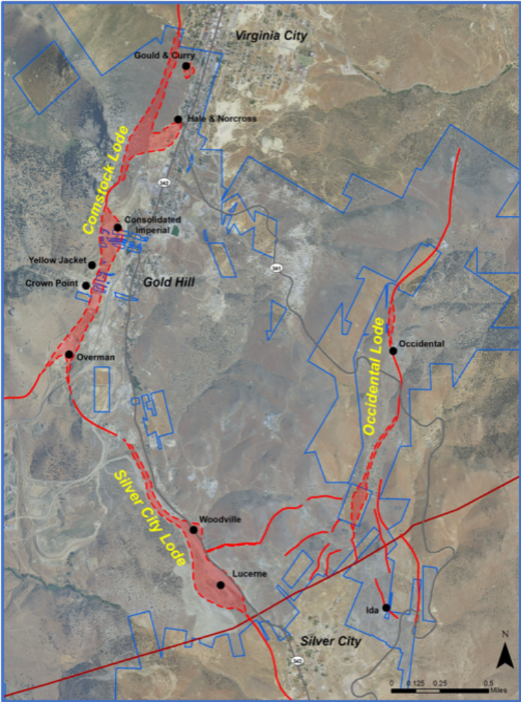
Tonogold’s Interest in Story County, Nevada, shown in blue outline
B
A
500
1,000

B

The economic conditions prevailing during the late 1800s mining era, required a minimum head grade of around 50 g/t AuEq merely to breakeven, compared to around 5 g/t AuEq today (for underground mining).
Metres
0
Tonogold’s historical research and economic analysis supports the contention that significant tonnes containing between 5 and 50 g/t AuEq was left in situ by nineteenth century miners.
Tonogold’s initial drill program on the Comstock Lode will have a two-tier focus:
- Drilling within the upper 500 meters (above the “Sutro Tunnel” level) of the strike as a “Proof of Concept”, which due to the relatively dry ground conditions prevailing as a result of the continual drainage of ground water by the Sutro Tunnel, will allow RC drilling methods to be employed.
- Drilling below the Sutro Tunnel (500-meter) level as further Proof of Concept as well as targeting areas where historic reports provide indications of “high-grade” intercepts. These holes will be drilled using an RC rig down to the Sutro Tunnel level (dry) and a core rig to drill the area known to have significant water.
A
B

The initial program is expected to take 9-months with additional rigs being utilized later in the program.
The program also includes modest shallow drilling on the Occidental Lode east of the main Comstock Lode.
Samples will be sent to ALS Global in Reno for analysis with an expected turnaround period of around 4 to 5 weeks.
Tonogold will provide investors with regular updates on the progress and results of the drill program.
Forward-Looking Statements
This press release and any related calls or discussions may include forward-looking statements within the meaning of the Private Securities Litigation Reform Act of 1995 about Comstock and Tonogold. Forward-looking statements are statements that are not historical facts. All statements, other than statements of historical facts, are forward-looking statements. Forward-looking statements include statements about matters such as: capital raising activities and negotiations; market conditions; future changes in exploration activities, production capacity and operations; future exploration, production, operating and overhead costs; production of feasibility studies, technical reports or other findings related to estimated mineralization; operational and management restructuring activities; capital expenditures (by Comstock, Tonogold or other parties) and their impact; investments, acquisitions, joint ventures, strategic alliances, business combinations, asset sales; consulting, operational, tax, financial and capital projects and initiatives; contingencies; environmental compliance and changes in the regulatory environment; 2 offerings, sales, equity dilution, and other actions regarding debt or equity securities; including a redemption of the debenture, and future working capital, costs, revenues, business opportunities, debt levels, cash flows, margins, earnings and growth. The words “believe,” “expect,” “anticipate,” “estimate,” “project,” “plan,” “should,” “intend,” “may,” “will,” “would,” “potential” and similar expressions identify forward-looking statements, but are not the exclusive means of doing so. These statements are based on assumptions and assessments made by the management of Comstock and Tonogold in light of their experience and their perception of historical and current trends, current conditions, possible future developments and other factors they believe to be appropriate. Forward-looking statements are not guaranteeing, representations or warranties and are subject to risks and uncertainties that could cause actual results, developments and business decisions to differ materially from those contemplated by such forward-looking statements. Some of those risks and uncertainties include the risk factors discussed in Item 1A, “Risk Factors” of the annual report on Form 10-K of Comstock. Occurrence of such events or circumstances could have a material adverse effect on the business, financial condition, results of operations or cash flows or the market price of Comstock and Tonogold’s securities. All subsequent written and oral forward-looking statements by or attributable to Comstock, Tonogold or persons acting on their behalf are expressly qualified in their entirety by these factors. Neither Comstock nor Tonogold undertake any obligation to publicly update or revise any forward-looking statement.

Neither this press release nor any related calls or discussions constitutes an offer to sell or the solicitation of an offer to buy any other securities or Tonogold.
Contact Information for Tonogold
Mark Ashley
President and CEO
M: +1 310 409 6504
E: mjashley3@gmail.com

