FOR IMMEDIATE RELEASE
Date: August 2022

Contact:
Robert F. Witko, President & CEO
Fort Orange Press
Office 518 489-3233
Mobile 518 281-2453
rwiko@fortorangepress.com
(Or)
Suzanne Anslow Gunther
CleverShove, LLC
518-275-8763
sgunther@clevershove.com

Fort Orange Press Adds Envelope Conversion Equipment to its Vote-by-Mail Operations

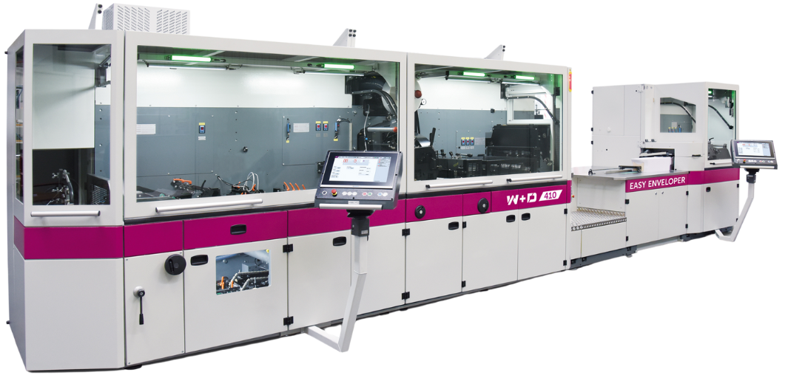
Albany, NY –– Fort Orange Press, one of the nation’s leading ballot printing and mailing companies, has added envelope converting equipment to its vote-by-mail operations.
Fort Orange Press purchased the 410EE envelope converter from German manufacturer W+D. The 410EE envelope converting machine purchase comes on top of
Fort Orange Press’s investment in several intelligent inserters to best serve the high integrity demands of the vote-by-mail industry.

Purchasing the envelope converter allows
Fort Orange Press to produce envelopes in-house and prevents the printing and mailing company from relying on sourcing envelopes in short supply for vote-by-mail production.

“Long-term supply chain and paper manufacturing trends have put the supply of envelopes for elections at risk. The in-house envelope converting equipment will allow Fort Orange Press to quickly and easily produce envelopes according to exact election specifications. Additionally, the new conversion technology offers in-line printing of variable data, offering workflow efficiencies and improving turnaround time, says Robert F. Witko, CEO and President of
Fort Orange Press.

Andrew Schipke, W+D’s Vice President of Marketing and Strategic Sales, adds, “the 410EE has speeds of up to 30,000 envelopes per hour and can change envelope sizes within an hour, making the machine responsive to last-minute changes and ‘drop dead’ mailing dates common in the vote-by-mail marketplace.”

Witko emphasizes, “beyond the speed of production, the 410EE converter also helps us up the ante with anti-counterfeit measures like spot embossing for the outer envelope and hot melt peel & seal for the oath/reply envelope. As a leader in vote-by-mail services, Fort Orange Press continually seeks and acquires best-in-class solutions to provide security and integrity to the election process. The new envelope converter is another example of how we deliver on our commitment.”

ABOUT FORT ORANGE PRESS
Fort Orange Press fulfills clients’ mission-critical printing and mailing needs from its high-tech, fully secure, modern manufacturing facilities in Albany, New York. For over 100 years,
Fort Orange Press has been a trusted partner to organizations and businesses and is one of the leading printing and mailing experts in the U.S. Fort Orange Press continues to escalate investments in technology and personnel to enhance services and provide the most efficient, accurate and secure printing and mailing programs available. Fort Orange Press offers printing and mailing services for state and national associations, government, financial groups, not-for-profit businesses, educational institutions and healthcare companies. For more information, go to www.fortorangepress.com.

ABOUT WINKLER+DÜNNEBIER GMBH
Winkler+Dünnebier GmbH (W+D) offers a wide range of highly efficient, integrated system solutions for the mail and postal industry and the tissue and hygiene industry. With more than 100 years of industry-shaping innovations, W+D has core competence in converting and processing thin and in-homogeneous materials—such as paper, tissue, and nonwovens—at high speeds and tight speed tolerances. With our innovative and tailor-made system solutions and services, W+D focuses on the entire internal value chain for its customers. Part of the Barry-Wehmiller family, W+D has production and distribution sites in Germany, Malaysia and the United States, with sales and service support worldwide. For more information, go to www.wdnorthamerica.com
#

