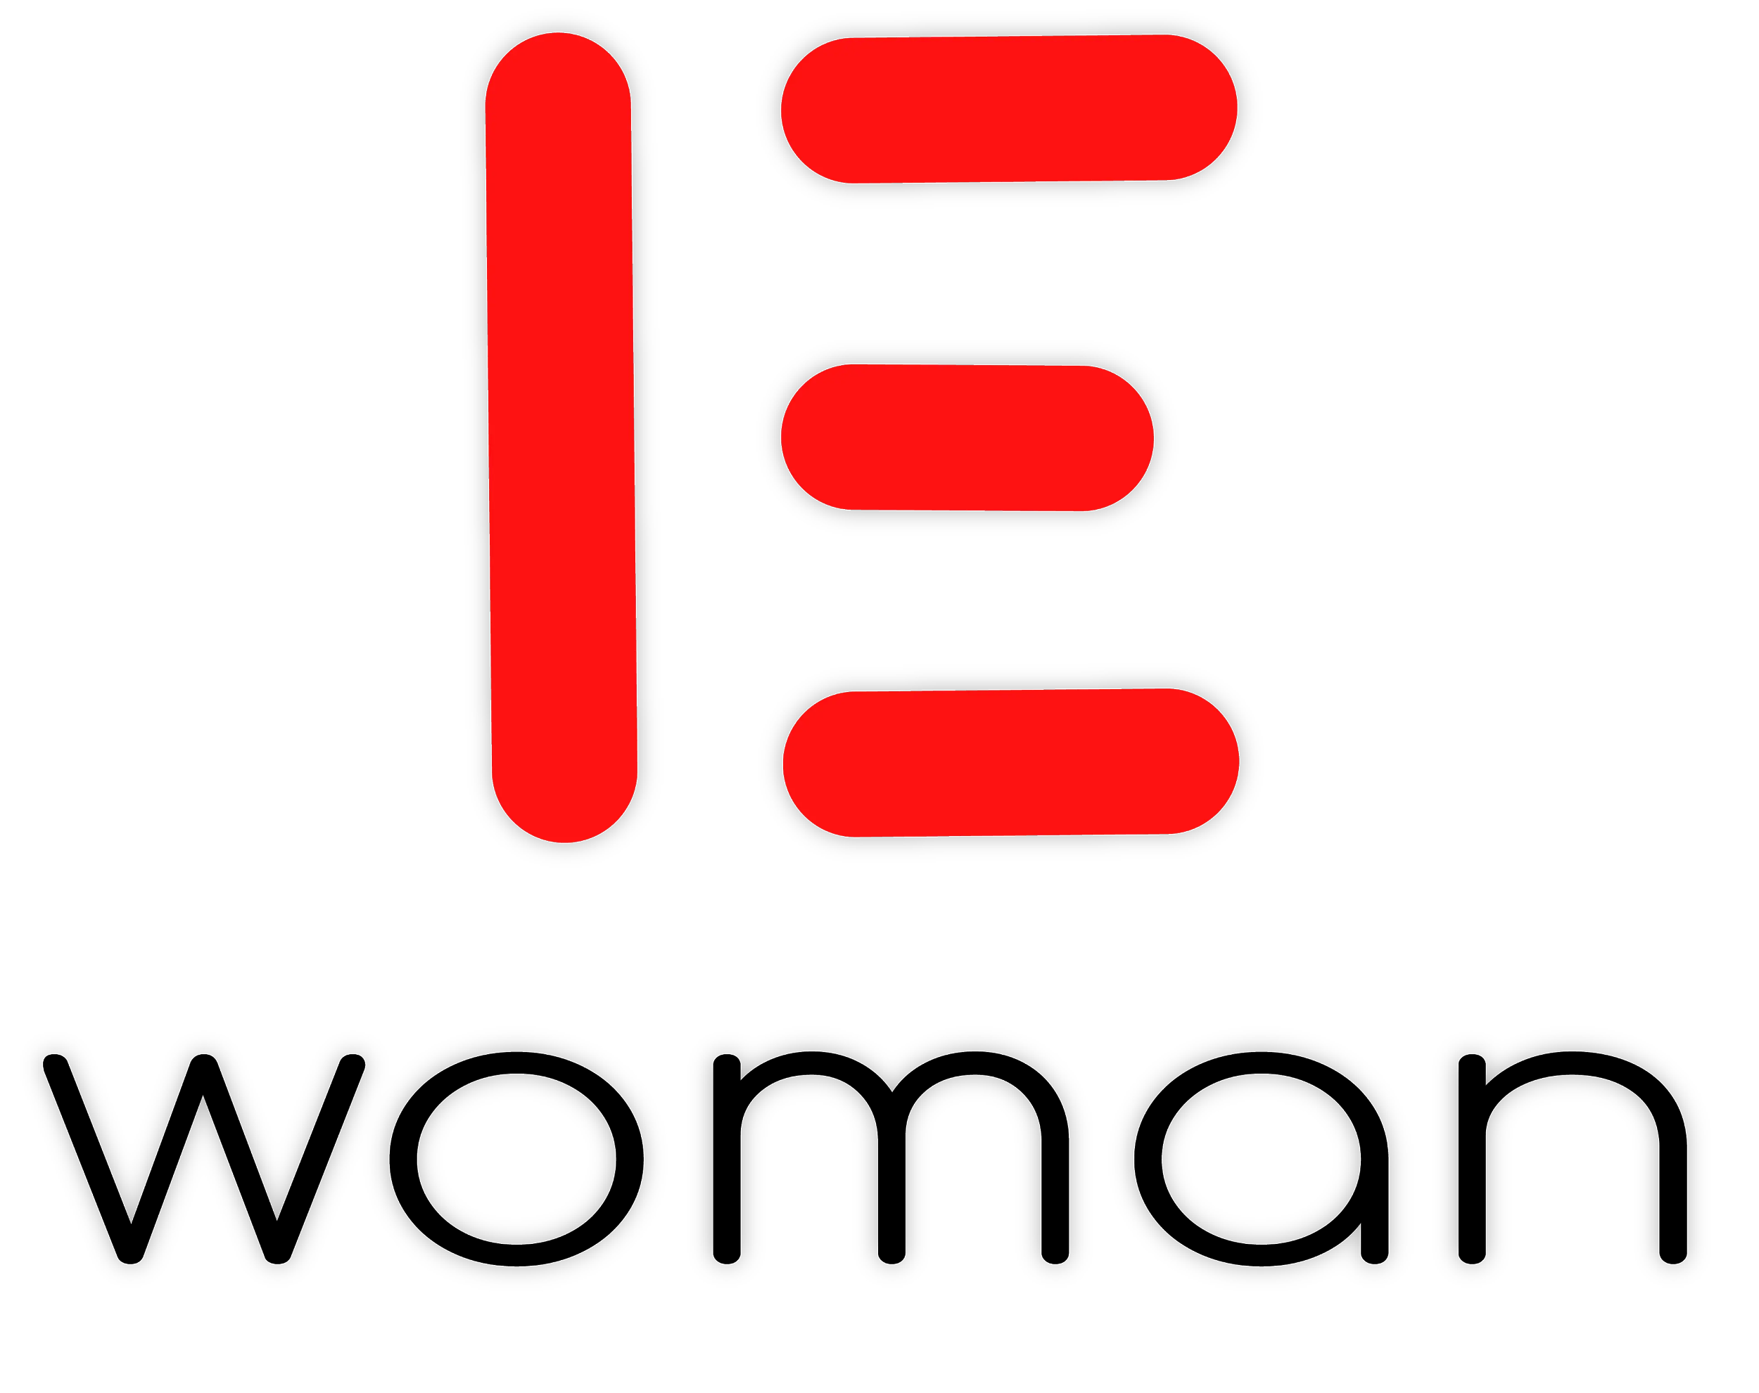 | Contact:  Amy Shakhlo Karaman  Founder and CEO  Nashville, TN  Office: (615) 498-2126  www.ewoman.world
FOR IMMEDIATE RELEASE

New Social Network Offers Anonymous Support Group for Women

Nashville, TN - E Woman is a growing social media platform dedicated to every woman who feels alone. Founded by Amy Shakhlo Karaman, an immigrant who escaped an arranged marriage in Uzbekistan and came to America to build her life from the ground up. Frustrated by the lack of real and raw conversations on social media, Amy sought out to build an online community that allowed women around the world to discuss their similar struggles.

From mental health, abuse, divorce, immigrations, LGBTQ+ relationships, self-care, and more, there is an online support group for every woman to openly discuss what they are going through with those who have already shared their story. Each group offers women the opportunity to anonymously share their struggles, offer advice, and ultimately be connected to those who have similar life experiences.
“After owning a beauty salon for over a decade, I learned how women face the same challenges on a daily basis. E Woman offers a platform for women to bring out the salon culture and step into a virtual community of mutually shared experiences.” - Amy Karaman

E Woman is now available to sign up on www.ewoman.world worldwide and offers every language. Members can join categorized groups anonymously or with their usernames to share their stories and connect in a judgement-free space.

“Love yourself and celebrate your worth.”
# # #
Copyright © 2021 EWoman. All Rights Reserved.

