

FOR IMMEDIATE RELEASE

Nelson-Jameson President Mike Rindy named a CEO to Watch by “Family Business Magazine”
Rindy will be featured in the November/December 2023 edition of the magazine

MARSHFIELD, WI – October 31, 2023 – Nelson-Jameson, a leading food processing distributor, announced that its President, Mike Rindy, was recognized by “Family Business Magazine” as a CEO to Watch, Class of 2023. The annual award recognizes “family and non-family chief executives whose exceptional leadership has put their businesses in a strong position for future generations.” A feature spotlighting Rindy will appear in both the November/December 2023 print edition of “Family Business Magazine” and the online edition.

“I couldn’t be more honored to receive this accolade from “Family Business Magazine,” one of the foremost publications for executive leaders,” says Rindy. “I’m especially appreciative of the award’s focus on leadership for the benefit of the next generation. This is a core principle of Nelson-Jameson’s culture, and I’m proud to carry its legacy forward.”

Rindy joined Nelson-Jameson in 2020. In his three-year tenure, he has steered the company through the pandemic and supply chain challenges, overseen expansion to new cities and markets, and sustained a longstanding company ethos of operating in an ethical manner with respect for people, the community, and the environment. The company was founded more than 75 years ago and has operated continuously as a family business ever since.

“Mike Rindy has been a tremendous asset to our organization, in part because of because of his unique ability to humbly inspire our employees, to empathize and show compassion, and to empower people to thrive,” says Adam Nelson, a fourth-generation owner of Nelson-Jameson who currently serves as the Chairman of Nelson-Jameson. “He has infused new energy and ideas into the company while honoring our family business values, and we congratulate him on this extremely well-deserved recognition.”
Family Business was launched more than 30 years ago, with the goal of supporting leadership teams in the unique position of managing businesses and family dynamics at the same time. The magazine is published by MLR Media, an organization that utilizes digital platforms, magazines, and events to provide relevant insights to public and private company directors, leaders and owners of multigenerational family businesses and C-suite executives.

More information on the company can be found at https://nelsonjameson.com.

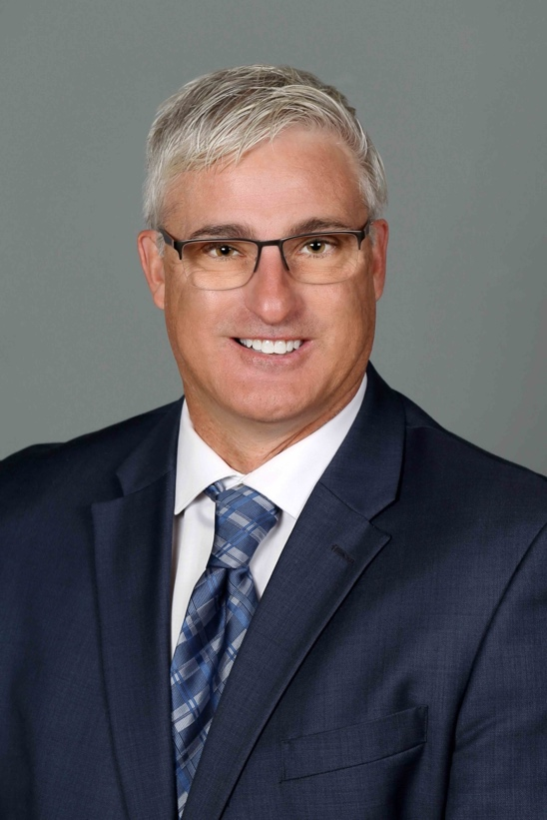
Photo caption (Courtesy of Nelson-Jameson): Nelson-Jameson President Mike Rindy has been named a CEO to Watch by “Family Business Magazine.”

###

About Nelson-Jameson
Nelson-Jameson is a fourth-generation, family-owned distributor to the dairy industry. From the company’s roots in dairy production supplies, it has expanded to offer a broad range of food processing products and services that help food and beverage organizations operate efficiently with the highest quality, safety, and compliance standards. The company represents more than 850 vendors, distributes more than 60,000 curated products, and employs more than 260 people nationwide. The dairy industry leader also operates NEXT Logistics, a transportation arm that provides delivery services from its Wisconsin, California, Idaho, Pennsylvania, and Texas strategic distribution centers.

For more than 75 years, Nelson-Jameson has supported food, beverage, and dairy processors with innovative products and a comprehensive set of solutions that keep pace with changing consumer tastes, manufacturing processes, and distribution channels. The company values delivering the exceptional for its customers by leading with the guiding principles of kindness and mutual respect. Nelson-Jameson is a supplier of choice for customers in all 50 states and international markets.

For more information, please visit: https://nelsonjameson.com

Media Contact:
Karolyn Raphael
karolyn@wingermarketing.com
(312) 494-0422

