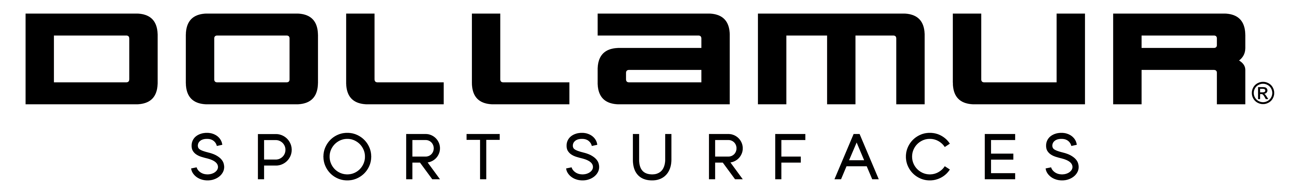

FOR IMMEDIATE RELEASE
Date: 05/28/2019
Contact:
Teri Hill
Director of Marketing
Dollamur Sport Surfaces
thill@dollamur.com
www.dollamur.com

Dollamur's Industry-Leading Sport Surface Cleaner Hits the Market with NEW Trademarked Identity - Mat Attack!
Dollamur introduces newly branded sport surface cleaner, Mat Attack!
At the peak of any training season common rashes and infections will occur on sport surfaces. Through-out regular training, mats should be cleaned daily to prevent what is commonly referred to as “Mat Funk,” a combination of infectious conditions such as ring worm, herpes simplex, impetigo, staph infections/MRSA and scabies.
“Contagious skin infections are a big concern for athletes who compete at any level,” said Chuck Thompson, VP at Dollamur. “As a manufacturer of high-performance sport surfaces for wrestling, martial arts, cross-training and fitness, Dollamur mats help protect athletes from falls and take-downs. Regular cleaning maintenance of your mats is critical to health and well-being of athletes. For many years, Dollamur has offered an Athletic Surface Disinfectant, but the decision was made to rebrand this product with a new name Mat Attack!™ Athletic Surface Cleaner to stress the importance for mat health.”
Mat Attack!™ is designed to provide effective cleaning, deodorizing and disinfection in areas where housekeeping maintenance is of prime importance in controlling the hazard of cross-contamination on surfaces. Use Dollamur’s Mat Attack!™ to disinfect hard, non-porous surfaces such as Wrestling, Martial Arts, MMA, Fitness, Yoga and Pilates mats, wall pads, athletic mats, athletic training tables, physical therapy tables, exercise equipment, athletic helmets, wrestling/boxing headgear, athletic shoe soles and in locker rooms.
“Even though all of our smooth and tatami vinyl mats are pre-treated with an anti-microbial, additional daily cleaning is a critical step for a safe and healthy mat,” added Thompson.
Check out this video for detailed proper cleaning instructions: https://www.youtube.com/watch?time_continue=71&v=8yWDUYxoIUE

ABOUT MAT ATTACK!
Mat Attack!™ is a phosphate-free formulation. It is a disinfectant effective against a broad spectrum of bacteria including Staphylococcus aureus (MRSA), and is viricidal including HIV-1, HCV, H5N1, H1N1, H9N2 and HBV. It also inhibits the growth of mold and mildew and their odors when used as directed. This product is an effective fungicide against Trichophyton mentagrophytes - the agent that causes Athlete’s Foot fungus on bathroom surfaces - and is used to clean and disinfect hard, non-porous sport surfaces.
