
News for Immediate Release
Electrovaya Reports Q1 Fiscal Year 2025 Results

Revenue of $11.2M and Positive Adjusted EBITDA for Seventh Consecutive Quarter

Strengthened Balance Sheet and improved financial position

Significant Progress in Closing EXIM and Bank Financing to support US Manufacturing Expansion and Overall Growth Plans

Reaffirms Fiscal 2025 Revenue Guidance Exceeding $60M, Driven by Strong Order Pipeline

Toronto, Ontario – February 13, 2025 – Electrovaya Inc. (“Electrovaya” or the “Company”) (Nasdaq: ELVA, TSX: ELVA), a leading lithium-ion battery technology and manufacturing company, today reported its financial results for the first quarter of the fiscal year ending September 30, 2025 (“Q1 2025”). All dollar amounts are in U.S. dollars unless otherwise noted.

Financial Highlights:
- Revenue for Q1 2025 was $11.2 million, compared to $12.1 million in the fiscal year ended December 31, 2023 (“Q1 2024”).
- Gross margin was 30.5% in Q1 2025, an improvement of 130 basis points compared to Q1 2024. Battery system margins remained strong at 30.8% for the quarter.
- Adjusted EBITDA¹ was $0.6 million. Q1 2025 was the Company’s seventh consecutive quarter of positive Adjusted EBITDA¹.
- The Company had positive working capital of $12.6 million for Q1 2025 compared to negative working capital of $0.4 million in Q1 2024.
- Cash in hand was $8.2 million at the end of Q1 2025 compared to $0.6 million for Q1 2024.
- The Company paid off all debts associated with its property in Jamestown, New York, including the existing mortgage and promissory notes.

Key Operational and Strategic Highlights - Q1 2025
- Received Direct Loan Approval from Export-Import Bank of the United States: On November 14, 2024, the Company announced that it had secured approval for a direct loan in the amount of US$50.8 million from the Export-Import Bank of the United States (“EXIM”) under the bank's “Make More in America” initiative. This financing is expected to fund Electrovaya's battery manufacturing buildout in Jamestown, New York including equipment, engineering and setup costs for the facility.

- Completed an Equity Offering with Gross Proceeds of $12.8 million: On December 18, 2024, the Company, after giving effect to the full exercise of the Over-Allotment Option, sold 5,951,250 Common Shares under a public offering, for aggregate gross proceeds of US$12,795,188.00. The Company intends to use the net proceeds from the Offering to satisfy conditions associated with the loan approved by EXIM, repayment of amounts under the Company’s existing working capital facility in advance of proposed bank refinancing and for the costs of such financing, and satisfaction of certain outstanding amounts in connection with the purchase of the Company’s Jamestown, New York manufacturing facility.

- Continued Growth from OEM Partners & Leading End-Customers: The Company continues to see good momentum from its key OEM partners and end customers of its material handling products. A recently introduced leasing program with one of the Company’s OEM partners has demonstrated high sales interest and has already led to encouraging order traction. Furthermore, the Company has seen momentum growing from one of its key end customers for repowering existing warehouse infrastructure with Electrovaya batteries. Finally, the Company’s current largest operator of battery equipment, a Fortune 100 retailer, has indicated renewed demand for Electrovaya’s products.

- Accelerated Battery Assembly Plans in Jamestown, New York: The Company has accelerated its plans for battery system assembly operations at its Jamestown facility. Assembly equipment that is used at its existing Ontario facility has been procured and hiring key personnel is underway. The Company anticipates being able to commence commercial operations in April 2025, however has capability to further accelerate if necessary. The start of assembly in Jamestown will help support ramp up in overall production while also supporting the Company’s mitigation strategy with respect to potential trade barriers.

- Progress in Closing EXIM & Bank Financing: Electrovaya is currently in the process of finalizing loan documentation with both EXIM and a leading North American bank for their respective financing packages to support both the Jamestown expansion as well as improve the Company’s overall working capital position. The anticipated closing and funding date is in the current quarter, Q2 FY 2025.

Management Commentary:

"Q1 2025 was a successful and pivotal quarter for the Company, marked by significant financial and operational progress.” stated Dr. Raj DasGupta, Electrovya’s CEO. “This included receiving approval from EXIM for a $51 million direct loan and completing a successful $12.8 million equity round with excellent institutional investors. The added equity capital strengthened the Company’s balance sheet and fortified our financial position, providing the necessary capital to accelerate our U.S. expansion and scale production at our Jamestown facility. With growing demand from both existing and new customers, we are confident in our trajectory for sustained growth and innovation in the lithium-ion battery sector.”

"Despite the typical weaker seasonality of Q1, we delivered strong financial performance, achieving over 30% margins and our seventh consecutive quarter of positive Adjusted EBITDA,” stated John Gibson, Electrovaya’s CFO. “This solid start to the fiscal year reinforces our financial strength and positions us well for continued growth. With a fortified balance sheet and increasing customer demand, we remain confident in our ability to achieve $60 million in revenue for FY 2025 while advancing profitability and scaling operations."
Positive Financial Outlook & Fiscal 2025 Guidance:

The Company anticipates strong growth into FY 2025 with estimated revenues to exceed $60 million driven by renewed demand from the Company’s largest end users of material handling batteries. This guidance considers its existing purchase orders, along with anticipated orders in its pipeline from key end users and customers. This guidance also takes into consideration a percentage of anticipated revenue that may be deferred to FY 2026 (please see Forward Looking Statements for further clarification).

Selected Financial Information for the quarters ended December 31, 2024 and 2023:

Results of Operations
(Expressed in thousands of U.S. dollars)

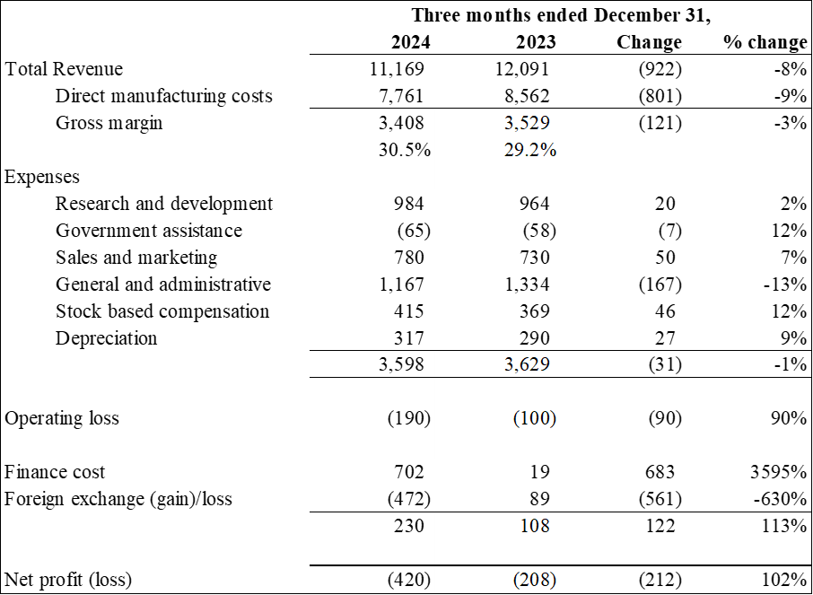

Adjusted EBITDA¹
(Expressed in thousands of U.S. dollars)

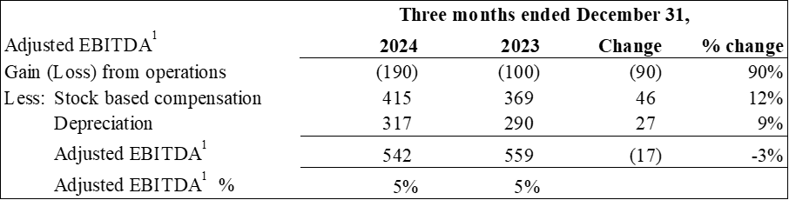

¹ Non-IFRS Measure: Adjusted EBITDA is defined as income/(loss) from operations, plus stock-based compensation costs and depreciation and amortization costs. Adjusted EBITDA does not have a standardized meaning under IFRS. Therefore it is unlikely to be comparable to similar measures presented by other issuers. Management believes that certain investors and analysts use adjusted EBITDA to measure the performance of the business and is an accepted measure of financial performance in our industry. It is not a measure of financial performance under IFRS, and may not be defined and calculated in the same manner by other companies and should not be considered in isolation or as an alternative to IFRS measures. The most directly comparable measure to Adjusted EBITDA calculated in accordance with IFRS is income (loss) from operations.

Summary Financial Position
(Expressed in thousands of U.S. dollars)

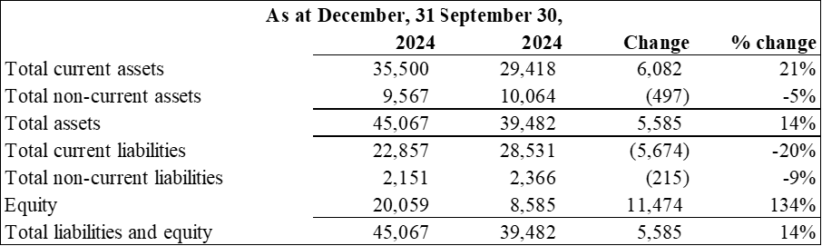

The Company’s complete Financial Statements and Management Discussion and Analysis for the quarter ended December 31, 2024 are available on SEDAR+ at www.sedarplus.ca and on EDGAR at www.sec.gov, as well as on the Company’s website at www.electrovaya.com.

Conference Call details:
- Date: Thursday, February 13, 2025
- Time: 5:00 pm. Eastern Time (ET)
- Toll Free: 888-506-0062
- International: 973-528-0011
- Participant Access Code: 253979

To help ensure that the conference begins in a timely manner, please dial in 10 minutes prior to the start of the call.
For those unable to participate in the conference call, a replay will be available for two weeks beginning on February 13, 2025 through February 27, 2025. To access the replay, the dial-in number is 877-481-4010 and 919-882-2331. The replay passcode is 51997.

Investor and Media Contact:
Jason Roy
VP, Corporate Development and Investor Relations
Electrovaya Inc.
jroy@electrovaya.com
905-855-4618

About Electrovaya Inc.
Electrovaya Inc. (NASDAQ:ELVA) (TSX:ELVA) is a pioneering leader in the global energy transformation, focused on contributing to the prevention of climate change by supplying safe and long-lasting lithium-ion batteries without compromising energy and power. The Company has extensive IP and designs, develops and manufactures proprietary lithium-ion batteries, battery systems, and battery-related products for energy storage, clean electric transportation, and other specialized applications. Electrovaya has two operating sites in Canada and a 52-acre site with a 135,000 square foot manufacturing facility in Jamestown New York state for its planned gigafactory. To learn more about how Electrovaya is powering mobility and energy storage, please explore www.electrovaya.com.

Forward-Looking Statements
This press release contains forward-looking statements, including statements that relate to, among other things, revenue growth and revenue guidance of approximately $60 million in FY 2025, other financial projections, including projected sales, cost of sales, gross margin, working capital, cash flow, and overheads anticipated in FY 2025, the expected timing of deliveries of pre-production battery modules in Japan, anticipated cash needs and the Company’s requirements for additional financing, purchase orders, mass production schedules, funding from EXIM and the ability to satisfy the conditions to drawing on any facility entered into with EXIM,, use of proceeds of the EXIM facility,, ability to deliver to customer requirements. Forward-looking statements can generally, but not always, be identified by the use of words such as “may”, “will”, “could”, “should”, “would”, “likely”, “possible”, “expect”, “intend”, “estimate”, “anticipate”, “believe”, “plan”, “objective” and “continue” (or the negative thereof) and words and expressions of similar import. Although the Company believes that the expectations reflected in such forward-looking statements are reasonable, such statements involve risks and uncertainties, and undue reliance should not be placed on such statements. Certain material factors and assumptions are applied in making forward looking statements, and actual results may differ materially from those expressed or implied in such statements. In making the forward-looking statements included in this news release, the Company has made various material assumptions, including but not limited to assumptions with respect to the Company’s customers deploying its products in accordance with communicated intentions, the Company’s customers completing new distribution centres in accordance with communicated expectations, intentions and plans, anticipated new orders in FY 2025 based on customers’ historical patterns and additional demand communicated to the Company and its partners, but not yet provided as a purchase order together with the Company’s current firm purchase order backlog totaling approximately $80 million, a discount of approximately 25% used in the revenue modeling applied to the overall expected order pipeline to account for potential delays in customer orders, expected decreases in input and material costs combined with stable selling prices in FY 2025, delivery of ordered products on a basis consistent with past deliveries, and that the Company’s customer counterparties will meet their production and demand growth targets, ]the Company’s ability to successfully execute its plans and intentions, including with respect to the entry into new business segments and servicing existing customers, the availability to obtain financing on reasonable commercial terms, including any EXIM facility. Factors that could cause actual results to differ materially from expectations include but are not limited to customers not placing orders roughly in accordance with historical ordering patterns and communicated intentions, macroeconomic effects on the Company and its business, and on the lithium battery industry generally, not being able to obtain financing on reasonable commercial terms or at all, including not being able to satisfy any condition of drawdowns under any EXIM facility if entered into, that the Company’s products will not perform as expected, supply and demand fundamentals for lithium-ion batteries, the risk of interest rate increases, persistent inflation in the United States and Canada and other macroeconomic challenges, the political, economic, and regulatory and business stability of, or otherwise affecting, the jurisdictions in which the Company operates, including new tariff regimes. There have been indications from the United States government of potential tariffs on Canada, Mexico and other countries, which if enacted would have a material impact on the Company. Additional information about material factors that could cause actual results to differ materially from expectations and about material factors or assumptions applied in making forward-looking statements may be found in the Company’s Annual Information Form for the year ended September 30, 2024 under “Risk Factors”, and in the Company’s most recent annual and interim Management’s Discussion and Analysis under “Qualitative And Quantitative Disclosures about Risk and Uncertainties” as well as in other public disclosure documents filed with Canadian securities regulatory authorities and filed or furnished with the SEC.. The Company does not undertake any obligation to update publicly or to revise any of the forward looking statements contained in this document, whether as a result of new information, future events or otherwise, except as required by law.
Revenue guidance for FY2025 described herein constitutes future‐oriented financial information and financial outlooks (collectively, “FOFI”), and generally, is, without limitation, based on the assumptions and subject to the risks set out above under “Forward‐Looking Statements”. Although management believes such assumptions to be reasonable, a number of such assumptions are beyond the Company’s control and there can be no assurance that the assumptions made in preparing the FOFI will prove accurate. FOFI is provided for the purpose of providing information about management’s current expectations and plans relating to the Company’s future performance, and may not be appropriate for other purposes.
The FOFI does not purport to present the Company’s financial condition in accordance with IFRS, and it is expected that there may be differences between audited results and preliminary results, and the differences may be material. The inclusion of the FOFI in this news release disclosure should not be regarded as an indication that the Company considers the FOFI to be a reliable prediction of future events, and the FOFI should not be relied upon as such.

