Swoosh Technologies

1422 Elbridge Payne Road #230
Chesterfield, MO 63017
(314) 549-8110
Swooshtech.com

FOR IMMEDIATE RELEASE

Swoosh Technologies Hosts NX University 2021
NXU will be hitting eight cities beginning this October!

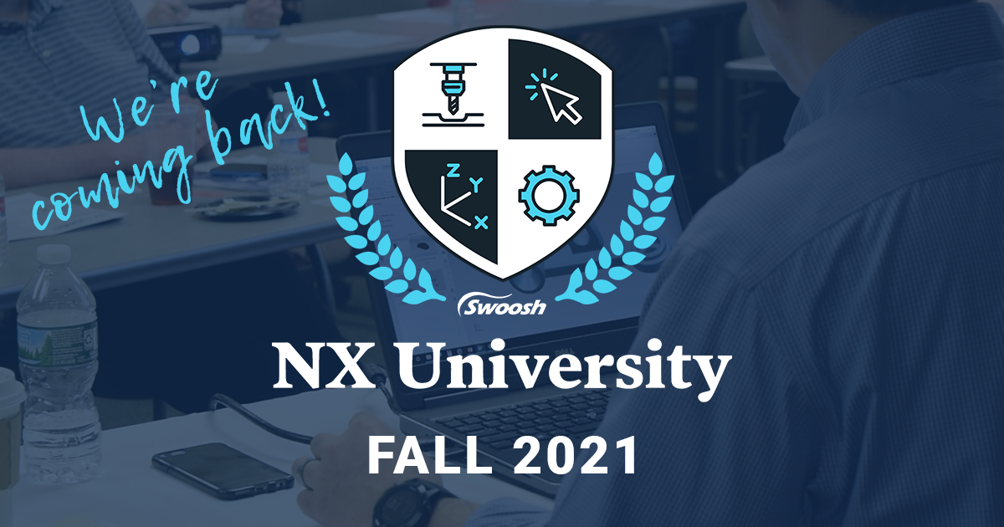

St. Louis, MO, August 26, 2021 – Swoosh Technologies, a Siemens PLM Software Partner, will be hosting NX University - Fall 2021. Beginning in October, our team of experts will travel to eight different cities across the United States. These free events are where NX users are encouraged to come together and learn more about topics covering NX CAD, NX CAM, and Data Management.

The user groups will be hosted in the following cities:
- Hartford, Connecticut – Tuesday, October 12, 2021
- Philadelphia, Pennsylvania – Wednesday, October 13, 2021
- Milwaukee, Wisconsin – Thursday, October 14, 2021
- Chicago, Illinois – Tuesday, October 26, 2021
- Fort Wayne, Indiana – Wednesday, October 27, 2021
- Dayton, Ohio – Thursday, October 28, 2021
- Buffalo, New York – Wednesday, November 10, 2021
- Rochester, New York – Thursday, November 11, 2021

NX University offers users the opportunity to learn latest features added to NX, tips and tricks to better leverage processes, and networking with fellow users. Not only is there a general session, but Swoosh Technologies also offers smaller breakout sessions with hands-on learning throughout the event!

"I was impressed with the topics and content presented. I'd certainly recommend this event to others looking to increase their knowledge of NX." – NXU Attendee, 2020

“The in-person events back in 2019 were a huge success! We hope to capture the same excitement and momentum with breakout sessions and presentations for the fall of 2021.” The Swoosh Team believes the NXU events offer not only information about the latest release and features, but also valuable input that helps everyday NX users accelerate their processes. “The conversations that occurred [at the user groups] were very insightful – those who presented, as well as those who attended offered their input to each other on how to better leverage certain features and tools.” The full day event will include a variety of breakout sessions, presentations, and hands-on tutorials.

An agenda has been published, with topics including the most recommended subjects from NX users themselves:
- Sessions covering NX CAD/CAM 1980 series
- Hidden gems in NX CAD/NX CAM – a crowd favorite!
- The New Sketch Solver

…and much more.

For more information on NX University Fall ‘21, interested parties can visit Swoosh Technologies’ website to register.

###

