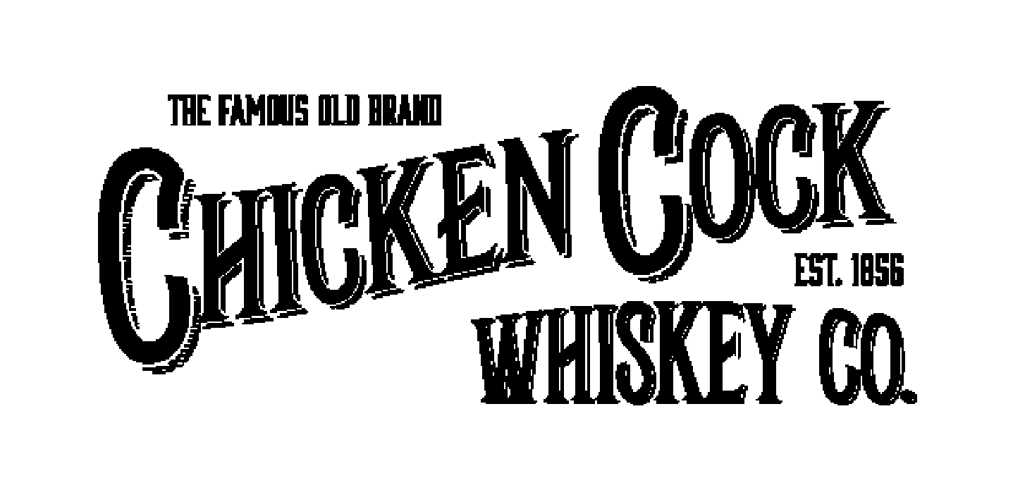
Contact: Christine Deussen
Deussen Global Communications, Inc.
cdeussen@deussenglobal.com
m.917-545-1459

Chicken Cock Whiskey Releases a Third Limited Run Bourbon: Beer Barrel Select A Bluegrass Collaboration with Goodwood Brewing

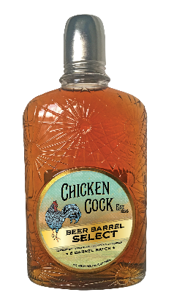
Bardstown, KY / June 20, 2019: Following in the footsteps of two award-winning limited releases -- the 160th Anniversary 8-Year-Old Single Barrel Bourbon (SRP: $100/750mL) and 10-Year-Old Double Barrel Bourbon (SRP: $250/750mL) -- Chicken Cock Whiskey has now released 1,800 bottles of Beer Barrel Select (SRP: $80.00/750mL), a blend of Kentucky Bourbons aged up to 11.5 years, finished in Walnut Brown Ale barrels.

This most recent limited release from Chicken Cock Whiskey -- one of the oldest American Whiskey brands, est. 1856 in Paris, Kentucky -- is the result of creative partnership, a hallmark approach of the brand and its parent company, Grain & Barrel Spirits. In the summer of 2018, six barrels that had held Chicken Cock’s 10-Year-Old Double Barrel Bourbon were given to Goodwood Brewing in Louisville to finish their Walnut Brown Ale. Once finished, Goodwood Brewing returned those six barrels to Chicken Cock. Chicken Cock Master Distiller Gregg Snyder then filled them with a blend of 100% Kentucky Bourbon aged up to 11.5 years. The Bourbon was finished in the six barrels for six months before final blending and bottling, yielding only 1,800 bottles of this all-Kentucky collaborative release.

Beer Barrel Select is full-bodied, with initial notes of butterscotch, caramel, and vanilla, followed by a hint of toasted oak, and then a sweet finish with nut and chocolate flavors. Never chill-filtered, Beer Barrel Select retains the flavors and slight haze of the Walnut Brown Ale. Chicken Cock’s unique, Prohibition-era bottle and “sipping glass” lid complete the heritage bourbon experience.

- Beer Barrel Select / 6 750mLs per case (6 barrels/1,800 bottles)
  - 45% ABV (90 Proof); SRP: $80/750mL
  - 100% distilled, aged, and bottled in Kentucky
  - Blend of Kentucky Bourbon aged up to 11.5 years
  - Available in AL, CO, FL, GA, IL, KY, LA, MS, NC, SC, and TN, as well as online
  - Managing Partner, Sales: Kevin Testa; m.305-458-1600; e-mail: kevin@grainandbarrel.com

About Chicken Cock Whiskey
Established in 1856 in Paris, Kentucky (ten years before Jack Daniels), Chicken Cock rose to fame as the house whiskey at the Cotton Club, one of the most legendary speakeasies during Prohibition. Known as “The Famous Old Brand” and “The Whiskey in a Tin Can,” Chicken Cock was smuggled into the Club in sealed tin cans, then ceremoniously opened tableside. After Prohibition, the brand enjoyed a resurgent couple of decades before a distillery fire put it out of business for more than 40 years. In 2012, Matti Anttila, founder of Grain & Barrel Spirits, rediscovered the “Famous Old Brand” and set a goal of bringing it back to its Prohibition and pre-Prohibition glory. Led by Master Distiller Gregg Snyder, Chicken Cock works hand in hand with some of the best distillers in Kentucky, including Bardstown Bourbon Company, as a proud member of its collaborative distiller’s program, as well as O.Z. Tyler in Owensboro, Kentucky for its limited release aging, blending, and bottling. To buy, please visit https://chickencock.passionspirits.com/chicken-cock/chicken-cock-beer-barrel-select.html

About Grain & Barrel Spirits
Founded in 2012 by entrepreneur Matti Anttila, West Palm Beach, Florida-based Grain & Barrel Spirits is an emerging craft spirits company at home in the Southeast with production and sales partners around the world. Wholly owned brands include Dixie Southern Vodka, the largest premium craft vodka produced in the Southeast; pre-Prohibition favorite Chicken Cock Whiskey; and The Endless Summer Spirits Company.

# # #

Please visit https://www.chickencockwhiskey.com and follow on Instagram @chickencockwhiskey and Facebook

Keep Calm and Carry On: Drink your Whiskey Responsibly
More information, media samples, hi-res images, and interviews available upon request.

