FOR IMMEDIATE RELEASE

Cornelius, N.C., [ENTER DATE] -- Hemplily is pleased to announce that they will be launching a new website, partnership and branding on [ENTER DATE].

Hemplily, founded in 2017, is a CBD wellness and education boutique offering their own brand of cannabis supplements. They are dedicated to educating and empowering everyone, especially women with changing bodies and menopause, to experience relief with natural remedies. They offer complimentary unlimited consultations about CBD and how to find the right product for each’s individual need.

“With so much information overload on CBD products and their use, consumers are overwhelmed and unable to decipher among the information available. For this reason, Hemplily is grounded in the idea that education must come first,” says Terri Long, owner of Hemplily. “Our new website and partnership allow us to focus on educating about the most effective benefits of CBD products. Ours are formulated with a focus on women and their changing bodies but can help anyone. Hemplily helps you find harmony and balance.”
A Shared Commitment
The associates at Hemplily are not doctors and are unable to give medical advice, yet they realize everyone’s situation is unique and possibly complex. So Hemplily has partnered with Leaf411, a cannabis nurse hotline you can call for FREE to speak directly with a someone who is both medically and cannabis trained. This distinctive partnership is a coveted membership only opportunity for a select few cannabis businesses. “The nurse line allows our customer to talk more specifically about their medical situation, and how CBD may help them”, says Terri. To learn more about this non-profit organization, visit Leaf411.org
More About Hemplily
“You’re Journey, More Joyful”. Hemplily is a female-owned boutique in Cornelius, North Carolina. They’re also found online at www.hemplily.com and ship free anywhere in the U.S. All of the Hemplily products are Third-Party Lab Tested to ensure potency and purity. They create an environment to soften the stigma of cannabis with a gentle name, bright, spa-like atmosphere and free samples to demonstrate the myriad of potential and fast-acting benefits that hemp CBD provides. They donate 10% of every purchase to the Hope House Foundation and offer a money back guarantee.

Contact Information
Terri Long info@hemplily.com
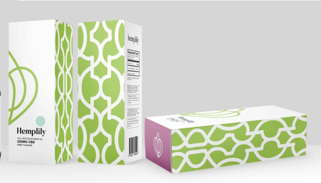
20124 W Catawba Ave, Suite C, Cornelius, NC
(855) 246-4367
facebook.com/hemplily/
instagram.com/hemplilync/
