W2 Form Printing: How to Fill Out and Print W2 Forms
EzW2 software is approved by SSA to print all W-2 forms and W-3 form on white paper. If you still prefer the red forms, ezW2 software can fill data on pre-printed forms too.
Here are the steps:

Step 1: Start ezW2 software.

 | ezW2 software can prepare, print and efile forms W2, W3, 1096-misc and 1099.  If you do not have ezW2 software installed, you can download the trial version for free from halfpricesoft.com. No registration needed and no obligation. You can follow the step by step online instructions to finish the installation in minutes  This W2 1099 software is compatible with Windows 8 system, 32-bit or 64-bit. It can run on Windows 7, XP, Me, 2003 and Vista system too.   

Step 2: Set up company information for W2 reporting
You can access this screen by clicking the top menu “Current Company->Company”. You need to enter the general company information for w2 and 1099 forms, such as Company Name, Address, Tax ID and others.
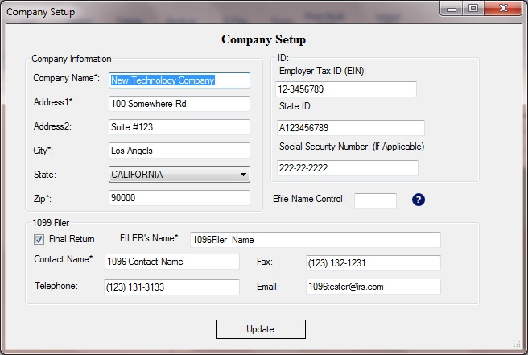

Step 3: Set up W-3 information
You can access this screen by clicking the top menu “Current Company->W-3 information”. You need to enter the W-3 control number, W3 Establishment Number, Contact Information and others. This information will be displayed on both forms W-2 and W-3.

Step 4: Add W-2 Employees
You can access employee by clicking the top menu “Current Company->W2 Employee list”. You can add a new employee or edit or delete an existing one easily by clicking the link on this form.
You can also import Employee information quickly by using W2 import form. You can access this import form by clicking the top menu “Current Company->Import W2”.

Step 5: Fill out W-2 information and Print Forms
You can access this W-2 editing screen by clicking the top menu “Current Company->Form W-2”.
- Once you select the employee from the list, the employee information will be filled automatically.
- Fill in the boxes on the w-2 Form.
- Click the Question icon or the instructions link to get help.
- Click the 'save' button to save the W-2 information.
- Click the 'Print W2' button to print the different W2 Copies for this recipient. ezW2 can print forms W2 copy A, B, C, D, 1 and 2
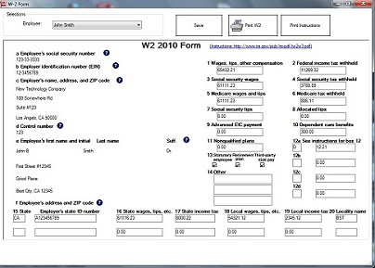
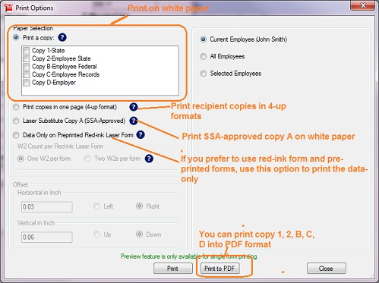
- Click the 'Print Instructions' button to print W-2 instructions.

Note
1. Form W-3 will be generate automatically based on form W2 information
2. ezW2 allows user to set up unlimited companies with one flat rate. So if you have multiple companies or you are an accountant, you can add new company by clicking top menu “Company Management->New company”

Related Links
• How can I roll forward my ezW2 2012 data to ezW2 2013?
• W2 and 1099 Forms Filing Deadline

W2 W3
• How to fill out and print Form W2
• How to print Form W2 W3 on White Paper
• How to Print W-2 Data on Red Forms
• How to convert W2's into PDF format files
• How to eFile W2 W3 Forms

1099-misc, 1096
• How to fill out and print Form 1099-misc
• How to eFile 1099-misc Forms
• How to Print 1099-misc Forms on Red Forms
• How to Convert 1099-misc Forms into PDF file

W2C, W3c
- Learn more about W2C and W3C

