


i-Core™ TECHNOLOGY LICENSING
< SAUDI ARABIA, OMAN, UAE, BAHRAIN, KUWAIT >
Photizo Global Pte Ltd is a Singapore based SME which has full rights to its patent pending i-Core™ technology, targeted at smart cities and their infrastructure development. The focus of Photizo’s business model is on licensing its Intellectual Property rights globally, therefore making its business strategy scalable and products deployable at a more rapid pace.

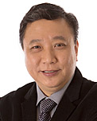
With more than 30 years of experience in the lighting industry, it has always been Michael’s passion and dream to transform the lighting world. As a pioneer in the evolution of LEDs in Singapore, he envisioned the next wave of innovation to be in the realm of the Smart Cities programs. Hence, Michael set up Photizo in 2015 with a vision to providing Smart Lighting solutions.

The investment in research & development has paid off with the creation of the patent-pending i-Core™ technology. With Photizo’s global licensing program, Michael will fulfil his vision of creating a Singapore-designed product that will make a world-wide presence.

Michael has received numerous accolades which include the “Spirit of Enterprise Award”, “ 2010 Successful Entrepreneur Award”, “The Entrepreneur of the Year Award 2017” as well as the “EYA for Enterprise Award”.

Mr Michael Chia
Founder/CEO
Photizo Global Pte Ltd


Christopher is a pure entrepreneur with a passion in creating new businesses. He started his own business at the age of 30 and had companies in the areas of Data Centre design & build, building construction, hospitality supplies and F&B, before putting his focus on lighting.

During the early stage when LED lamps were developed to replace incandescent lamps in 2006, Christopher founded Ecogreen Solutions with the aim of providing professional LED retrofit solutions to hospitality projects globally. The Ecogreen brand was recognized for its innovation in technology, quality and high performance. As LED adoption stabilized, Beyond Illumination was formed in 2013, partnering eldoLED to provide intelligent driving solutions as LED driver is the key to performance and lifespan of all LED luminaire.

The lighting industry evolved very quickly from LED to Smart Lighting within a short span of 3 years. In order to stay relevant to this evolution, Christopher co-founded Photizo in 2015 which integrates digitalization and IoT in the creation of smart lighting solutions using advanced sensors, wireless communications and data analytics.

Mr Christopher Lee
Co-Founder
Photizo Global Pte Ltd


Gorm is a lighting veteran with 25 years of experience in the management of lighting companies around the world.

Gorm embraced the technology development of LED as a light source from the very beginning, and is now fully engaged in the next generation of indoor and outdoor connectivity fusion of IoT and light.

Gorm lives in Copenhagen, Denmark but most of his activities lie outside Europe, connecting business and creating values for companies through his business acumen and enriching his life mission.

Mr Gorm Teichert
Head, Global Licensing
Photizo Global Pte Ltd
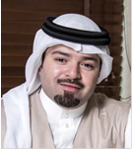
Mr Nawaf F. Al Sharif
CEO
ASG Holdings
Al Sharif Group Holdings (ASG) is a Saudi company established in 1980. Grounded in meticulous planning, prudent management and group effort, ASG has become a leader in providing energy through distribution and transmission. They are expanding into many new areas and have robustly grown in parallel with Saudi Arabia’s infrastructural development.
Al Sharif Networks & Distribution Limited Co (ASGX) is a subsidiary of ASG, with focus on energy distribution stations from 500 to 1,600 KVA and distribution network requirements.

Mr Al Sharif aims to drive ASG Holdings to a new age of performance across multiple sectors of activity touching on electricity, extending beyond overhead transmission lines, to substations, renewable energies and more, with the highest standards and most rigorous work flows. He has orchestrated the steady growth of the company by defining and delegating responsibilities.

Leading the team for the formulation, development and implementation of transformation strategies, he continues to transform the company by establishing new departments and functions, as well as leading the team for implementing an ERP and introducing Enterprise Project Management tools.

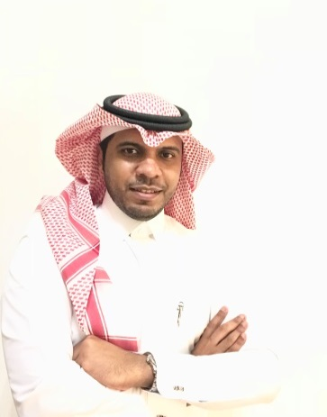
Mr Wail Bamhair
CEO
Taqnia Energy (TE)
Taqnia Energy is a subsidiary of the Saudi Technology Development and Investment Company (Taqnia), and was established at the end of 2014, with headquarters in Riyadh. In order to contribute in technology localization and job creation, Taqnia Energy was founded with a clear mandate of developing and investing in bankable technology-focused energy business opportunities.

In 2015, Mr Bamhair joined Taqnia Energy (TE) as a first employee after the CEO, as the Business Development Manager. His role was to lead the development of a business unit in TE, held the responsibility of originating and managing the evaluation and execution of partnerships, projects and portfolio investment opportunities and acquisitions, related to the solar business in order to increase the competitive advantage for TE. The big move was when he was leading the development of the first solar Independent Power Producer (IPP) project in the country, Layla solar plant (50 MW) with the lowest worldwide tariff at that time.

He also worked for King Abdullah City for Atomic and Renewable Energy (K.A.CARE) as Renewable Energy Researcher, under the Research, Development & Innovation Division. He participated in developing the infrastructure of the national program including national strategy, value chain, local content, R&D, technology development and human capacity building. He was also in charge of the first of its kind intiative in the kingdom, the National Renewable Energy Atlas which supported the achievement of a sustainable energy mix.

Mid of 2017, the board of directors assigned him to be the CEO for Taqnia Energy.

