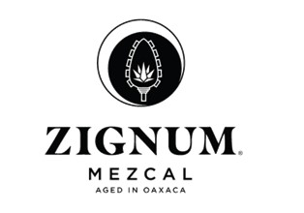
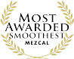
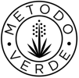
Media Contact:

Victoria Camargo
Deussen Global Communications, Inc.
vcamargo@deussenglobal.com
m.786-271-4641

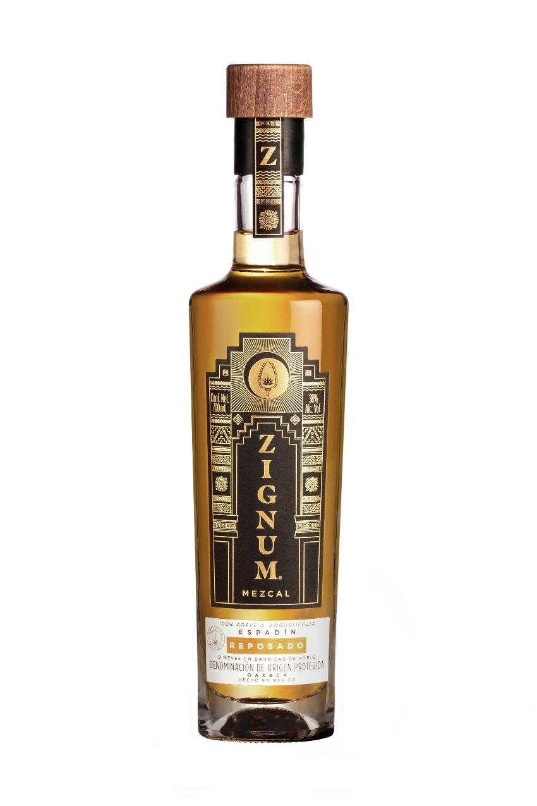
ZIGNUM REPOSADO MEZCAL (NOM-070)
About ZIGNUM Mezcal: ZIGNUM, one of the leading Mezcals in Mexico and Mexican duty free as well as the most awarded Mezcal in the world, is dressed in packaging inspired by pre-Hispanic Oaxacan temples. ZIGNUM’s MÉTODO VERDE™ sustainability programs include being cruelty-free, certified Clean Industry by Mexico’s Federal Environmental Protection Agency, and Kosher certified, among other designations. The distillery also has a wastewater treatment facility and engages in several eco-friendly processes, including rainwater collection and solar panel usage for heating. ZIGNUM’s pioneering agave nursery program, which promotes bio- and genetic diversity as well as protects against over-harvesting, is wholeheartedly adopted by its Oaxacan partner growers and is part of sustainable agriculture curriculums at some of Mexico’s most respected universities. ZIGNUM Reposado is best enjoyed with a slice of orange sprinkled with sal de gusano, and is highly enjoyable in cocktails.
About ZIGNUM Reposado:
Rich orange and golden tones. Aged for 8 months after distillation in medium charred American white oak barrels.

Tasting Notes:
Surprisingly delicate body with notes of raisins, banana, and vanilla.

State: Oaxaca UPC: 7503009838078
Country: Mexico Case Dimensions: 9.5”x7.2”x13.4”
Where to Find it: AZ, CA, CO, FL, GA, Cases/Pallet: 104
IL, NY, TX Layers/Pallet: 4
Alcohol by Volume (ABV): 40% Case Weight: 19.36 lbs.
SRP: $35.00/750mL Packed: 6 750mLs/case
DUN-14: 17503009838075

More information, media samples, hi-res imagery, recipes, and interviews available upon request.
Please drink responsibly. ZIGNUM is imported exclusively by Winesource International, Hilton Head, SC

