For Immediate Release

HSG Advisors Executives to Speak at Two SHSMD Sponsored Events in October

HSG’s CEO Travis Ansel and Chief Strategy Officer DJ Sullivan will present

Louisville, KY (October 4, 2023) – HSG Advisors, a national healthcare consultancy, announced that two of its top executives will speak at Society for Healthcare Strategy & Market Development (SHSMD) events to share insights on strategic utilization of healthcare metrics.
Travis Ansel, HSG’s Chief Executive Officer, and DJ Sullivan, HSG’s Chief Strategy Officer, will lead a one-hour sponsored webcast on October 11th, and Sullivan will speak again at the SHSMD Virtual Conference on October 20th. SHSMD is a professional membership group of the American Hospital Association that’s focused on professions in health care strategy. It’s the largest membership association in its sector.
“Holistic, data-informed strategy is the cornerstone of a health system’s ability to provide optimal patient care, retain healthcare employees, and thrive financially,” says Ansel. “We appreciate the important work SHSMD does to provide value and ongoing education for its members and are delighted to have the opportunity to speak at its upcoming events.”
Ansel and Sullivan’s sponsored webcast presentation is entitled “Key Market and Provider Metrics to Drive Strategic Service Line Growth.” They will cover methods to measure and interpret healthcare data, including patient utilization, competitor market positioning, and inpatient/outpatient market share, and will provide real-world case study examples. The webcast is scheduled for October 11th from 12:00-1:00 CDT and registration is free of charge.
Sullivan will then present at SHSMD23 Connections – SHSMD’s virtual conference for members. He will speak on a panel alongside Thomas Tiller II, Chief Operations Officer of Tiller-Hewitt HealthCare Strategies;
Brock Dockery, MBA, Assistant Vice President of Archbold Medical Group; and Catherine Hurst, MSN/MBA, RN, Assistant Vice President Clinical Services of Archbold Memorial Hospital in a session called “Attracting and Retaining New Patients: Acting on Provider Relationship Data.” The interactive presentation will cover ways to analyze provider relationships using claims-based and internal data, steps to identify and remove care access barriers, and best practices for building closer physician alignment and optimizing a provider network. The session is part of the conference’s Strategic Planning and Business Development track and is scheduled for October 20th from 12:00-12:45 CDT.

“SHSMD is an important partner for HSG Advisors and we value our ongoing collaboration,” says Sullivan. “We’ve seen impressive transformations in health systems that excel in utilizing data analytics to drive strategy, and I’m thrilled to be presenting on this topic to members.”

###

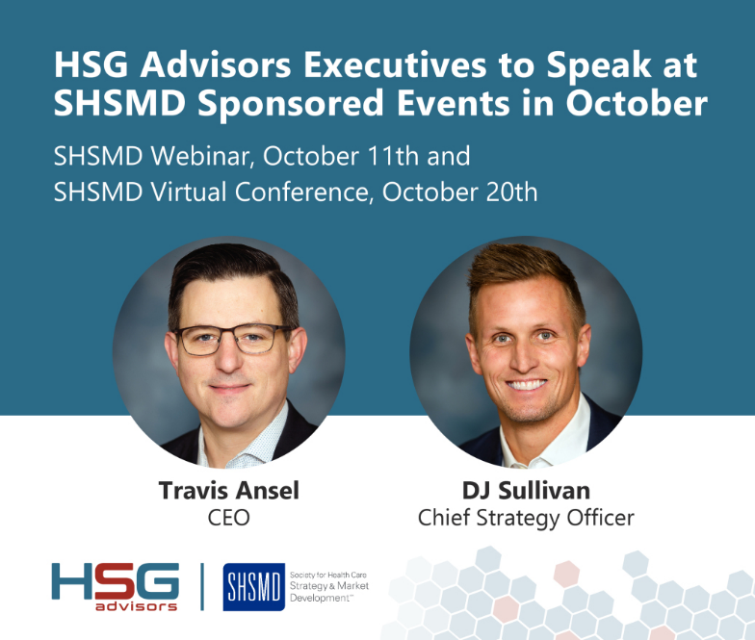

Caption: HSG Advisors executives, Travis Ansel, CEO, and DJ Sullivan, Chief Strategy Officer, to speak at SHSMD sponsored events in October.

About HSG Advisors
HSG Advisors is a national healthcare consulting firm that partners with health systems to transform their approach to markets, services, and providers for improved growth and operational and financial sustainability. The practice empowers leaders to build differentiated health system strategies and high-performing employed physician networks by pairing data intelligence with experienced advice. The firm's comprehensive approach to leveraging market data and analytics to inform healthcare strategies allows leaders to understand opportunities and deliver the right care to their communities. For more information about HSG, visit www.HSGAdvisors.com, LinkedIn, email info@hsgadvisors.com, or call (502) 814-1180.

Media Contact: Karolyn Raphael
Winger Marketing
(312) 494-0422
karolyn@wingermarketing.com

