BLUETTI AC500 is Finally Available on Canadian Official Store & Amazon

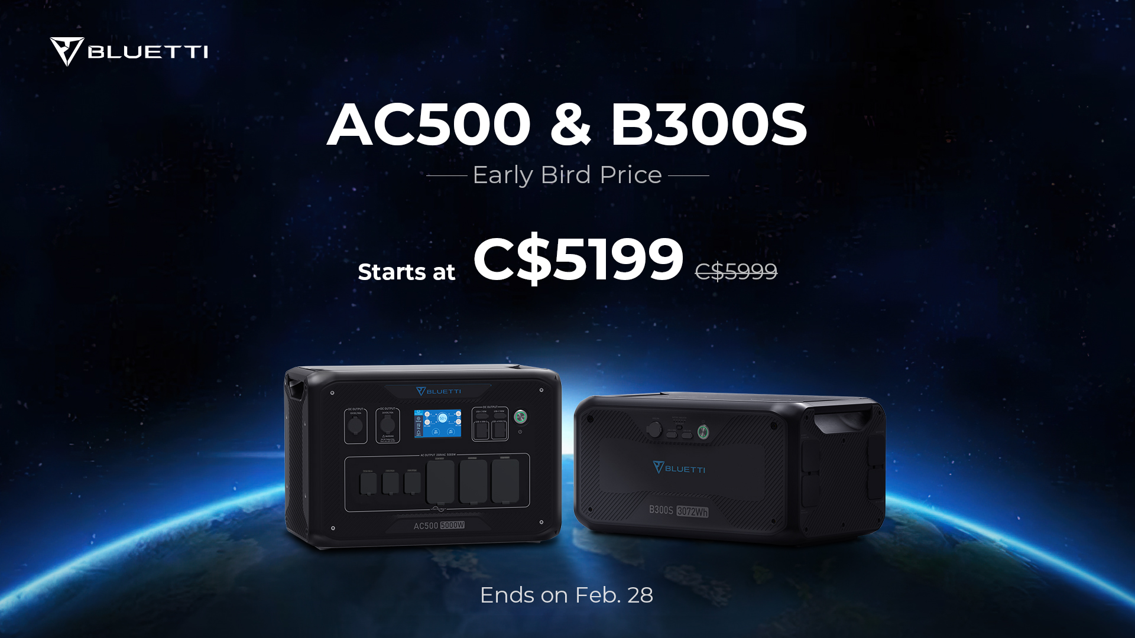

BLUETTI AC500 has eventually raised $11 million on Indiegogo, breaking another record in BLUETTI’s history. As of January, the AC500 and its expansion battery B300S have hit the shelves of Canadian online store and Amazon.
Although sharing many parallels with the first modular model AC300, the AC500 goes far beyond with a bunch of improvements that make it outshine most competitors in the solar generator market.

Charge Safer, Last Longer
AC500 system adopts selected LiFePO4 battery cells for long-term durability and 3,500+ charging cycles to 80% of its original capacity. Compared to the lithium-ion battery that most power stations and power banks use nowadays, the LiFePO4 battery offers optimal performance, which is expected to last for over 10 years.

Efficient Solar Intake
Built-in with a matchless MPPT solar inverter, AC500 allows a 3000W maximum solar input. Therefore, it’s surely no surprise that recharging it from 0 to 80% SOC by prime sunshine only takes about 1.5 hours. Creating a solar system with compatible solar panels can literally realize power independence as unlimited energy will be available for the entire house, outdoor camping, road trip, etc.

Impressive Home Backup Power
While considering a reliable backup power for emergencies or unexpected blackouts, there’s no better option than AC500. The modular AC500 welcomes up to six B300s battery packs for a total capacity of 18,432Wh. Furthermore, thanks to the Fusion Box Pro, two AC500 sets can be connected in series to boast up to a 240V/10,000W output and 36,864Wh capacity, making it a solid power center to run your home essentials for days or weeks.

Monitor& Control at The Palm of Your Hand
The intuitive BLUETTI App allows users to take everything under control, including power in/out, real-time power consumption, charging profiles, and OTA update the firmware to the latest version anytime from anywhere.

Blazing-Fast Recharging
Charging a power monster doesn’t have to be time-consuming. AC500 can be recharged by AC, solar, generator, lead-acid batteries, dual, or triple charging methods. Plug in the wall outlet and solar panels, and you can efficiently charge the AC500 with a max 8,000W input.

Charging time for AC500 + 2* B300S combo (for reference ONLY):
- 3,000W MPPT solar charge: ≈2.5 hours
- 5,000W AC charging: ≈1.7 hours
- 8,000W AC+PV dual charging:≈ 1.2 hours
With the AC500, the future of building a sustainable lifestyle seems fairly bright.

Pricing
Orders before Feb. 28 will enjoy the early bird price, which is C$2599 for AC500, and C$2799 for B300S, while the AC500+B300S combo only costs C$5199.

About BLUETTI
With over 10 years of industry experience, BLUETTI has tried to stay true to a sustainable future through green energy storage solutions for both indoor and outdoor use while delivering an exceptional eco-friendly experience for everyone and the world. BLUETTI is making its presence in 70+ countries and is trusted by millions of customers across the globe. For more information, please visit BLUETTI online at https://www.bluettipower.ca/

