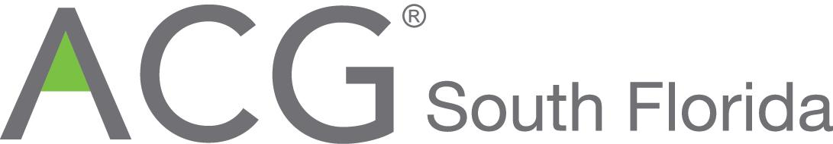

FOR IMMEDIATE RELEASE

Deal of the Year Awards to Chewy and Modernizing Medicine – Association for Corporate Growth South Florida

South Florida, May 15 2018. The South Florida Chapter of the Association for Corporate Growth (ACG-South Florida) announced today the winners of its “Deal of the Year” awards. Chewy, Inc. was awarded for its successful acquisition by PetSmart. Modernizing Medicine, Inc. was named for its significant capital raise from Warburg Pincus. These awards, based on 2017 transactions, will be presented along with other awards to South Florida’s leading businesses. The awards are Outstanding Growth Company of the Year, Emerging Growth Company of the Year, Deal(s) of the Year and the President’s Private Equity Award. A cocktail reception, awards dinner and post event reception will be held at the Westin Fort Lauderdale, Florida, 400 Corporate Drive, on June 21st beginning at 5:30pm.

ACG South Florida offers a wide range of sponsorship opportunities to businesses and organizations in Miami-Dade, Broward and Palm Beach Counties, that wish to join us in honoring the best in South Florida business.

Chewy, Inc.


Chewy is a leading online retailer of pet food and supplies in the United States. Founded in 2011, Chewy set out to offer pet parents the expertise and service of a local pet store with the convenience of online shopping. Chewy delivers on that promise with its dedication to 24/7 customer service, creation of cutting-edge software and technology to enhance the user experience, and commitment to sourcing high quality products. Headquartered in Dania Beach, Florida, Chewy currently employs more than 7,000 pet lovers both in their home office, Boston office, customer service center in Hollywood, Florida and six fulfillment centers in Pennsylvania, Indiana, Texas, Nevada and Florida.
For more information, visit www.chewy.com,

Modernizing Medicine, Inc.

Specialty-specific health information technology leader Modernizing Medicine, Inc. in 2017 announced that funds affiliated with Warburg Pincus, a global private equity firm focused on growth investing, made a substantial investment of $231 million into the company to provide liquidity to existing shareholders, fund further expansion and support future strategic endeavors.

Founded in 2010 by Daniel Cane and Dr. Michael Sherling, Modernizing Medicine is at the forefront of providing intelligent, medical technology. The company’s award-winning flagship product EMA™, is a mobile, cloud-based, specialty-specific electronic health record (EHR) system that is used by thousands of specialty practices nationwide.

Modernizing Medicine’s success can be attributed to its development of technology to support the unique needs of physicians in surgical and medical specialties. With the premise that it was easier to teach physicians how to code software rather than for engineers to learn medicine, Modernizing Medicine hired practicing physicians to build EHR software. The results of this model and time-saving features such as adaptive learning and automated outputs supported by structured data collection have been embraced by physicians. The company now offers a full suite of products and services to empower physicians including Practice Management, Revenue Cycle Management, Telehealth for dermatology, Analytics and more.

With the latest round of funding, the company anticipates pursuing certain strategic initiatives, that may include automation of prior authorization workflows, deployment of an eCommerce platform, investment in data exchange and reconciliation to help practices move clinically relevant data effectively throughout the evolving ecosystem of a patient’s healthcare experience and improvement of access to healthcare via telemedicine.

About ACG

Founded in 1954, the Association for Corporate Growth Inc. (“ACG”) is the premier global association for professionals involved in corporate growth, corporate development, and mergers and acquisitions. ACG has over 14,500 members from corporations, private equity, finance and professional service firms representing Fortune 500, Fortune 1000, FTSE 100 and middle-market companies through chapters in North America, Europe and Asia. These leaders are focused on building value. ACG serves 90,000 investors, executives, lenders and advisers to growing middle-market companies.

Information about ACG South Florida Chapter and the ACG-South Florida Awards Banquet, including the aforementioned availability of sponsorships, advertising and tickets, can be obtained from persons listed below and from the ACG-South Florida website http://www.acg.org/southflorida/. ACG member tickets are $150; for non-members $175.

Ari Roloff
ACG South Florida President
954-732-1291; Aroloff@cbiz.com

Thomas H. Hicks
ACG South Florida Treasurer, Awards Chair
954-971-3555; renparlc@gate.net

Elena Djakonova
ACG South Florida Chapter Executive
954-947-6080
edjakonova@acg.org



Leadership Quote: “I am glad to be a part of the ACG annual awards dinner where some of the best companies of South Florida are honored and recognized for their great achievements"
James S. Cassel, Chairman, Cassel Salpeter & Co., LLC

