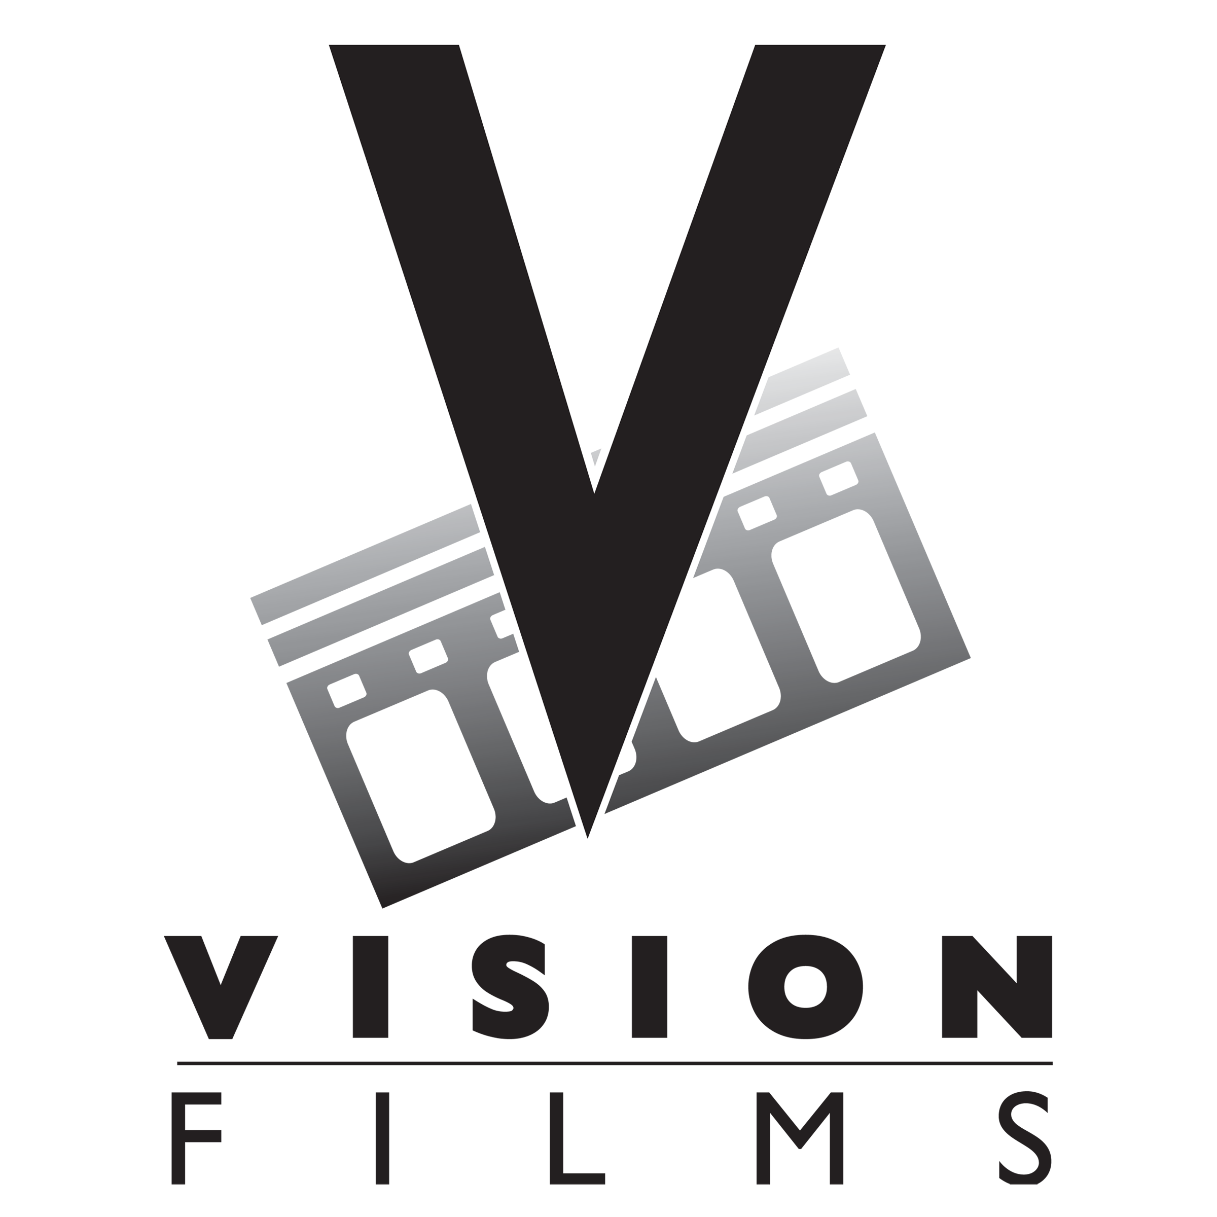

FOR IMMEDIATE RELEASE- July 25, 2019

VISION FILMS APPOINTS ROBBY AMAR AS VICE PRESIDENT OF INTERNATIONAL SALES & ACQUISITIONS

Los Angeles, CA- July 25, 2019- Vision Films Inc. (“Vision”) announced on Thursday the addition of Robby Amar in a lead international sales role as Vice President of Sales and Acquisitions.

Robby Amar is a seasoned international distribution executive with over 15 years of experience in sales and acquisitions. Amar joins Vision Films as Vice President of Sales & Acquisitions where he will oversee international licensing of the extensive Vision library of feature films, television series, and timely documentaries. Before joining Vision Films, Amar served as Vice President of Acquisitions and Co-Productions at Red Apollo Group (First Kill, starring Bruce Willis and Hayden Christensen, The Zookeeper’s Wife, starring Jessica Chastain), Gaumont TV (“Narcos,” “El Presidente”), as Vice President of Acquisitions and Co-Productions where he acquired such titles as El Chapo, and the WGN series “Bellevue,” and as Executive Director of International Sales at MarVista (16 Wishes with Debbie Ryan, Zapped starring Zendaya).

Amar’s extensive experience in sales, acquisitions, development, and production have provided him with a deep working knowledge of both sides of the market and have enabled him to create and nurture relationships with distributors, channels, and producers the world over. Adding to his skills, Robby is fluently tri-lingual in English, Spanish and French.

“As we expand into the world of VOD on a global basis, Vision Films is looking forward to adding Robby Amar to our already stellar team,” said Lise Romanoff, CEO and Managing Director of Vision Films. “Robby is well-respected by the international film community and brings a great deal of experience in multiple backgrounds to Vision Films. As Vision looks to the future in expanding our company on the domestic and international forefronts, we know that Robby will be an excellent representative for our diverse slate of content.”

“I am overjoyed to be joining the incredible team at Vision Films,” said Amar. “An established company with a track record of success, Vision is a well-oiled machine with an abundant library of films, series, and documentaries that are current and resonate with audiences worldwide. I look forward to representing these films to the international market.”

Vision Films is known worldwide as a leading distributor and sales agency, which represents the highest caliber of independent film content. Vision aims to provide quality entertainment with the independent filmmaking spirit to fans everywhere. Feature films include Adverse with Academy Award winner Mickey Rourke, Penelope Ann Miller, and Sean Astin and Eternal Code starring Scout Taylor-Compton, Richard Tyson, and Billy Wirth and award-winning feature documentaries including Living in the Future’s Past, narrated by Academy Award winner Jeff Bridges, and Long Gone Wild, the follow up to Blackfish.

About Vision Films

Vision Films is a leading independent distributor and VOD aggregator specializing in the licensing, marketing, and distribution of over 800 feature films, documentaries, and series from some of the most prolific independent film producers in the world. Led by Lise Romanoff, Managing Director/CEO Worldwide Distribution, Vision Films releases 2-4 films a month across Theatrical, VOD, DVD, and television platforms. www.visionfilms.net

CONTACT: Kristen Bedno Kristen@visionfilms.net

