November 1, 2020 For Immediate Release

SCA Appraisal Sending Free PPE and Speeding Appraiser Pay in Advance of COVID-19 Spikes

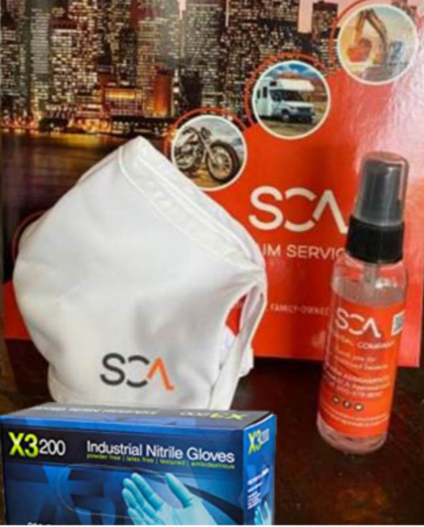
Burbank, CA – In anticipation of an accelerating spike in COVID-19 cases and in the interest of safety for its nearly 800 franchise and network appraisers, SCA appraisal has launched a second round of up to $25,000 of complimentary COVID-19 PPE directly to field appraisers as an effort to mitigate potential exposure to COVID-19 and mitigate any possible exposure to clients. Additionally, SCA is accelerating pay to appraisers and increasing the frequency of payments to help assist with any financial challenges associated with potential shutdowns.

“As a society and as businesses, we learned a lot about the impact of CVID-19 spikes and related shutdowns throughout 2020. SCA wants to ensure we are doing all we can to promote safety and assist with financial stability in the event the increased COVID-19 cases being reported nationally translate into further business disruption.”, says Timothy Davis, Jr., president of SCA Appraisal. “Nothing is more important to us here at SCA than our people, our franchise network and our clients’ vehicle owners. The PPE and accelerated compensation is our small way of cementing the commitment to the industry that SCA has proudly-served for over 40 years.”

“For our franchise and network partners, getting them paid is more important now than ever and SCA has committed resources to expediting these payments.”, states Monica Warner, CFO. “We know times may have been tight for some in the industry and we are proud to be able to extend payments faster than ever.”

Additional information regarding this program can be obtained by visiting SCA’s dedicated website at: http://sca.claims/ppe
++++++++++++++++++++++++++++++++++++++++++++++++++++++++++

For inquiries:

Phil Langley
plangley@sca-appraisal.com / 214-914-0187

