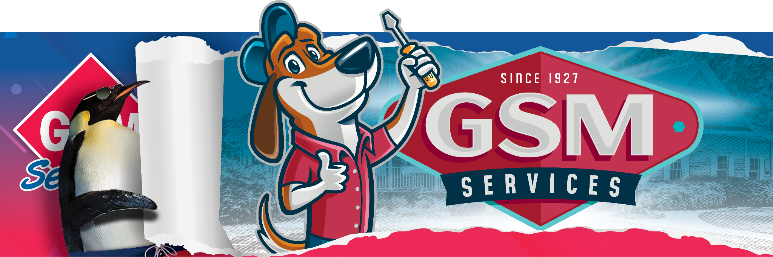
GSM Services Approaches 100. Reveals New Brand with an Employee Celebration and a Look to the Future.
Be on the lookout for Max…the new 4-legged mascot for GSM Services!
Date: May 20, 2024
For more info: Michael Sumner 704-747-5498
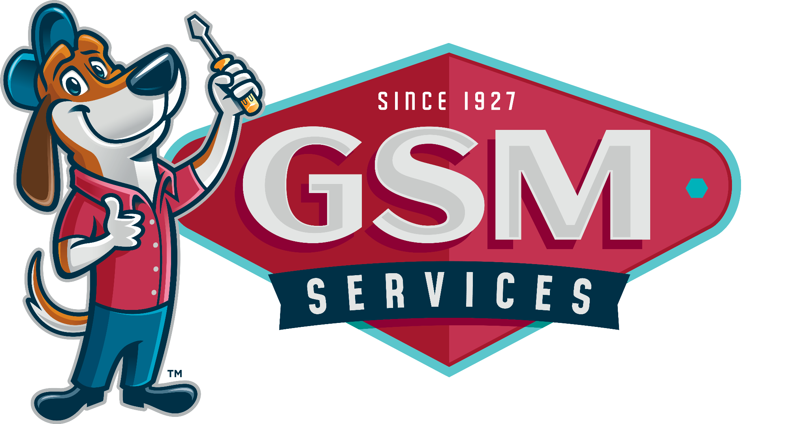
Gastonia – On May 16th GSM Services, a 300-team-member HVAC company based in North Carolina, unveiled an exciting new logo. According to Steven Long, President/CFO Residential Division, “The new identity represents our growth and vision for the future.” He continued, “This change also reflects our commitment to innovation and excellence. GSM is the same company you have trusted for almost a century! Only with an updated look and a new mascot - Max!”

The presentation of the brand and the new mascot, “Max” included a showcase of the full wrap of two of their 100+ service vehicles and t-shirts to all team members. Over the next year, the new logo will be displayed on all marketing components, including vehicles, signage, printed materials, website as well as community service projects which has been an important part of their legacy. “GSM is one of the founding sponsors of Gastonia Baseball Club,” said Marketing Director Amy Anderson.

“Max will be making appearances at games soon. We are all in, and we are looking forward to introducing Max to not just our customers and team members but to the communities and service organizations we help in Gaston, York, Lincoln, Cleveland, and Mecklenburg Counties,” commented Anderson.

According to Long, “The project has been in the works for 18 months; the meeting was the first peek at the new brand. One of our core values is always to evaluate the current business climate and focus on growth as a company.” He continued, “We believe it is time to refresh our brand to build on our success over the previous 97+ years.”

GSM is one of the few remaining locally owned HVAC companies in the area and wanted to make a strong commitment to their upcoming 100-year anniversary. GSM provides:
Heating & Cooling – HVAC System Repair, Maintenance, and installations
Duct Cleaning – Duct Cleaning & Dryer Vent Cleaning
Crawl Space & Attic Solutions – Insulation Services, Humidity and Mold Solutions, Crawl Space Repairs and Encapsulations, air leak sealing, standby generators, complimentary Energy Audits and more.
Commercial HVAC & Commercial Roofing – Services for commercial properties including HVAC and/or Roofing design, repair, installation, maintenance and more.

GSM Services is a family-owned business that has served the area since 1927. They specialize in residential and commercial heating and air conditioning, commercial roofing, and energy services. For more than 97 years, GSM has served homeowners and the region’s largest corporations, hospitals, manufacturing, industrial, education, religious, government, and banking industries. Additional information about GSM Services can be found at GSMsince1927.com

