
FOR IMMEDIATE RELEASE:

Jack Rabbit Gallery Celebrates the Feminine Spirit with “Face It” Exhibition in Houston, Texas, Ahead of Upcoming Move to the Houston Design District.

HOUSTON, Tex., March 24, 2021 – On March 27, Jack Rabbit Gallery will introduce “FACE IT,” an art exhibition that features five amazing artists and their unique interpretation of the feminine spirit. Jack Rabbit will host an opening reception from 6-9 pm on March 27, 2021.

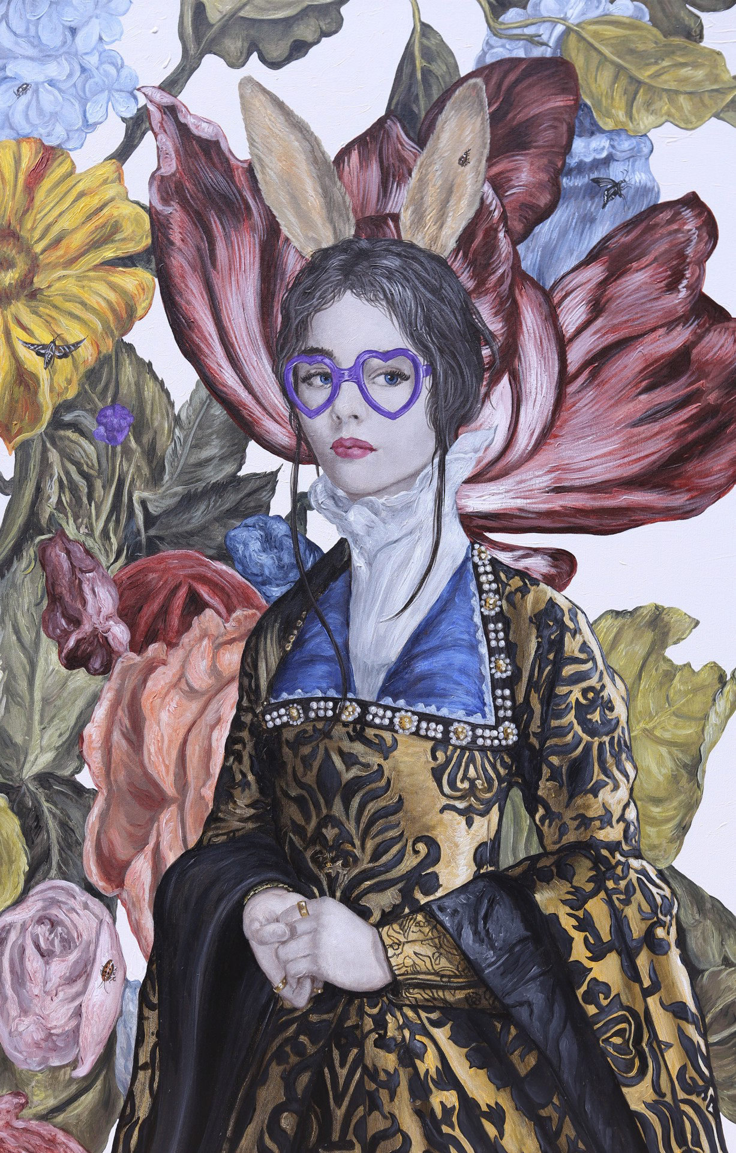
“FACE IT” will remain on view until May, at which time the Gallery is looking forward to opening its new flagship location at 7800 Washington Ave. in the Houston Design District. Since opening its doors, Jack Rabbit has experienced remarkable growth and continued success. “Our unprecedented growth over the past two years necessitated the need for a larger space,” said Jack Rabbit’s founder James Grogan of Houston. “The Houston Design District is close to our clients, and it represents a hub in the City of Houston for innovative design, architecture, and luxury furnishings. We are thrilled at the prospect of being the only fine art gallery among this amazing collection of creative businesses.”

“FACE IT” will feature artists whose primary subject matter is the female form: Juan Carlos Navarro, René Romero Schuler, Matthew Paoletti, Carlos Gamez de Francisco, and Feebee Joynt. Through the show, guests of Jack Rabbit Gallery will enjoy the depth and diversity of contemporary art in the U.S.

Among other works, “FACE IT” will feature lush floral portraits by Carlos Gamez de Francisco, an artist who grew up in Cuba and studied under some of the leading Russian artists during his academy days. Francisco’s work will fill a space elegantly and unapologetically. The use of pastels and muted colors mirrors the gentle nature of the subject's lifelike appearance. These feminine compositions tell a story that emphasizes strength, softness, and structured beauty, with a sprinkle of lighthearted humor.
Purple Bunny by Carlos Gamez de Francisco

RSVP on Eventbrite and join Jack Rabbit Gallery in this final exhibition at their current location. Updates on the Gallery’s buildout and move to the new space will be available at jackrabbitgallery.com and on Instagram @jackrabbitgallery.

Opening Reception 03/27/2021, 6-9 pm
228 E 27th St, Houston, TX 77008 (Houston Heights)
RSVP https://www.eventbrite.com/e/144481320519
More information: https://jackrabbitgallery.com/show/jack-rabbit-gallery-face-it

About Jack Rabbit Gallery
Jack Rabbit Gallery has established itself as one of the leading contemporary art venues in Houston, Texas. Owners James and Jodi Grogan have more than 30 years’ experience in the industry. Jack Rabbit represents a dynamic roster of established and mid-career contemporary artists working in various media, many of whom have been widely collected by private, corporate and museum collections. Jack Rabbit sponsors an impressive range of thematically oriented art exhibitions annually.

MEDIA ONLY CONTACT: James Grogan | 917.859.2040| james@jackrabbitgallery.com

