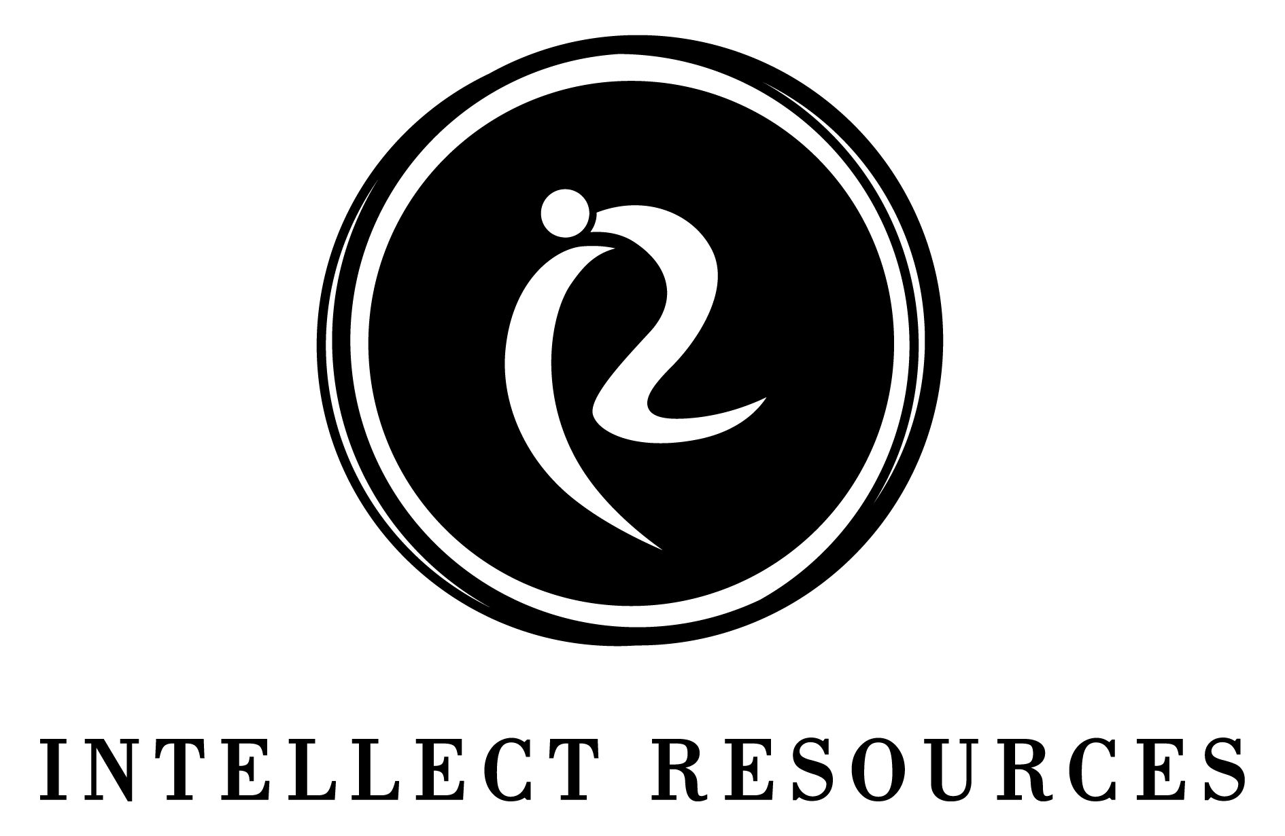 |  | Media contact: Catey Moore  cmoore@intellectresources.com

Intellect Resources Names Jennifer Anderson Vice President of Client Services Delivery
GREENSBORO, N.C., March 4, 2021 Intellect Resources is proud to welcome Jennifer Anderson as Vice President of Client Services Delivery. In her role, Anderson will be responsible for delivering innovative and comprehensive consulting services to clients. Anderson will be focused on optimizing client services to meet the dynamic needs of the healthcare environment.
"Jennifer is a great addition to our team and has already hit the ground running assisting with the delivery of several high-profile projects and go-live engagements to existing clients," said Tiffany Crenshaw, President, and CEO of Intellect Resources. "Jennifer has a wealth of knowledge, contacts, and career achievements in the healthcare IT industry, making her addition as Vice President of Client Services Delivery an ideal fit. Adding Jennifer immediately strengthens our existing team. Having known Jennifer for over a decade, I'm confident her expertise will allow us to continue our focus on providing innovative healthcare IT solutions to our clients."
Jennifer joins Intellect Resources to us with more than 20 years of experience, having served as the Executive Director for the North Carolina Healthcare Information and Communications Alliance (NCHICA), a non-profit healthcare organization with the mission of transforming the delivery of healthcare through the effective use of technology, informatics, and analytics. Prior to her role at NCHICA, Anderson was the Market Operations Director for Tenet Healthcare and Director of Physician and Community Services at The Carolinas Center for Medical Excellence. In addition to her role with Intellect Resources, Anderson continues to serve on the Board of Directors for the North Carolina Telehealth Network Association and the North Carolina Center for Cybersecurity.
About Intellect Resources
Intellect Resources stands apart in the healthcare IT industry for an unparalleled ability to recruit talent and healthcare IT professionals. Services are tailored to meet a client's strategic business initiatives, individual project needs, and budget. From an individual hire to teams of over 500, Intellect Resources can provide the solution to your recruiting needs quickly and reliably. Intellect Resources is certified as a women's business enterprise through the Women's Business Enterprise National Council (WBENC), the nation's largest third-party certifier of businesses owned and operated by women in the U.S.
For more information, visit us at www.intellectresources.com.

