Cariflex to double its Polyisoprene Latex capacity at the Paulinia facility in Brazil

- Cariflex Board of Directors approved the approximate $50 million capital project in April 2020
- The new plant is expected to be operational in the 1st quarter of 2021

SINGAPORE (July 17th, 2020) - Cariflex PTE. Ltd. (Cariflex) today announced that it will be constructing a new large-scale polyisoprene latex plant at its Paulinia, Brazil facility to meet the strong market demand from its medical and consumer product customers.

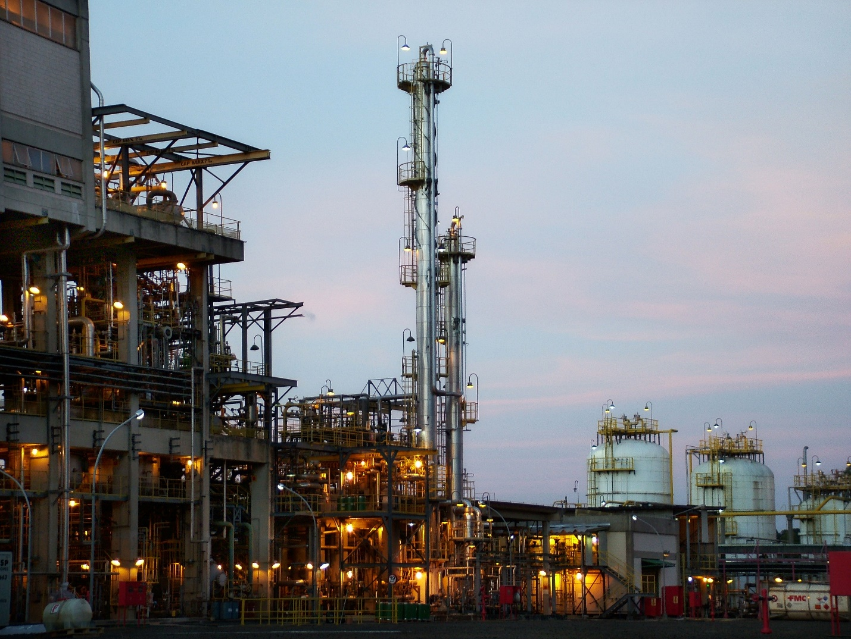

“Cariflex is excited to be making a sizeable investment in the growth of the polyisoprene latex business. Cariflex polyisoprene latex is a unique synthetic alternative to natural rubber latex for dipped goods and various specialty products. With the current strong demand for medical protective equipment such as surgical gloves, we recognize our customers’ needs to have more material available,” said Philippe Henderson, Cariflex Sales & Marketing leader.

With our increased production capacity and unmatched global service network, our customers can be assured of secure supplies anywhere in the world. Following the addition of this polyisoprene latex unit, the new resulting capacity in Paulinia, Brazil combined with the existing capacity in Himeji, Japan will strengthen our position as the global leader of polyisoprene latex with unmatched quality and supply diversity. Customers will benefit from Cariflex IR0401 latex volumes sourced from four distinct production lines.

The addition of this new production line is replicating the technology of the current fully utilized unit, and will double the polyisoprene latex capacity of the site.

Daelim Industrial Co., Ltd named Mr. Prakash Kolluri as Chief Executive Officer of Cariflex Pte Ltd, for the global business. Sean Kim, Chief Executive Officer for Daelim Industrial Co., Ltd said, “We are delighted to have appointed Mr. Prakash Kolluri who is a huge asset to the company. We are confident Prakash will move Cariflex Pte Ltd forward and bring a wealth of experience which will be extremely valuable in driving our future growth globally”

“Our strategic decision of capacity expansion, in support of organic growth, separates us from competition. Our industry leading polyisoprene latex capacity acts as a catalyst for our valued customer base to make inroads in new geographies. Cariflex is strategically positioned and has a bright future serving medical and other high value markets,” Prakash Kolluri, Chief Executive Officer mentioned.

ABOUT Cariflex
Cariflex is a global leader of isoprene rubber latex (“IR Latex”) and isoprene rubber (“IR”) for medical end markets and other high-value markets with strong growth drivers. Cariflex produces high value-added synthetic rubbers and latexes used for medical materials such as surgical gloves and rubber stoppers and seals for drug delivery devices. Cariflex is a wholly owned subsidiary of Daelim Industrial Co., Ltd.

ABOUT DAELIM INDUSTRIAL
Daelim Industrial Co., Ltd. (KSE: 000210) is the flagship company of Daelim Group, one of Korea's top conglomerates, with more than 80 years of business history. Daelim Industrial is mainly engaged in petrochemical and engineering & construction businesses with $ 8.5 billion in sales as of 2019 fiscal year and is continuing on its path to become a leading global developer. Daelim Industrial's Petrochemical Division has maintained its market leadership through its proprietary technology. Daelim Industrial's cutting-edge technological advancements has enabled it to sustain its global leadership position in the Polyisobutylene market worldwide, having commercialized metallocene polyethylene for the first time in Korea and developing BOCD (Broad Orthogonal Co-Monomer Distribution) polyethylene and EPO (Ethylene-Propylene Oligomer) for only the second time worldwide.

For Press Inquiries
Sang-woo Ryu, Cariflex: sangwoo.ryu@cariflex.com
Eric Byun, KorCom Porter Novelli (Daelim Industrial’s PR agency): eric@korcom.com

