

DigiCor is excited to announce the launch of its two institutional-grade digital assets passive Funds: the DigiCor90, which tracks a market-cap weighted index, and the DigiCorEW, an equal-weighted version of the DigiCor90. Both index Funds are built to meet the highest fiduciary, security, and compliance standards. For instance, 100% of the assets are held in cold storage vault with a qualified custodian and have management fees comparable to traditional high-risk index funds (e.g. 0.5% for DigiCor90 vs 0.69% for the iShares MSCI Emerging Markets ETF).
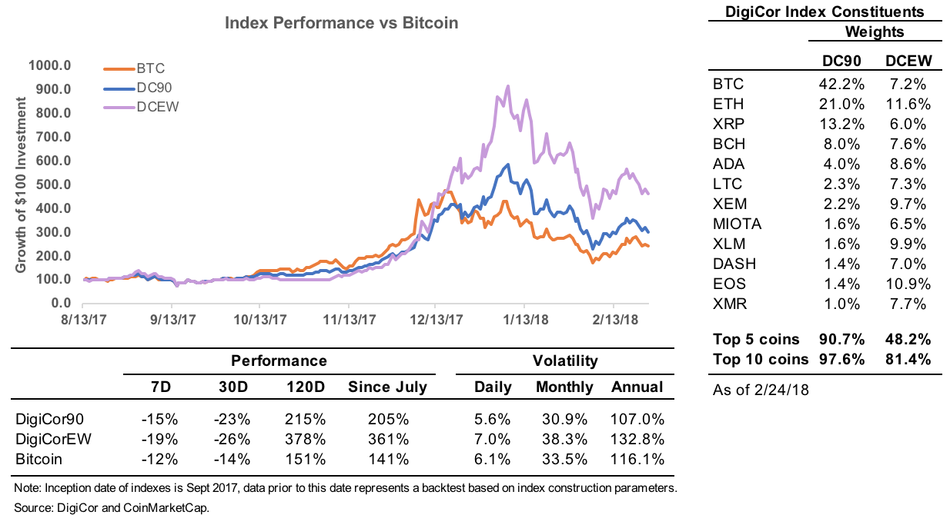
According to CoinMarketCap, the digital assets market expanded by over 30x in 2017 and added as many as 300 new cryptocurrencies. Investors understand the large disruptive potential from blockchain technology and how it could translate into higher prices for digital assets in the long run. However, accessing this investment opportunity remains difficult, risky, and expensive. Those willing to invest despite these challenges have to manage multiple cryptocurrency wallets, keep their coins secure, find liquidity in a fragmented market, and deal with high trading fees. Critically, for most investors the expertise required to perform due diligence is technologically complex, expensive, and time consuming.
BACKTESTED/HYPOTHETICAL PERFORMANCE

The performance results presented herein are back-tested based on hypothetical performance testing. Back-tested performance does not reflect trading in actual accounts and is provided for informational purposes only to indicate historical performance had the Funds indexes strategy been implemented over the relevant time period. These performance results have inherent limitations as to their relevance and use. One of the limitations is that they are prepared with the benefit of hindsight. In addition, back-tested investing does not involve financial risk, and no hypothetical trading record can completely account for the impact of financial risk in actual trading/investing. Any and all of these factors mean that no representation is being made that the Funds will achieve performance similar to that shown.

DigiCor addresses these problems by providing two simple, secure, and cost-efficient index Funds that facilitate diversified broad market exposure to digital assets without the need of complex due diligence. The investment vehicles are built with risk management in mind and all holdings are deposited with a qualified custodian in cold storage vaults, and subject to yearly audits. In addition, all investors receive monthly performance updates and the necessary tax documentation at the end of the year. The Funds provide monthly liquidity at low management fees between 0.5% and 0.6%, which decrease with larger investment amounts. Furthermore, in their ambition to create the highest quality indexes in the digital assets space, the company is in the process of implementing the IOSCO principles for financial benchmarks.

The team is made up of:
- Matias Antonio, CEO: is a mathematician and macroeconomist with 7 years of experience in buy-side investing and macroeconomic policy. Matias has been involved in the development and deployment of tactical and strategic asset allocation models to manage $25bn in AUM and the successful reconstruction and management of a $2bn emerging market equities portfolio at the World Bank Pension Fund. In addition, Matias has been engaged in the construction and deployment of various World Bank and International Monetary Fund macroeconomic stabilization programs.
- Kamran Jiwani, CTO: has over 12 years of experience in enterprise-grade software development in a wide-range of areas including finance and human resources. During his career, Kamran has been involved as a software developer and technical lead in numerous implementation, conversion and upgrade projects. He has worked for corporate clients such as The Depository Trust & Clearing Corporation, the World Bank, Citigroup, Aetna, Blue Cross Blue Shield and the Navy Federal. Additionally, Kamran has extensive knowledge of numerous open source and proprietary technologies and his skill set includes: machine learning tools (including predictive analysis, supervised, and unsupervised learning algorithms), big data, full stack development, and PeopleSoft.
- Solomon Stavis, CFO: has 8 years of experience in international trade, financial regulation, and macroeconomic policy. At the International Finance Corporation, Solomon assessed the export and import markets of country economies and developed reform initiatives based on good international practices. Prior to the IFC, Solomon worked at World Bank where he engaged in policy dialogue with local authorities to harmonize financial sector regulations across ASEAN countries.

Their combined knowledge enables them to understand the technology behind blockchain and build products which meets the needs of the most sophisticated asset allocators.

In addition, as of March 1st, Marc Tabah will join the advisory board of DigiCor. As the company’s first advisor, Marc brings over 30 years of experience at three of the most prestigious firms in the financial services industry: Lazard, Credit Suisse and Morgan Stanley. His experiences in distribution, client relationship management and capital raising will be particularly valuable to us.

DigiCor is based in Washington, D.C., and its goal is to provide institutional-grade products that investors can use to understand and gain exposure to digital assets, and the company’s products reflect this objective.

To learn about the work of DigiCor, the team and products, please visit DigiCor.io or send an email to hello@DigiCor.io.

