Terra Innovatum Submits Engagement Plan to the United States Nuclear Regulatory Commission (USNRC) for SOLO Micro Modular Reactor Marking a Fundamental Milestone in 2025
Propelling Nuclear Innovation: Terra Innovatum, a Leader in the Clean Energy Revolution, Setting New Industry Benchmarks with SOLO Micro-Modular Reactor (SMR)

NEW YORK, NY / ACCESSWIRE / Jan 29th, 2025 / Following an informal introductory meeting in November 2024, Terra Innovatum—company at the frontier of innovation and nuclear technology—is proud to announce the submission of its Regulatory Engagement Plan (REP) to the United States Nuclear Regulatory Commission (USNRC) for the pioneering SOLO Micro-Modular Nuclear Reactor. This milestone marks a critical step in the rigorous regulatory process required to bring innovative nuclear technologies to market. The announcement reflects Terra Innovatum’s commitment to revolutionizing clean energy solutions with immediate impact while taking the necessary steps to render this technology available for the world.

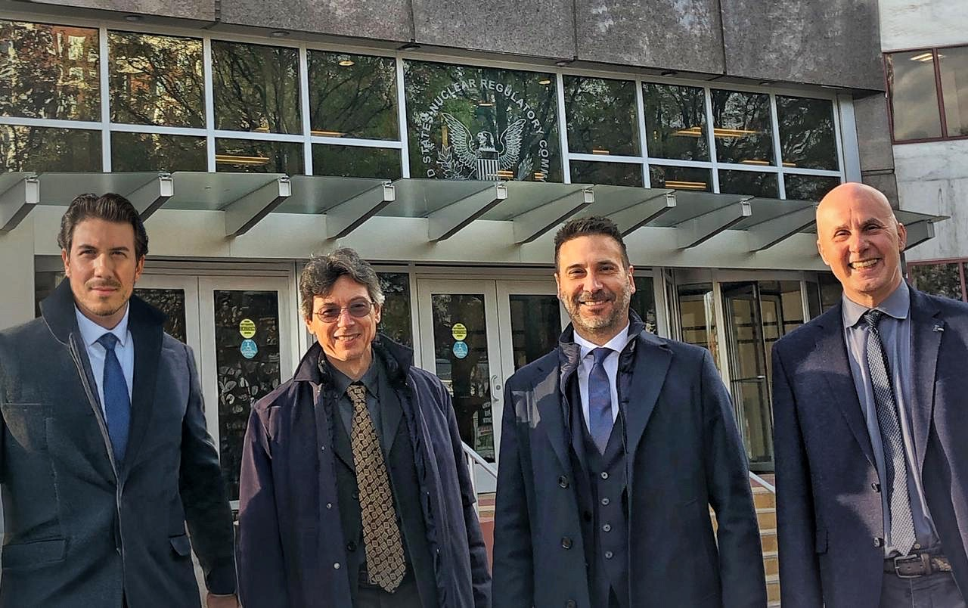

Left to Right: Giordano Morichi – Partner, Chief Business Development Officer & Investor Relations, Marco Cherubini - Co-Founder, Chief Technology Officer & Product Director, Alessandro Petruzzi - Co-Founder & Chief Executive Officer, Cesare Frepoli – Co-Founder, Chief Operating Officer & Director of Licensing and Regulatory Affairs at USNRC HQ in Washington DC.

With SOLO’s pioneering design tailored for industrial applications, such as factories, mining zones, pink-hydrogen and cement electrification plants, data centers for AI, quantum computing hubs, as well as underserved regions, the company is poised to transform the nuclear energy landscape, advancing global efforts toward equitable energy access and carbon neutrality. This milestone achievement underscores Terra Innovatum’s commitment to propelling humankind by democratizing energy distribution and ensuring equitable energy access worldwide, for businesses and communities alike, all while placing safety protocols as its highest priority.

“Submitting to the USNRC marks a pivotal moment for Terra Innovatum as it progresses toward bringing the SOLO Micro-Modular Nuclear Reactor to life. Our decision to build the first-of-a-kind (FOAK) reactor in the United States highlights Terra Innovatum’s dedication to strengthening U.S. energy independence while contributing to global advancements in clean energy”, announced Alessandro Petruzzi - Co-Founder & Chief Executive Officer. “As nuclear engineers and scientists, we are truly eager to advance our licensing process. Drawing on our extensive licensing experience and the years dedicated to refining the reactor design, we are confident in maintaining productive and seamless discussions with regulators, ensuring a timely path to licensing.” concluded the head of the company.

Highlights on SOLO Groundbreaking Technology

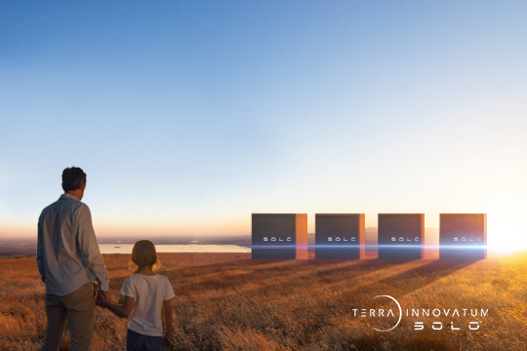

In Picture: Visual Representation of SOLO Micro-Modular Nuclear Reactors in Series of Four (4 MWe) on U.S. Soil.

SOLO is a groundbreaking solution that offers scalable (1MWe-1GWe) CO2-free energy, delivering baseload power for 15 years without the need for grid infrastructure. The reactor, able to extend its life-cycle to 45+ years via a core-swap, is ideated with a Zero Emergency zone planning, diverse and redundant safety measures, and embedded safeguards by design to allow 24/7 IAEA monitoring for each reactor globally. SOLO, purposely designed for commercialization by 2028, can produce 1MWe when using Low Enriched Uranium (LEU) and 5MWe using High Assay Low Enriched Uranium (HALEU), bridging today’s proven technologies with next-generation advancements.

The SOLO reactor combines Italian innovation, nuclear knowhow, and internationally acclaimed nuclear expertise with the industrial strength, supply chain resilience, and mass-production capabilities of the United States, paving the way for exponential scaling and sustained growth. The first-of-a-kind (FOAK) reactor will be deployed in the U.S., underscoring Terra Innovatum’s commitment to energy independence—particularly in off-grid applications—while showcasing globally validated expertise and the ability to navigate diverse regulatory landscapes. SOLO’s modular design integrates inherent safety, scalability, and cost efficiency, supporting applications ranging from remote communities to industrial operations and AI data centers, with scalability from MWe to GWe-class platforms.

USNRC - ADAMS System Reference Link to Regulatory Engagement Plan Submission: https://adamswebsearch2.nrc.gov/webSearch2/main.jsp?AccessionNumber=ML25017A401

Giordano Morichi - Partner, Chief Business Development Officer & Investor Relations announced: “Our SOLO reactor exemplifies the collaboration between Italy and the United States. By combining Italy’s cutting-edge innovation and globally acclaimed nuclear expertise with the United States’ industrial strength and supply chain resilience, SOLO will embody the very best of these two powerhouses. We believe that this synergy not only strengthens U.S. energy independence but also cultivates a robust techno-economic partnership that will benefit both nations and the prosperity of mankind. The submission of our USNRC Engagement Plan marks an important milestone demonstrating our commitment to the highest standards of safety, reliability, and environmental stewardship, while ensuring we stay on track to bring this groundbreaking technology to market.”

“The USNRC submission of the Regulatory Engagement Plan demonstrates our commitment toward achieving our vision of making micro-modular nuclear technology accessible and transformative,” continued Cesare Frepoli, Co-Founder, Chief Operating Officer & Director of Licensing and Regulatory Affairs. “The SOLO design was conceived with safety, simplicity, and modularity as guiding principles, ensuring it can meet the energy demands of diverse applications, from resource-constrained regions to advanced industrial systems like AI data centers. We are excited to bring this innovative solution to life, starting here in the United States- where it will not only advance clean energy but also strengthen energy independence and align with global sustainability goals.”
Marco Cherubini, Co-Founder, Chief Technology Officer & Product Director, concluded: “The Regulatory Engagement Plan outlines a clear roadmap for Terra Innovatum with the USNRC, showcasing our proactive approach to navigating the technical and operational considerations essential for licensing and deployment. This comprehensive regulatory process ensures that the SOLO reactor will meet the highest safety, environmental, and performance standards. As we continue to engage with regulators, we are confident that SOLO’s unparalleled design and safety protocols will set a new benchmark for nuclear innovation, bringing us closer to realizing its full commercial operation and contributing to a sustainable energy future.”
By deploying its innovative technology for the first-of-a-kind (FOAK) SOLO Micro-Modular Reactor in the United States, and submitting its Regulatory Engagement Plan (REP) to the USNRC, Terra Innovatum is aiming to set a new global standard for micro-modular reactor projects. SOLO’s transformative design represents a breakthrough in clean energy, tailored to support industrial applications, urban centers, and communities worldwide, all while advancing the global transition to net-zero emissions. This milestone underscores Terra Innovatum’s leadership in nuclear innovation and its unwavering commitment to equitable energy access, carbon neutrality, and a sustainable future for all.

About Terra Innovatum & SOLO™:

Terra Innovatum (TINN) is a pioneering force in the energy sector, dedicated to delivering innovative and sustainable power solutions. As the parent company of SOLO™, TINN leverages cutting-edge nuclear technology through the SOLO™ Micro-Modular Reactor (SMR™) to provide efficient, safe, and environmentally conscious energy. With a mission to address global energy shortages, TINN combines extensive expertise in nuclear industry design, manufacturing, and installation licensing to offer disruptive and immediate solutions. Committed to propelling technological advancements, Terra Innovatum and SOLO™ are dedicated to fostering prosperity and sustainability for humankind.

SOLO (2028) is set to be available globally within the next four years. Conceptualized in 2018 and engineered over five years by experts in nuclear safety, licensing, innovation, and R&D, SOLO addresses pressing global energy demands with a market-ready solution. Built from readily available commercial off-the-shelf (COTS) components, SOLO’s proven licensing path enables rapid deployment and minimizes supply chain risks, ensuring final cost predictability. Designed to adapt with evolving fuel options, SOLO supports both LEU+ and HALEU, offering a platform ready to transition to future fuel supplies.

SOLO offers a wide range of versatile applications, providing CO2-free, behind-the-meter, and off-grid power solutions for data centers, mini-grids serving remote towns and villages, and large-scale industrial operations in hard-to-abate sectors like cement production, oil and gas, steel manufacturing, and mining. It also supports specialized heat supply processes, water treatment, and desalination. Thanks to its modular design, SOLO can easily scale to deliver up to 1GW or more of CO2-free power with a minimal footprint, making it an ideal solution for rapidly replacing fossil fuel-based thermal plants. Beyond electricity and heat generation, SOLO also contributes to critical applications in the medical sector by producing radioisotopes essential for oncology research and cancer treatment.

W: https://www.x-solo.com/

Contact:

Giordano Morichi
Partner, Chief Business Development Officer & Investor Relations
Terra Innovatum
E: g.morichi@terrainnovatum.com

