GreenPro Capital strengthen its lineup of advisors for Thailand Entertainment Complex consortium

KUALA LUMPUR, MALAYSIA / ACCESSWIRE / January 16, 2025 / Greenpro Capital Corp. (NASDAQ:GRNQ) a multinational financial services company, previously announced on 5th December 2024 that it is leading the proposed business development of Thailand Entertainment Complex, a US$6 billion (~200 billion Thai Bhat) mega entertainment complex with various amenities such as horse-racing track, 6-star hotels, golf courses and other hospitalities. The consortium will now add General Dr. Uthai Shinawatra, a former Deputy Permanent Secretary of Defense, Thailand and former Advisor to the Minister of Interior Thailand, to its list of eminent advisors. General Dr. Uthai brings a wealth of experience to the consortium with this appointment, having served in key governmental positions in Thailand over the past 40 years.
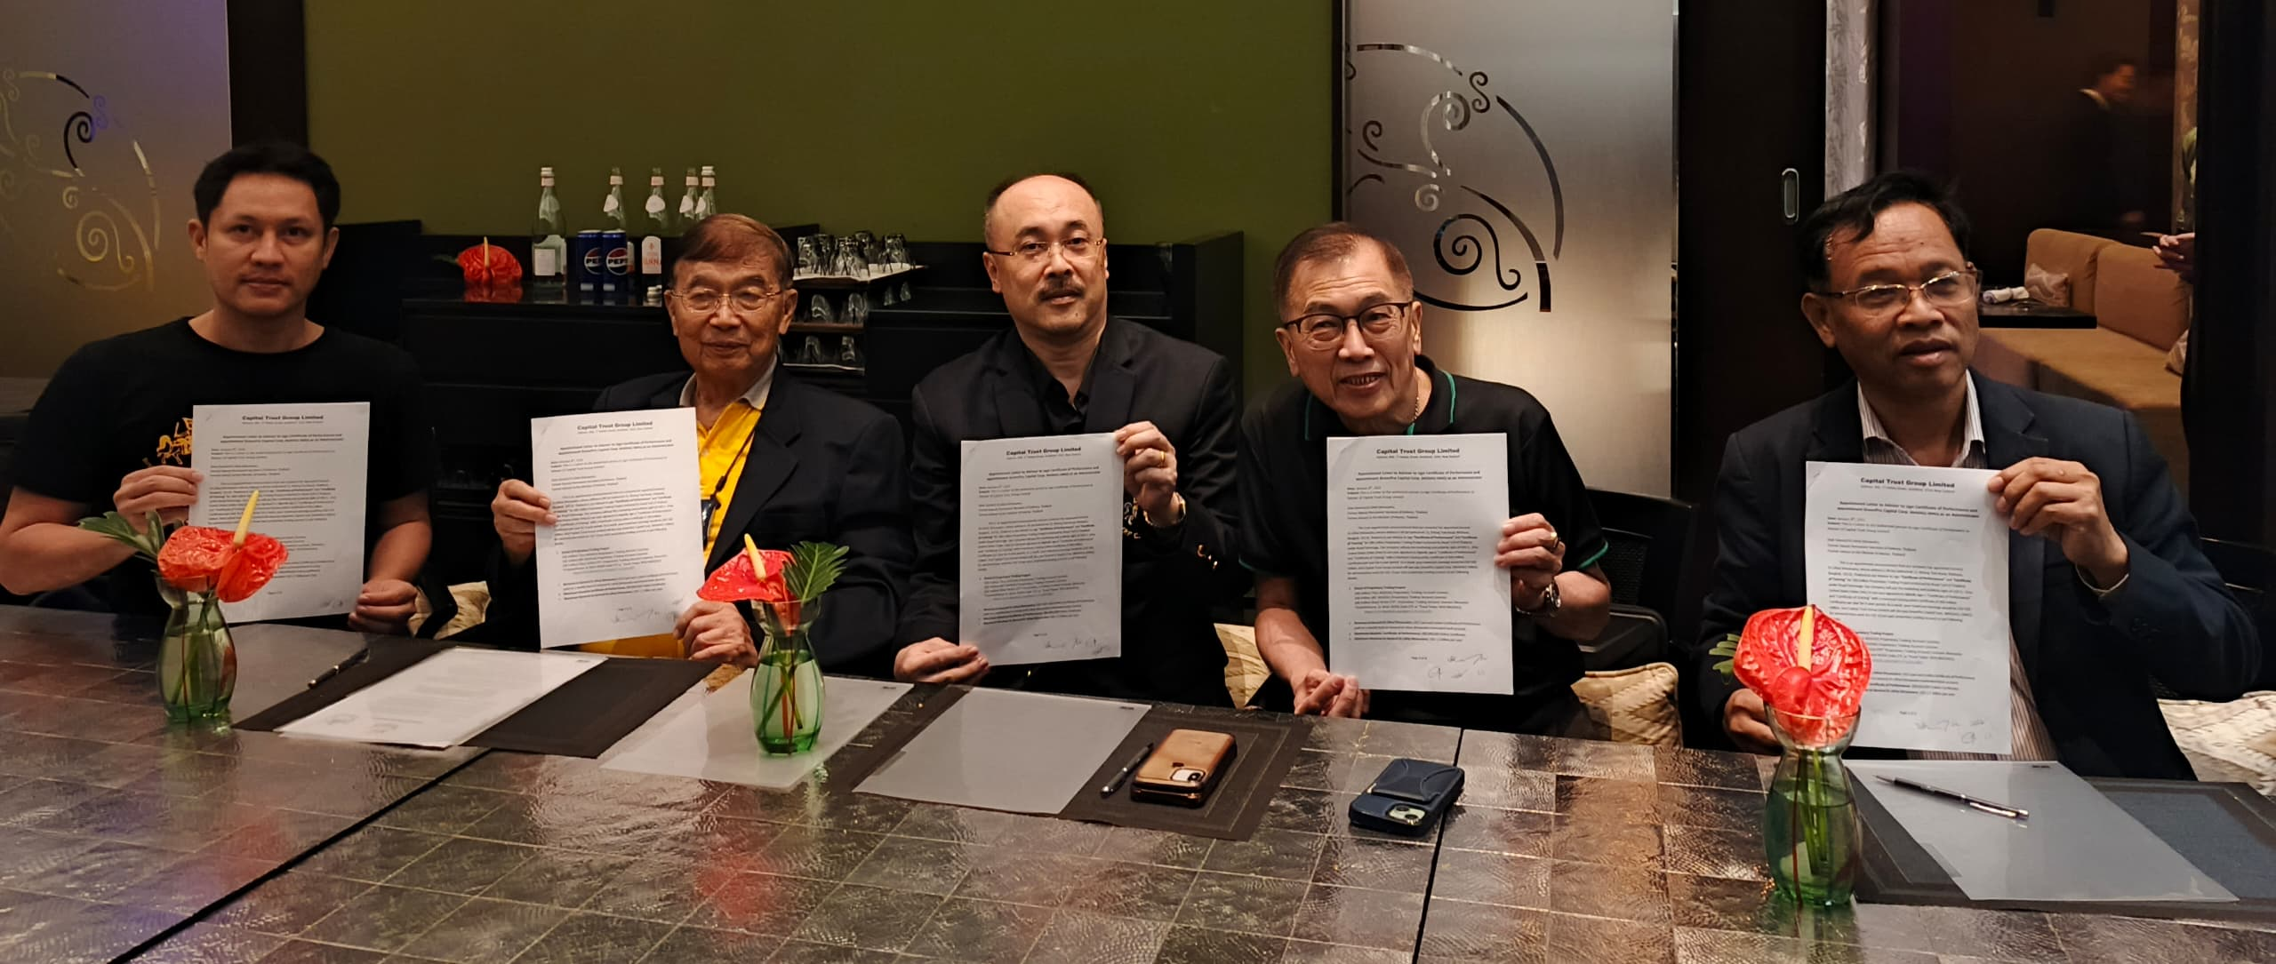
Contributing to the social aspect of the engagement, General Dr. Uthai would also be endorsing free online financial courses that teaches youth and students to build and manage world class investment portfolios, uplift their financial literacy and reduce poverty. Up to 300 million “Certificate of Performance” and “Certificate of Training” carrying the digital signature of General Dr. Uthai, issued by Capital Trust Group (CTG) will be awarded to qualified young generations.
CEO and Co-Founder Dr. CK Lee, said, “we are fully aware of the positive economic impact that Thailand Entertainment Complex will bring to the nation and people of Thailand. Nevertheless, we should also take note the social aspect of the project to be aligned with Thailand’s Sustainable Development Goals (SDG) Roadmap. We are hopeful that a small initiative such as the free online financial courses above will kickstart greater things to come.”

About Capital Trust Group Limited (CTG)
Capital Trust Group Limited is a New Zealand investment management and fintech company specializing in providing white-label EdTech Platform targets to startups to build their social investment networks. https://www.ctgprime.com/

About Greenpro Capital Corp

Headquartered in Kuala Lumpur and a Nevada corporation, Greenpro Capital Corp. (NASDAQ:GRNQ), is a business incubator with strategic offices across Asia. With a diversified business portfolio comprising of finance, technology, banking, and Green-X for STOs, health and wellness as well as 30 years of experience in various industries, Greenpro has been assisting and supporting businesses and High-Net-Worth-Individuals to capitalize and securitize their value on a global scale. This is done through the provision of cross-border business solutions, spinoffs on major stock exchanges and accounting outsourcing services to small and medium-size businesses located in Asia. The comprehensive range of cross-border business services includes, but are not limited to, trust and wealth management, listing advisory services, transaction services, cross-border business solutions, record management services, accounting outsourcing services and tax advisory services. Greenpro also operates venture capital businesses, including business development for start-ups and high growth companies.
For further information regarding the company, please visit http://www.greenprocapital.com.

Forward-Looking Statements
This press release contains forward-looking statements, particularly as related to, among other things, the business plans of the Company, statements relating to goals, plans and projections regarding the Company's financial position and business strategy. The words or phrases "plans," "would be," "will allow," "intends to," "may result," "are expected to," "will continue," "anticipates," "expects," "estimate," "project," "indicate," "could," "potentially," "should," "believe," "think," "considers" or similar expressions are intended to identify "forward-looking statements." These forward-looking statements fall within the meaning of Section 27A of the Securities Act of 1933 and Section 21E of the Securities Act of 1934 and are subject to the safe harbor created by these sections. Actual results could differ materially from those projected in the forward-looking statements as a result of a number of risks and uncertainties. Such forward-looking statements are based on current expectations, involve known and unknown risks, a reliance on third parties for information, transactions or orders that may be cancelled, and other factors that may cause our actual results, performance or achievements, or developments in our industry, to differ materially from the anticipated results, performance or achievements expressed or implied by such forward-looking statements. Factors that could cause actual results to differ materially from anticipated results include risks and uncertainties related to the fluctuation of local, regional, and global economic conditions, the performance of management and our employees, our ability to obtain financing, competition, general economic conditions and other factors that are detailed in our periodic reports and on documents we file from time to time with the Securities and Exchange Commission. Statements made herein are as of the date of this press release and should not be relied upon as of any subsequent date, and the Company specifically disclaims any obligation, to update any forward-looking statements to reflect occurrences, developments, unanticipated events or circumstances after the date of such statement.

GRNQ has 7,575,813 shares issued and outstanding with a float of 4,089,641 shares

Gilbert Loke, CFO, Director
Greenpro Capital Corp.
Email: ir.hk@greenprocapital.com
Phone: +852-3111 7718

Contact Dennis Burns. Investor Relations.
Tel (567) 237-4132
dburns@nvestrain.com
Phone: +603-2201 3192
mycorp@greenprocapital.com
SOURCE: Greenpro Capital Corp.

