PRESS RELEASE

Media contact
Nina Morton
Marketing Manager
Particle Measuring Systems
Tel: 303-443-7100
nmorton@pmeasuring.com

FOR IMMEDIATE RELEASE
The World’s First 20 nm Chemical Particle Counter
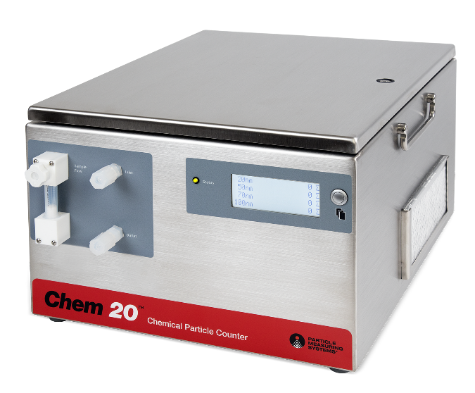
Particle Measuring Systems releases the new Chem 20™ particle counter.
July 12th, 2016, Boulder, CO – Particle Measuring Systems (PMS) has released the world’s first and only 20 nm particle counter for high purity process chemicals. The Chem 20™ has particle size sensitivity of 20 nm with PSL and 9 nm with gold particles.
With PMS’s advanced laser optics and detector technology, this innovative new product detects very small particles not seen with legacy products. The Chem 20 features an on-board chemical flow meter and bubble detector to maximize data quality and protect sensor performance. In another industry first, Chem 20 is offered in two models optimized for low or high refractive index chemicals greatly improving instrument performance and accuracy over existing technologies.
“The Chem 20 enables semiconductor manufacturers to detect yield-limiting particles not possible with lesser technologies“, said Brian Knollenberg, VP for Electronics at Particle Measuring Systems. He continued, “This helps them react quickly to particle excursions long before surface scan or yield data are available. With flexible installation options, Chem 20 can help our customers optimize chemical delivery systems from the loading dock to point-of-process, with improved sample population statistics for tighter process control limits.”
Get more information now.


About Particle Measuring Systems
Particle Measuring Systems Inc. (PMS), a subsidiary of Spectris plc, is a global technology leader in contamination monitoring, the inventor of laser particle counting, and is now the leading provider of solutions for monitoring and controlling many forms of contamination that impact companies that manufacture in ultra-clean environments. For more information on PMS, visit pmeasuring.com.
###

