“This is a definite break, but you have to go through it.”
Dancing avatars, nightmares and Diana Vishneva in the most unusual show of the season
Add to My Ribbon About the service
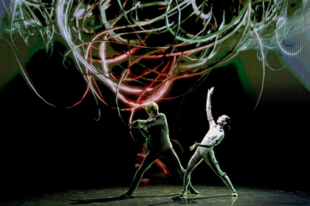
Photo: Alexander Demyanchuk / TASS
On September 14 and 15 at the Mariinsky Theater in St. Petersburg they gave “Dreams of the Sleeping Beauty” with Diana Vishneva as Aurora. The Russian premiere of the most striking and unusual show of the season was attended by the main and subtle connoisseurs of contemporary art, including Alexey Miller and Roman Abramovich . Reviews are the most enthusiastic. “Immersion into the deeper layers of the subconscious”, “the synthesis of digital art, modern dance and advanced technologies”, “electronic music introduces into a trance”, “a breakthrough into the future in the art of dance, which can only be compared with the breakthrough made by Diagel in Russian Seasons” "," Excellence that cannot be surpassed "...

Soft, gentle, very gentle ... Bam!
The Dark Hall of the Lensovet Palace of Culture. Only the scene is illuminated, behind it is a screen that occupies the entire backdrop.
- Three - four - five - six - seven - eight. Bam - pam - pam - pam - pam ... Once again. A bit slower. Elbow above ...
Avatar of eroticism and passion
Edward Klug , the world famous choreographer from Maribor, is conducting a rehearsal.
- Softly, gently ... Getting ready!
Klug jumps onto the stage:
Реклама 05
- Soft, gentle, very gentle ... Bam! Hit!
The club falls sideways on a special ballet cover. It rises and falls back on its side, showing the desired movement again.
There are two pairs on the stage. Diana Vishneva and Marain Rademaker - princess and prince of the first composition and their understudies - Asami Nakashima and Denis Savin .
Vishneva is regal. Each of her movements is honed to such an extent that it becomes completely organic. Organics give confidence, and confidence gives rise to freedom. Vishneva - prima. Here she sets the limits of what is allowed: when you need to do everything with an accuracy of a millimeter, and where you can relax a bit.
Japanese stressed second. Keeps a distance. A clear hierarchy in her blood.
A little aside, Chinese woman Mi Dang is dancing. Looks not older than 22-23 years. It is gradually brought to the basic structure. She will dance in November when the show is shown in her native Vancouver. The Chinese woman is smooth and airy like a shadow in the wind. Formally, she repeats the movements for Vishneva, but she still makes them in her own way. At Diana, each movement is clearly fixed, and the Chinese woman swims and shimmers. For a miniature body, it has a wide and long foot, which allows you to keep balance at the most implausible body tilt angles. And very thin and long fingers.
Plastic paradise
New episode. Corps de ballet dancers raise Diana on thin bamboo poles. Klug jumps onto the stage again, now he is repeating the movements of the dancers, as if unconsciously insuring his leading dancer.

The main thing is always a dance
The episode is over. Small break. I go to a choreographer who looks preoccupied. Edward Klug is a world star and an absolute perfectionist. He works with the Bolshoi Theater, Stuttgart, Amsterdam, London, Montreal. He flew to Petersburg from Les Grands Ballets Montreal to prepare the Russian premiere.
Are you satisfied with today's rehearsal?
Edward Klug: More than satisfied. What you see today is the result of a whole year of our work.
But a year ago, the show was already shown in New York and Florida. What has changed since the first impressions in the USA?
I would say that these are completely different shows. In the USA, we did not have enough time to fully prepare such an ambitious and complex project. To be honest, this has become one of my biggest disappointments.
- 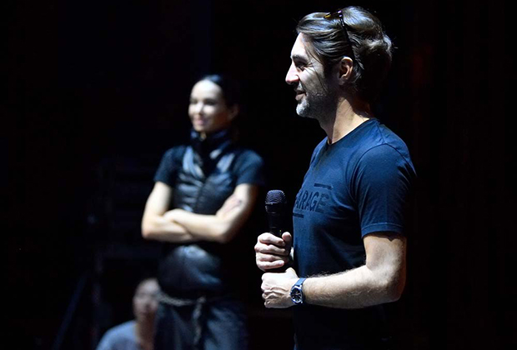
Edward Klug - a world star and an absolute perfectionist
Photo: provided by the organizers
1/4
- 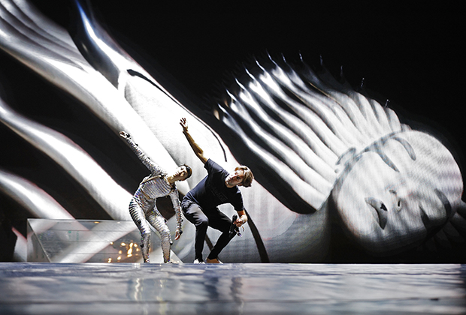
Edward and Asami
Photo: provided by the organizers
2/4
- 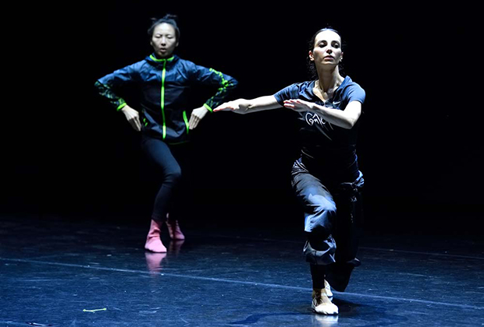
Diana and Mi Dong
Photo: provided by the organizers
3/4
- 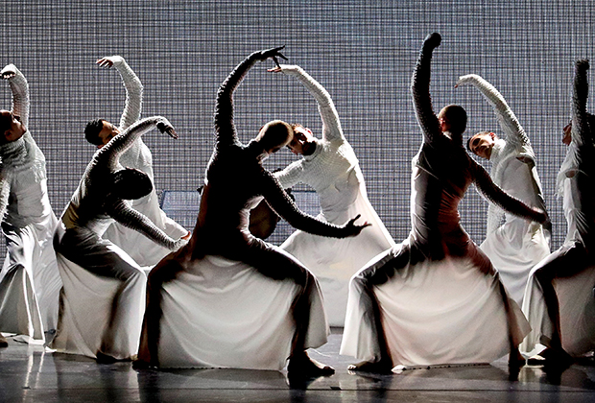
Russian premiere of the ballet show “Dreams of a Sleeping Beauty” in St. Petersburg
Photo: Alexander Demyanchuk / TASS
4/4
But in America, “Dreams” was a success. Were very well received ...
In the USA, we only showed how great this show has potential, but we could not realize it. Now it's time to put together all the elements: choreography, technology, music, costumes, light. The connection and separation of all elements should become organic. The viewer should be immersed in an atmosphere of sleep. And all this, and not just staging dances, I must do. But dance is the main thing. Because visual and sound effects should not destroy the dance, as happened in the USA.

The monster broke free
The rehearsal continues, but now new participants have appeared in it. These are avatars. Seventeen motion-sensitive sensors are mounted on Diana. Their signals are processed in the computer "brain" and transmitted to the screen in several versions of the images, depending on the plot and the emotional component of the dance episode.
Avatars dance with Diana, repeating her movements on a 3D screen in real time. The effect of the full involvement of the audience in the process is created by the very sophisticated Real-Time Digital Avatar technologies, a huge screen and the L-ISA (L-Acoustics Immersive Sound Art) entire system. As a result, outlandish metamorphoses of images from the dreams of Aurora look absolutely real.
Diana is dancing, and the many-armed avatar literally wraps her around in a stuffy nightmare, from which the dancer tries in vain to escape. At some moments, it begins to seem that the monster on the screen has received free will and seeks to devour its mistress. The interaction of a live dance and its projections is so unusual that it fascinates and scares. And this is just a rehearsal!
Demon of fear and horror

The nightmares and horrors of our dreams
While Diana works on stage, Mi Dang enthusiastically plays on the phone - the new generation chooses gadgets, and there’s nothing to be done about it.
Is it hard to dance in this costume?
Mi Dang: There are problems with sensors. Especially during a duet with the prince. When we work in a pair, the sensor can jump off when it contacts a partner. We have to constantly monitor this, protect it, and this distracts from the drama of the dance itself, because the story is developing, and the princess must survive the content of her dreams, passions, emotions, fears ...
What is your relationship with avatars? What do you see in their execution on the screen is very different from what you do yourself?
For me, an avatar is what comes from within me, from my soul and is projected onto the screen. Sometimes it reproduces exactly what it seems to me that I am doing with my body, and sometimes it is different. It shows me from the inside, my fears and my dreams. And I certainly react to this. So it turns out work in a duet - I and he, as it were, our joint work.
The dreams of the sleeping beauty look creepy, they have a lot of anxiety, fears, and is it present in your own dreams?
Yes of course. The fears of our dreams are something that we could not overcome in real life. Dreams is an adventure that can be very difficult to take. Real events are interpreted in our dreams in the most bizarre and fantastic way. In real life, we have the freedom to protect ourselves, and in dreams we are completely helpless and defenseless. There are no limits.
Is it possible, say, to dance a nightmare? To translate the potential energy of fear into the kinetic energy of dance and free yourself from it?
Yes. I think yes. Fear is very deep in us. If you want to overcome it, then you should let it out. From the inside to the outside. Free yourself from the energy of fear that lurks within you. In dance, you can reveal your experiences. And this can be an effective way to deal with fear.
There is a theory of body language. You are a professional. Can you control your body language?
Yes of course. I am a professional dancer, I learn to speak with my body, I learn to control it and constantly monitor it. To show something, I don’t need to talk about it loudly, I can do it with my body. Dance is always the whole story.
Ed Ratnikov on "Dreams of a Sleeping Beauty"

Nobody has done this before.
Another short break. It's time to turn to technology. They are at the site run by Americans Rich Barr and Jeremy Ferland.
How does it work guys?
Rich Barr: Wi-Fi touch sensors read information about the artist’s movements and transmit it to a computer. This is our brain. It processes the signal and creates a projection in the form of an avatar on a display that occupies the entire backdrop of the scene. An avatar can acquire different images, but at the same time it repeats the movements of the person who is dancing. That is, we, combining technology with a dancer, get an avatar that begins to live on the screen.
At the same time, the multi-channel sound reinforcement system L-ISA Audio System immerses viewers in the sound space due to additional systems for expanding the sound stage and channels of spatial effects.
Before us, such a scheme was created only stationary, and it worked only on the site where it was mounted. Our task is to create such a space that can be integrated into any sphere, whether it be a concert hall, a classical opera and ballet theater or a stadium.
And if the sensor falls off?
If the battery falls off, we can handle it, but if the sensor falls, it will no longer control any part of the body, and this is a problem. An avatar may lose a leg or arm. Therefore, we carefully strengthen and test everything before the show. But if this does happen, the show will continue, and most likely people will not even notice it. As a last resort, we can replace some part of the live show with a recording and solve this problem.
Is there a delay between the movement of the dancer and the reaction of the avatar?
There was a second in America - and this could be seen. Now the delay is half a second, and it is almost not noticeable.
Does site size matter?
We have options for arranging shows for different venues. Here in St. Petersburg everything is designed for a small hall, and in Moscow the screen will be almost twice as large. Technologies make it possible to make shows in the open air. All this is transported on two or three tracks. In Russia - three, in America - two, because they are bigger there. We can rent video, light and L-ISA on the spot, and we carry the “brain” everywhere with us wherever we go.
Demon of power and aggression
Will technology soon kill classical ballet?
Jeremy Ferland: I think not. But we have already entered a new age of technology, and they are gradually changing the space around us, being introduced into all areas, including ballet. With today's technology and modern dance, you can do a lot of things.
Your show has a live dance, a live avatar, and music?
Rich Barr: All the music is composed and recorded in the studio especially for this show by the very famous trio from the Netherlands Noisia. But she is not frozen, thanks to the L-ISA, she moves with the dancer in the process of changing his position on the stage. That is, if the dancer moves to the edge of the stage, the music moves behind him.
And what was the hardest thing to do?
Jeremy Ferland: The most difficult thing is to create a team of like-minded people, because everyone who participates in this project has their own experience and their own vision of the result. Classical choreography, modern dance, and the latest technologies are intertwined here, but in order to combine all this and make one big show, everyone should speak a common language. A year ago, this did not work in America, now everything is much better.

And goosebumps...
“Last year in the United States, we took only the first test step,” enters the conversation Project Manager (Chief Executive Officer) Eduard (Ed) Ratnikov . He is the president of TCI, one of the largest concert agencies in Russia, who has just brought Rammstein and Jennifer Lopez to us .
- The tight deadlines for preparation were then dictated by a tight budget, because if you do everything supercomfortably and evolutionarily, honing the idea, bringing it to perfectionism, it will take months of work. And this, in turn, is months of equipment rental, months of people, artists, and a hellish budget.
The premieres of Dreams in the USA were pretty good, and we made sure that the project had great potential. Since then, we have replaced some people, added something, changed something, finished up roughnesses, filled in the voids that should carry their mission psychologically and associatively ... Those who see our show should have an absolute reading of the process into one single global component.
Before we begin to storm the world, we are all running around and honing. So everything is going according to plan.
You lead one of the largest and very successful concert agencies in Russia, why did you take on this project?
I like everything about this project. I like the fact that one of the best prima ballerinas in the world Diana Vishneva, the coolest choreographer Edward Klug, takes part in it. I like that this is a technologically revolutionary show. I like that a well-known story is told by us from a completely unusual angle. Theis de Vliger, known for his work at Nosia, wrote great music. In places, goosebumps run across the skin, in places it just becomes scary, the edge of reality is erased - and people get the impression that they are inside a dream. I like everything in this story, we took it out, brought it up, tried to implement everything that was intended and are now ready to present it to a large audience.
Ed Ratnikov on "Dreams of a Sleeping Beauty"

What do you dream of, Princess Aurora
The tale of a sleeping beauty has existed in the oral European tradition for several centuries. In 1697, it was recorded and published by Charles Perrault . Half a century later, the Grimm brothers presented their version. In 1890, the ballet Sleeping Beauty to the music of Pyotr Ilyich Tchaikovsky was staged by Marius Petipa . In 1930, the Soviet director Sergei Vasiliev made the film of the same name. Thirty years after this, "Sleeping Beauty" in the form of a cartoon drawn released Walt Disney .
These are only the most famous versions of reading the story of Princess Aurora, which can be typed already hundreds. And for all this time no one has ever wondered: what did she dream about?
Aurora slept a hundred years. One hundred years of slow and fast dreams. Slow, dark and empty dreams, like death itself, and fast - filled with passion, horror or rapture, joy or fear, sensual, erotic, with forebodings and nightmares, dreams about the past and future.
Seven p.m. The rehearsal ended, and I had the opportunity to talk with the main star of the show, one of the best dancers of our time, Diana Vishneva.
- 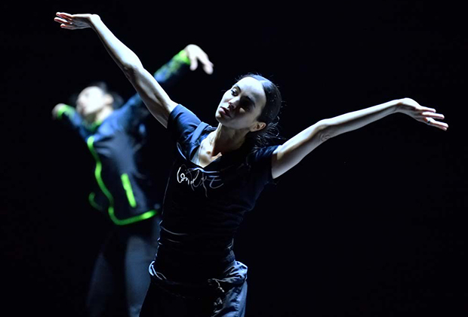
Diana and Mi (in defocus)
Photo: provided by the organizers
1/4
- 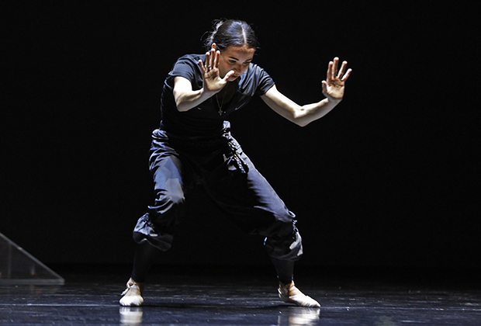
To
Photo: provided by the organizers
2/4
- 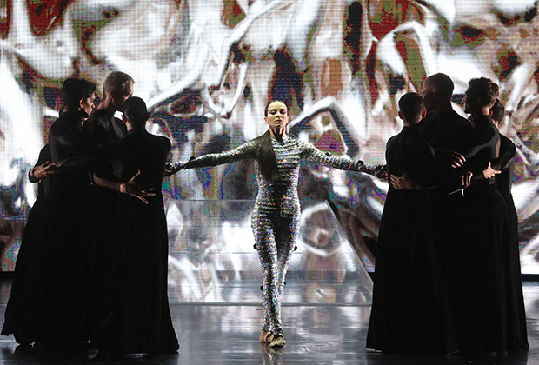
Russian premiere of the ballet show “Dreams of a Sleeping Beauty” in St. Petersburg
Photo: Alexander Demyanchuk / TASS
Russian premiere of the ballet show “Dreams of a Sleeping Beauty” in St. Petersburg
3/4
- 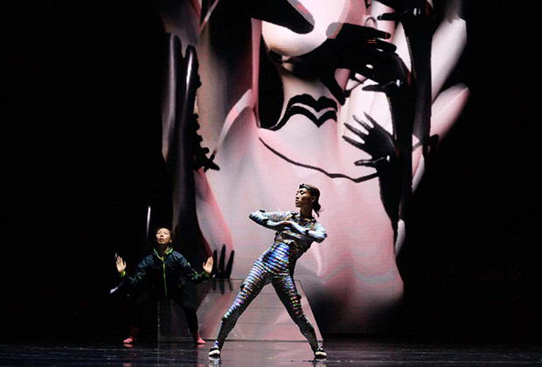
Asami and Me
Photo: provided by the organizers
4/4
Dreams of a sleeping beauty, how do you feel about dreams?
Diana Vishneva: I try to be serious. Of course, I do not keep any notes, but dreams are important to me, I try to unravel them. For example, let's say you didn’t remember a person for a long time, and he suddenly dreamed of you, and you understand that he dreamed for a reason. You understand that there is some kind of connection with the cosmos and that means something.
Do you believe in prophetic dreams?
I do not particularly believe in prophetic dreams. It has never happened to me that I dreamed of a picture - and then it is duplicated for life, but I believe in the interpretation of dreams. If I have a dream before the performance, I can interpret it a little. Imagine what will happen to me at the play. Sometimes this is due to the fact that the brain is overloaded, a nervous state and it is difficult to relax. Today, I suddenly dreamed of Giselle. It was here that I dreamed about measures. And for some reason, before the start of the performance, I break the ballet shoe, and it becomes soft. I need to go out, but instead of pointe shoes I have a soft shoe and no other ballet shoes. This is a real nightmare in which you need to find meaning, somehow interpret it.
Sometimes dreams are visions, sometimes nightmares, sometimes anticipation, sometimes they lead you somewhere ... I know what dreams I have before a disease or before the death of a friend. There are some recurring dreams.
Ed Ratnikov on "Dreams of a Sleeping Beauty"
You have been dancing the classical ballet Sleeping Beauty for a very long time. Is there anything that you brought here from that ballet?
I was a classic Sleeping Beauty, but nothing in common ...
So this is a completely different story?
I do not use anything, but I have a given. It is deep in me. There is my shape, my classic body, there is experience. And it enriches me. That is, the choreographer is more interesting with me. Not everyone is ready for experiments when you need to forget everything that was with you before. This is a definite breakdown, but you have to go through it ... The person who dances this performance without dancing the classic "Sleeping Beauty" looks different.
Are you a cautious person?
I am careful. Always look around first before diving and making my choice. I dive with my terms, you see. I will not adapt to the system, but I will try so that the system does not injure me and does not change my path. Therefore, I am very scrupulous about the choice of the project, and with what kind of person I work ... or not work. I make a choice to be able to remain free and sincere. And I really value freedom and protect it. Therefore, I am very free.
A full interview with Diana Vishneva will be released on Lente.ru in the near future. In the meantime, do not miss the opportunity to see the “Dreams of the Sleeping Beauty” with your own eyes on September 20 in the Moscow hall of the Crocus City Hall.

