

PRESS RELEASE
FOR IMMEDIATE RELEASE

iXsystems Expands TrueNAS Product Line with
R-Series Systems and Scale-out HCI Software

R-Series Appliances Deliver Open Source Economics to Enterprise
Storage while TrueNAS SCALE Removes Barriers to Growth

SAN JOSE, CA – October 20, 2020 -- The TrueNAS Open Storage portfolio expands with the TrueNAS R-Series storage systems and the TrueNAS SCALE Open Source HyperConverged Infrastructure (HCI) software. The new R-Series storage systems include four models designed for maximum density, performance, Open Storage flexibility, and cost savings. TrueNAS SCALE introduces easy-to-manage hyperconvergence based on scale-out OpenZFS.

TrueNAS R-Series Storage Systems
The TrueNAS R-Series combines the advantages of purpose-built storage systems with the flexibility of TrueNAS, the world’s most popular storage OS. The R-Series includes the ability to run any of three TrueNAS software editions:

TrueNAS CORE: Free and Open Source, the Community edition, formerly known as FreeNAS, supports File, Block, Object, and Application storage.
TrueNAS Enterprise: The feature-rich Enterprise edition with Enterprise-grade support provides additional security, Fibre Channel, and Enterprise integrations.
TrueNAS SCALE: The new hyperconverged edition includes scale-out ZFS, KVM, and Kubernetes.

Unlike proprietary alternatives, the R-Series is designed to provide industry-leading CapEx/OpEx storage economics, performance, deployment flexibility, and storage density. Each of the TrueNAS R-Series models feature IntelⓇ XeonⓇ Scalable CPUs and can be configured with the processing, memory, and networking needed to deliver up to 100 Gb/s of storage performance:

- TrueNAS R50: High capacity 4U with 48 x 3.5" & 4 x 2.5" NVMe Bay, and up to 890 TB capacity. The TrueNAS R50 can also scale-up to 3PB and then scale-out to 300PB.
- TrueNAS R40: High density 2U all-flash system with 48 x 2.5" Bays, and up to 360 TB of flash capacity.
- TrueNAS R20: Power efficient 2U with 12 x 3.5" and 2 x 2.5" Bays and up to 230 TB capacity.
- TrueNAS R10: Compact 1U all-flash system with 16 x 2.5" Bays and up to 120 TB of flash capacity.

“In my experience, looking for the right storage solution at the right price can be a daunting task, with some providers charging premiums per feature and others burying those premiums into over-inflated support bundles that approach the cost of the system itself,” said Peter Boleski, IT Infrastructure Manager, INFINITT North America, Inc. “With iXsystems’ TrueNAS, the vast array of features are included and the systems are priced fairly, so I don’t need to worry about a pay-per-feature approach, artificial capacity limits, or unreasonable support costs. We’re building a cost-effective storage environment with a full suite of features throughout our data centers, with confidence our data will be safe on the robust OpenZFS file system.”

R-Series pricing starts at under $4,000 and grows with processing and storage capacity. All-flash system prices of less than $300/TB are provided with TrueNAS SCALE software included.

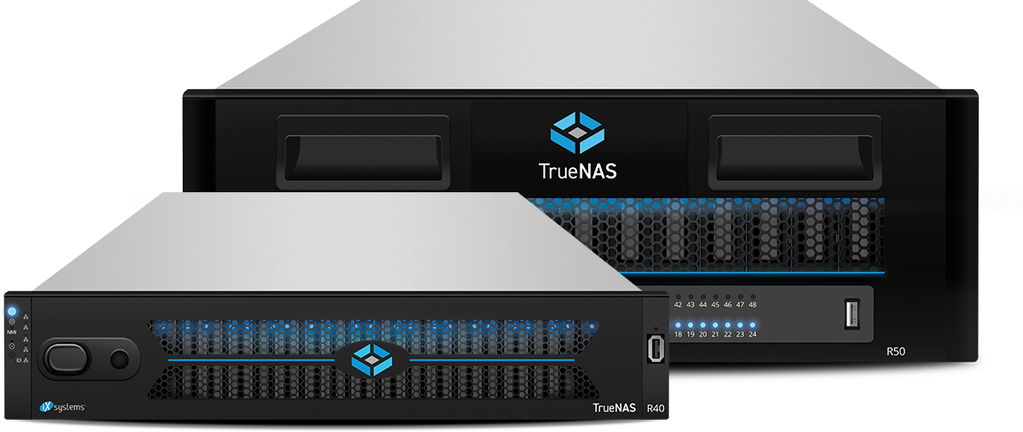

TrueNAS SCALE Hyperconvergence

iXsystems is also announcing the first release of TrueNAS SCALE: a unique, easy to manage HCI platform for converged compute and scale-out Open ZFS storage. TrueNAS SCALE is available as Open Source software built atop Debian Linux, or as an appliance-based solution that combines TrueNAS SCALE with purpose-built systems, including High-Availability (HA) systems like the X-Series, M-Series, or the all-new R-Series systems. The Open Source economics of TrueNAS SCALE changes the existing HCI playing field.

TrueNAS SCALE Open Source HCI addresses the cost of scaling compute and storage with all of the advantages of Open Storage, Open Virtualization, and Open APIs. The TrueNAS-based technology is backed by a community of more than 250,000 users worldwide and applies Open Source economics to deliver ultra-low capital and operational costs. The platform uses best-of-breed components that deliver SMB and NFS File Sharing, iSCSI Block Storage, S3 Object API integration, and Cloud Sync with public cloud storage like S3.

Unlike other HCI platforms, a user can get started with TrueNAS SCALE on a single node and incrementally scale up and scale out to over 100 storage nodes with many additional compute-only nodes. TrueNAS SCALE is true Disaggregated HCI, meaning storage and compute can be scaled independently. Each node can support Virtual Machines (via the KVM hypervisor) as well as Docker containers via native Kubernetes.

"I have long admired iXsystems for its well-engineered storage systems and its leadership in Open Source storage. The new iXsystems TrueNAS SCALE Open Source operating system and R-Series arrays enable iXsystems to address much higher capacity storage environments," observes Ken Clipperton, Lead Analyst, Storage, DCIG. "TrueNAS SCALE creates even more value by delivering both enterprise NAS and disaggregated hyperconverged infrastructure. TrueCommand management software--running locally on TrueNAS or in the cloud--further drives down cost by simplifying the management of large TrueNAS deployments."

"TrueNAS is enabling a new era in Open Storage for businesses in every sector that have requirements for reliable, secure, and agile data access while removing the limitations of proprietary storage," said Brett Davis, Executive Vice President, iXsystems. "TrueNAS systems and solutions democratize enterprise storage by providing best-in-class platform choices combined with Open Storage software to deliver ‘Storage Freedom’ and Open Source economics to our customers around the globe."

To learn more about how TrueNAS Open Storage can help your organization, contact us via https://www.truenas.com/contact-us/, or give us a call at 1-855-GREP-4-IX.

Tweet This: iXsystems Expands TrueNAS Product Line with R-Series Systems and Scale-out HCI Software - https://www.ixsystems.com/press-releases/

Additional Resources:
● To learn more about TrueNAS Open Storage, visit: https://www.truenas.com
● Follow TrueNAS News on Twitter at: http://twitter.com/iXsystems

About iXsystems and TrueNAS
Through decades of expertise in system design and development of Open Source software (FreeNAS, FreeBSD, OpenZFS, and TrueNAS), iXsystems has become an innovation leader in high-availability storage and servers powered by Open Source solutions. With over one million deployments and backed by the legendary ZFS file system, TrueNAS offers the stability and reliability required for Backup, Multimedia, Cloud Hosting, Virtualization, Hyper-converged Infrastructure, and much more. Since the founding of iXsystems in 2002, thousands of companies, universities, and government organizations have come to rely on the company’s enterprise servers, TrueNAS Open Storage, and consultative approach to building IT infrastructure and Private Clouds with Open Source economics.

- END -

