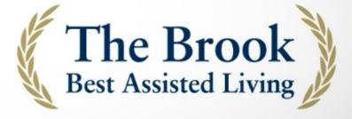
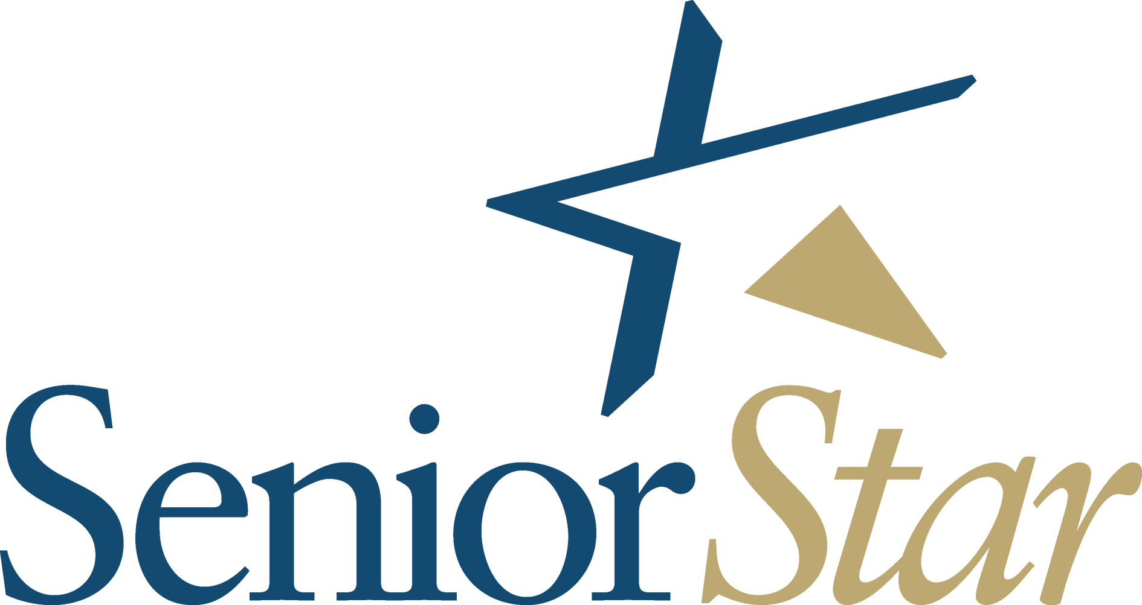
_________________________________________________________________________
FOR IMMEDIATE RELEASE
Media Contact:
Dionicia L. McCallum Kelley, Senior Star Marketing Director
918-938-1306 or dmccallumkelley@seniorstar.com

U.S. News & World Report Names Senior Star at The Brook a 2022-23
Best Assisted Living Community
Senior living community part of inaugural U.S. News Best Senior Living ratings

Davenport, IA (May 10, 2022) – Senior Star at The Brook announces today that it has been recognized by U.S. News & World Report as a 2022-23 Best Assisted Living Community.

The inaugural U.S. News Best Senior Living ratings and profiles offer comprehensive information and exclusive analysis of consumer satisfaction data evaluating factors including community & activity, food & dining, caregiving, and management & staff for nearly 2,500 communities in the continental U.S. and Hawaii.

Senior Star at The Brook is one of the senior living communities recognized by U.S. News that earned “Best” status by achieving the highest possible rating for Assisted Living. “We are honored to be part of U.S News & World Report’s inaugural Best Senior Living ratings,” said Anja Rogers, Senior Star CEO. “These results provide valuable information from our residents and families letting us know we are doing our job well. I’m also proud that this recognition aligns with our vision to be A World of Difference Makers committed to exceeding the expectations of residents who choose to reside with us as well as their loved ones who entrust us with their care.”

U.S. News awards the designation of Best Senior Living only to those communities that satisfy U.S. News’s objective statistical assessment of each senior living community’s performance from consumer satisfaction surveys administered between March 2021 and February 2022, reflecting the viewpoints of more than 200,000 current residents and family members of residents living in thousands of senior living communities nationwide.

For more information behind the data analyzed in the U.S. News ratings for Senior Living, please refer to the methodology. For more information about Senior Star at The Brook, 918-756-1253 or visit the website at https://www.seniorstar.com/the-brook/.

###
About Senior Star at The Brook
Senior Star at The Brook a part of Senior Star, a family-owned company founded in 1976 that has become a nationally recognized industry leader for providing quality and innovative services to America’s seniors. The Senior Star mission to unite as exceptional stewards for seniors and those who love them, and serve as thoughtful spokespeople for senior living. The portfolio includes 8 retirement communities in four states offering independent living, assisted living, memory support and nursing care. For more information, visit https://www.seniorstar.com.

About U.S. News & World Report
U.S. News & World Report is the global leader in quality rankings that empower consumers, business leaders and policy officials to make better, more informed decisions about important issues affecting their lives. A multifaceted digital media company with Education, Health, Money, Travel, Cars, News and 360 Reviews platforms, U.S. News provides rankings, independent reporting, data journalism, consumer advice and U.S. News Live events. More than 40 million people visit USNews.com each month for research and guidance. Founded in 1933, U.S. News is headquartered in Washington, D.C.

