What you do when you help ShortstackTM…
Shortstack is not just about modeling and young girls accomplishing a dream of walking
an actual runway in front of 300 guests and a jam packed photo pit.
Shortstack is an 8-month long self-esteem and modeling program for girls who do not meet
the “normal” standards of the fashion industry. Through innovative and interactive workshops, we teach them how to love themselves for who they are.
For years, girls have been rejected from the industry because they do not fit a certain criteria.
Shortstack was created to change those standards, so in order to join Shortstack, all girls must be 4’8” to 5’6” tall, 14 to 22 years of age, and weight nor experience, are a factor.
Girls accepted into the program will be taught lessons on self-esteem, confidence,
healthy habits and body image, along with tips and advice on how to pose for cameras, walk a runway, participate in professional photo shoots, take part in interviews, and much more.
Aimed at building self esteem, we like to think of their first walk down the 56’ foot runway
as a graduation. Photo shoots with various photographers, community service, fundraising events, and of course fashion shows are all a part of the Shortstack program to give its models what they need to forge ahead into the world with added confidence.
This coming June 2016 Shortstack will be holding its 10th Annual Charity Fashion Show in New York City to benefit Windows of Opportunity, Inc.
Windows Of Opportunity, Inc. A 501c-3 non-profit organization creating a shift in what is possible for youth in the areas of leadership, empowerment, self-esteem, school performance and career planning... A shift from
dis-empowerment, differences, and indecision to possibility, acceptance and opportunity.
Find out more at: www.wooinc.org
Our success depends on the generosity of our sponsors… WE NEED YOUR SUPPORT.
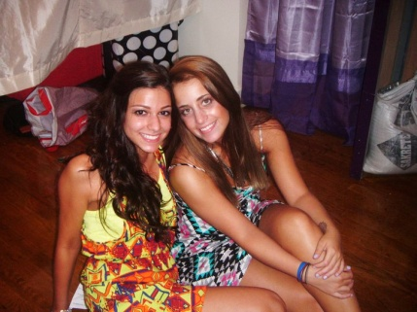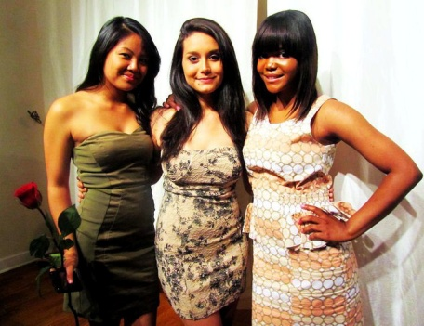
For more information on the different ways that you can support the Shortstack program and the many ways we give back please visit: www.wooshortstack.org
Find us on Facebook at: www.facebook.com/wooshortstack

