NanoTech Gaming Brings “Vegas 2047” Skill-Based Gaming Machine To G2E 2015
“Vegas 2047” is High limit Advantage Play Video Pinball for the intelligent gambler.
LAS VEGAS, September 3, 2015
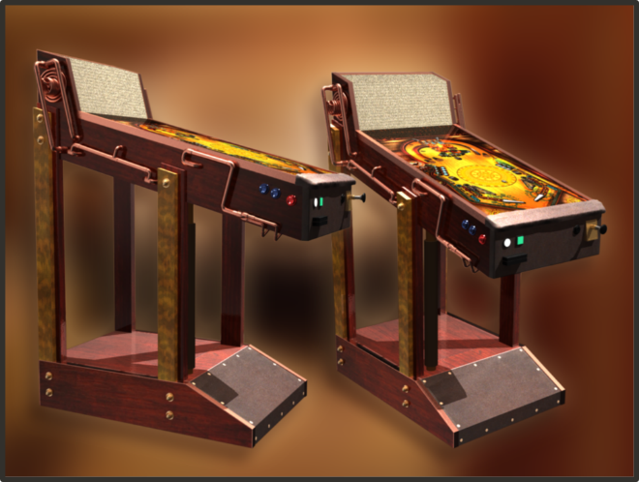
NanoTech Gaming (OTCPINK: NTGL) brings the ‘Future of Gaming’ with “Vegas 2047” to the Global Gaming Expo (G2E) on September 29 to October 1, 2015, where the element of skill is a key for players to unlock a player edge. This unique player edge does not expose the casino to losses any more than any other purely negative expectation game.
“Vegas 2047” is designed with the professional gambler in mind, the likes of whom will enjoy lifetime winnings in the millions of dollars. With baccarat’s surge to dominance in Las Vegas, lucky Asian gamblers are comfortable making $100,000 and larger single bets. For the Western gambler ready to demonstrate their skill to win big money, “Vegas 2047” is poised to enable their high limit Bets where previously there was no motivation for them to play high limit table games.
“Vegas 2047” targets a new demographic: one that includes the competitive video game player, the gambler who does research to seek out positive EVs, and those who are enthusiastic about casual pinball gameplay. All of these attributes are specifically within a player who is a more intelligent Western style player.
The “Vegas 2047” machine is hand-crafted out of quilted maple and red oak wood. Polished copper and brass fittings accentuate the game’s steampunk visual style. A real leather locking-bar – where the player’s hands rest during play – and leather kick-plate finish this one-of-a-kind luxury piece of art.
NanoTech Gaming debuted “Vegas 2047” at G2E 2014. Michael Shackleford, also known as “The Wizard of Odds”, wrote that, “Vegas 2047 Pinball was by far the most innovative idea at the show. After the last ball is gone, a wheel will spin on the game, with winning and losing sectors. Depending on the player's ratio of winning goal to bet, his performance in the pinball game, and the performance of other players, the size of the winning slices will be adjusted. If the wheel stops in a winning slice, the player wins.”
For more information, visit NanoTech Gaming at booth 4116 at G2E, and the “Vegas 2047” page at: http://nanotechgaming.com/vegas2047.pdf

About NanoTech Gaming
Headquartered in Las Vegas Nevada, the global center of the gaming industry, NanoTech Gaming is a revolutionary company that focuses on all aspects of the development of gaming products. NanoTech Gaming creates the world's most compelling gaming experiences by using patent-pending math models and non-traditional designs. NanoTech Gaming builds products for both traditional players as well as a new class of gambler that is intelligent and informed offering the ability to realize life changing winnings while continuing to offer operators exactly the House Edge they need to operate their business. Based on extensive research of modern social and competitive games, NanoTech Gaming’s machines allow players to choose exactly how they want to balance their skill and intelligence against the risk / reward model of the game. Players enjoy compelling video experiences that are entertaining independent of the gambling component. More information about NanoTech Gaming and its products can be found on the web at www.NanoTechGaming.com.
"Safe Harbor" Statement: This press release contains forward-looking statements, including expected industry patterns and other financial and business results that involve known and unknown risks, uncertainties and other factors that may cause our actual results, levels of activity, performance or achievements to differ materially from results expressed or implied by this press release. Such risk factors include, among others: the sustainability of recent growth rates in of the company; the positioning of NanoTech Gaming, Inc. in the market; ability to integrate both developed and acquired companies and technology; ability to retain key employees; ability to successfully market product offerings and customer acceptance of products; general market conditions, fluctuations in currency exchange rates, changes to systems and product strategy by vendors of systems; and whether NanoTech Gaming, Inc. can successfully gain market share. Actual results may differ materially from those contained in the forward-looking statements in this press release. Since this information may contain statements that involve risk and uncertainties and are subject to change at any time, the company's actual results may differ materially from expected results.
NanoTech Gaming Labs, NanoTech Gaming Ball, NanoTech Gaming Dice, 1337, Vegas 2047, NanoTech Advantage, NanoTech Bet Cube, Game Flow, HVS, High Limit Advantage Play, XRR, Pinball Wizard, MultiPin, Mot-Ion, OptiGun, Retr-IO, aAMP, Jumper, Masher, CMYK and their associated logos are trademarks of NanoTech Gaming. "The Future of Gaming" is a Service Mark of NanoTech Gaming. All rights reserved. All other marks are the property of their respective owners.
NTGL Contact: Aaron Hightower
Phone: (702) 577-2895
Email: ahigh@nanotechgaming.com
Investor Contact: Dan Wong
Phone: (858) 381-4622
Email: dan@nanotechgaming.com

