FOR IMMEDIATE RELEASE:
February 25, 2021
Ryan Hodgens
Asylon, Inc.
(916) 218-2450
rhodgens@flyasylon.com

Asylon Welcomes Former FAA Acting Administrator Dan Elwell Onto Advisory Board
Drone and robotic security company continues to work with industry leaders

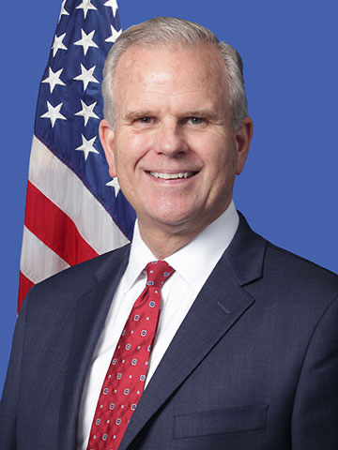
Philadelphia, Pennsylvania — Asylon, Inc., an American unmanned aerial system (UAS) and robotic perimeter security company, is pleased to announce former United States Federal Aviation Administration (FAA) Deputy and Acting Administrator Daniel K. Elwell as an official member of the board of advisors.

As the Deputy and Acting Administrator within the FAA, Mr. Elwell was responsible for managing the safety and efficiency of civil aviation within the United States. In addition, Mr. Elwell helped usher in a new breed of aircraft — UAS. This came at a time when commercial demand, application, and capability of UAS skyrocketed.

Mr. Elwell played a crucial role in the UAS industry through working to develop the Department of Transportation (DoT) UAS Integration Pilot Program (IPP), serving as the government’s designated official for the Drone Advisory Committee (DAC), and creating rules surrounding UAS remote ID and operations over people.

“As an American UAS security company who has partnered with the FAA on these new programs, Asylon has been proving the use-case and is set to expand and help lead the UAS security industry in complex operations. I’m excited to join their advisory board to work with them and continue to develop safe and effective UAS policy.” said Mr. Elwell.

Having retired from the FAA, Mr. Elwell is now dedicating his efforts toward American innovation, UAS, and aviation. He recently joined the Alaskan Airlines Board of Directors as well.

“Over the last few years, we’ve conducted over 5,000 automated UAS missions for our customers. There are significant ways to provide even more value to our customers and effective UAS policy to further enable proven technologies like ours is a key part in doing so. We’re excited to have Dan on-board to support continued progress on UAS policy and regulation for Asylon and the industry as a whole.” said, Damon Henry, Co-Founder and Chief Executive Officer at Asylon.

With their patented DroneCore system, Asylon has been a pioneer of UAS and robotic security within the United States. As one example, through the FAA’s UAS Integration Pilot Program (IPP) and BEYOND program, they launched the first UAS automated security program near a major airport within the United States. As the system operates currently at Memphis International Airport, FedEx is using Asylon’s DroneCore product to conduct automated security missions to help protect their assets as part of the program.

DroneCore systems are operating on a daily basis at Fortune 500 sites in the industrial, manufacturing, and logistics industries. To enable expanded and more complex operations, Asylon is working closely with the FAA as they scale with their customers.

The introduction of Mr. Elwell onto the board of advisors at Asylon brings extensive knowledge and background in UAS policy and will support an effort to expand the capabilities American UAS manufacturers can offer.

About Asylon:
Asylon is based in Philadelphia and was founded in 2015. The team is made up of world class experts in the UAS, security, and robotics space coming from distinguished backgrounds such as Lockheed Martin, L3 Communications, Boeing Aerospace, Johns Hopkins University Applied Physics Lab, UTC, Intelligent Drone Systems, WhiteFox Defense Technologies, United States Air Force Security Forces & MIT.

Asylon manufactures & deploys the DroneCore System as an end-to-end white glove service for advanced perimeter security. DroneCore is a combination of hardware and software designed to streamline security efficiency, conduct automated operations, and gather vital real-time intelligence. The system is an American Made, fully automated perimeter security drone platform operating as a robotic, aerial and ground guard to serve as a primary perimeter security deterrent and first responder. Customers are leveraging unprecedented value from Asylon's DroneCore system by automating their routine perimeter patrols, integrating ground and aerial robotics into their existing security technologies to provide automated alarm response (which makes their legacy technology investments smarter) and receiving double digit ROI against their current security posture.

LinkedIn
Facebook
Twitter
Instagram

