FOR IMMEDIATE RELEASE
September 28, 2020

CONTACT:
Katina Fields
Jade Marlin
714-865-5690
Katina.jademarlin@outlook.com

LONG CELEBRATED FASHION DESIGNER TELLS FACINATING STORY IN NEWLY RELEASED BOOK
Jade Marlin Pens His Life Journey in ‘Beyond The Threads’
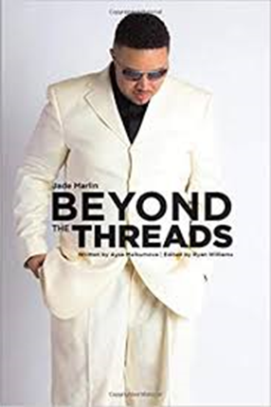
LOS ANGELES — Fashion Designer Jade Marlin newly launched his first book Beyond The Threads. Published Nov. 14, 2019, the book focuses on how his great dream and vision of being a successful designer and his brand collection came to life. After successfully launching his clothing brand in 2005, Jade Marlin wanted to share his journey and secrets to building his fashion empire, and paving his path to a successful career.

Beyond The Threads is an astonishing book about Jade’s dream to make it big in the fashion industry. He shares his unyielding journey, in which he believes every aspiring fashion designer and entrepreneur should know and learn; in that dreams can come true, if you have the determination to chase them.

“This was an exciting experience for me, as I put my heart and soul into this book,” said Jade Marlin. “With the help of my Co-Writer Aysa Melkumova, I was able to really capture the trials and tribulations of my journey, in hopes to motivate and inspire other young fashion designers and entrepreneurs to stay focused, determined and persistent in order to achieve their dreams.”

Jade Marlin is a prominent fashion designer. His menswear collection is heavily influenced by historical roots in sport and classic, and urban menswear. The clothing range, including the iconic slim fit polo shirt, blends British style with the edge and attitude garnered from the brand’s unique streetwear credentials. While his designs have been featured in magazines like Shimmer, Cliché, Obscurae, and Dream Fashion, Jade Marlin collection has also been featured on other media platforms.

Beyond The Threads can be purchased at Barnes and Noble, Walmart, Amazon, Lulu and Google Books.

# # #
Please Note: Follow Jade Marlin on Twitter, Facebook and Instagram. For more information about Jade Marlin visit www.jademarlin.com and www.jademarlinhome.com. Videos are also available to watch on YouTube at https://youtu.be/TMelIXRKV6A.

