Ascent Vision Technologies Delivers Latest X-MADIS CUAS Systems to US DoD Customer
May 13, 2020, Bozeman, Montana…. Last week, Ascent Vision Technologies (AVT) completed the delivery of several units of the eXpeditionary Mobile Air Defense Integrated System (X-MADIS) to a non-disclosed US DoD customer. The delivery, part of a major contract award, included the latest variant of the X-MADIS, which incorporates cutting-edge technology innovations for improved portable, on-the-move capabilities in combating small Unmanned Aerial Systems (sUAS).
To provide forces with greater protection against hostile sUAS, the latest variant of the X-MADIS offers superior situational awareness by combining radar with a Radio Frequency (RF) detection sensor. Multiple detection methods ensure no sUAS threat goes undetected, while offering greater reliability in detection, classification and locating of one or multiple sUAS simultaneously. The rugged Electro-Optical/Infrared (EO/IR) imaging system delivers accurate identification of sUAS in all light conditions. With high zoom capabilities, the system provides long range sUAS identification at day and night. With a powerful Electronic Warfare (EW) system for neutralization, the X-MADIS offers a portable, full-spectrum solution for combating sUAS and drone swarms. Other enhancements include improved power distribution, simpler setup and deployment features and new hardware components for reliable Counter UAS on-the-move in rough terrain. All components are integrated into AVT’s latest CUAS Suite software for seamless command and control of the entire kill-chain.
“As the threat of weaponized sUAS and drone incidents escalate, it’s critical that we continue to offer the latest technologies to provide effective and reliable counter UAS systems to the U.S. Military and our allies around the world,” said Terry Erb, Air Defense Program Manager at AVT. “The latest variant of the X-MADIS builds on our combat-proven technology with innovative enhancements that offers better protection against hostile drones.”

Prior to delivery of the first units to the customer, AVT conducted a series of field tests tailored to the customer’s specific operational needs. The final phase of field testing, which focused on optimizing the X-MADIS for integration into the customer’s selected platforms, was completed late last year.

“We are proud to support our customers around the world with cutting-edge technologies and products designed to protect combat forces, governmental leaders, civilians and critical infrastructure,” added Lee Dingman, AVT President. “The team has done a great job in successfully delivering these units while also aggressively supporting healthcare workers with the production and delivery of over 1,000 face shields during this pandemic.”

(more)

Page 2

About Ascent Vision Technologies (AVT)
Ascent Vision Technologies (AVT) specializes in gyro-stabilized imaging systems, fully integrated solutions and innovative software for ISR (intelligence, surveillance and reconnaissance), air defense and counter drone operations for the defense, aerospace and unmanned systems industries. AVT’s pioneering systems are supporting airborne, ground and maritime missions around the world. Founded in 2015 by combat veterans of the U.S. Military, AVT has become a leader in various disciplines, including counter drone technology, aerial firefighting sensors and surveillance systems, and offers custom innovations as well as a range of field proven solutions. For more information, please visit, www.ascentvision.com.

###

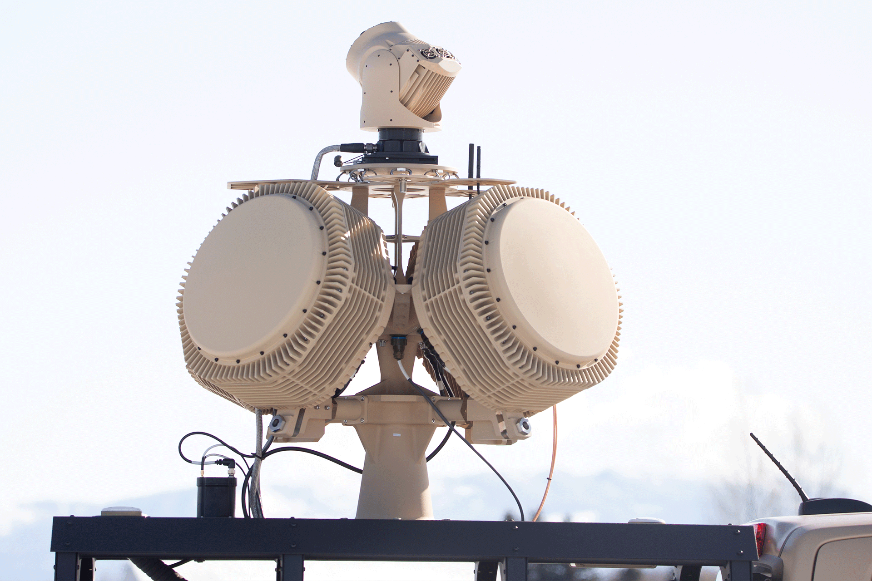
Latest Variant of the X-MADIS Delivered to US DoD Customer

