The Houston Chapter of Financial Executives International Announces the New Board


From the FEI Houston President
"Financial Executives International Houston Chapter is one of the largest FEI chapters nationally, and for over 90 years, FEI's members have been representative of the Houston area's major industries, and finance organizations. We provide unparalleled Peer Networking, Education, and Career Development for current and future financial executives. We have awarded scholarships to area university students for more than 50 years”
The Houston Chapter of Financial Executives International (FEI) is excited to announce the 2021 - 2022 Board of Directors and Committee Chairs. With about 200 members, the Houston Chapter of FEI is one of the most active in the country. We are looking forward to a year of great programming and connecting with fellow financial executives.

The FEI Houston Chapter Board Member are as follows:
- Gary Paul Brooks, Chapter President Andrew A. Nat, Jr., President-Elect
- John Briscoe, Immediate Past-President/Audit Committee Roundtable Chair
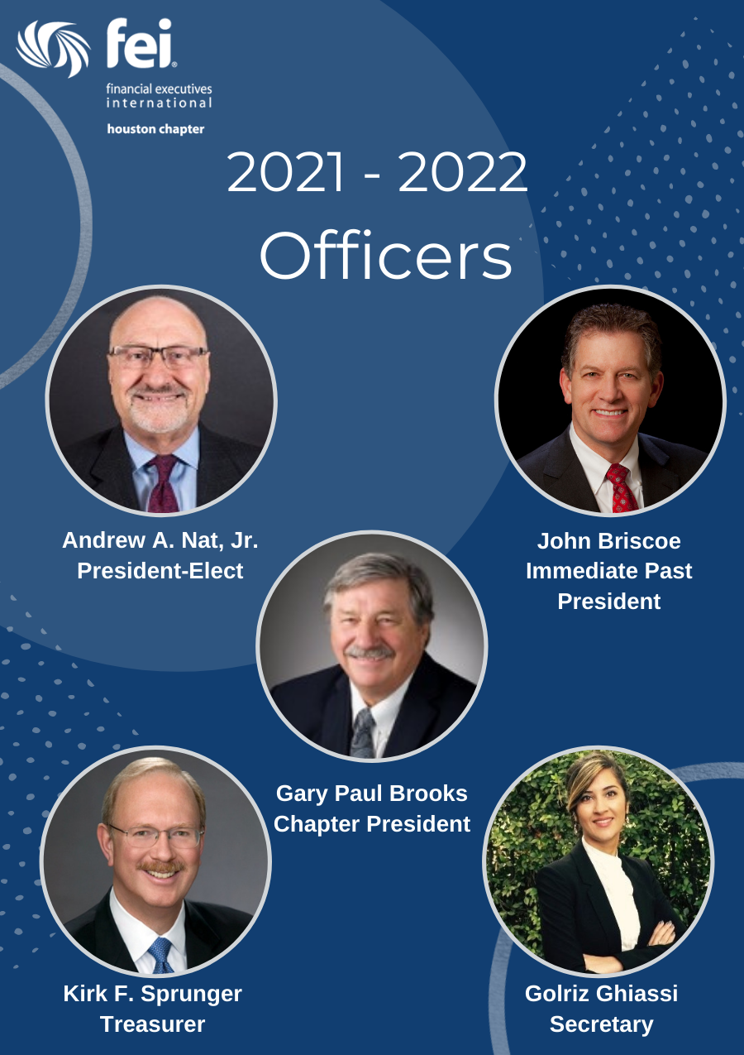
- Kirk F. Sprunger, Treasurer/Sponsorship Chair
- Golriz Ghiassi, Secretary
- Deborah Clark, Director/Membership Vice Chair
- Laura C. Fulton, Director
- Alan Gahm, Director Allen D. Gibson, Director
- Frances Powell Hawes, Director
- Marcus Jonesi, Director
- Tony Maresca, Director
- Mark K. Vise, Director
- Johnnie Williams, Director
- Mark S. Petersen, Executive Career Management Chair
- Andrew B. Nobbay, CFO University Chair
- Eric Khan, Communications/Branding Chair
- Evelyn Angelle, Women’s Initiative Chair
- Marcus Jonesi, FEI National/FERF Liaison Chair
- Mark K Vise, GHP Liaison Chair
- Ann Kaesermann, Membership Chair
- Maurice Nassar, Socials & Happy Hour Chair
- Robert M. Schmitz, North/West Houston Chair & Events Coordinator
- Paul Steven Marsh, Program Chair/Social Dinner Chair
FEI would also like to acknowledge the service of six outgoing directors
and officers:
- Rob Schmitz, Immediate Past President
- Allen Gibson, Treasurer
- Scott Skrabanek, Secretary
- Ann Kaesermann, Director
- Eric Khan, Director
- Phil McCormick, Director
"The strength of this board and officers will continue FEI Houston's inclusive growth, development of future leaders, and raising the performance of Houston's financial executives. I'm very humbled to lead FEI Houston as its new President." - Gary Brooks

2021 – 2022 FEI Houston Chapter Officers

About FEI Houston FEI is one of the trustees of the Financial Accounting Foundation (FAF). The foundation is responsible for the oversight, administration, and finances of its standard-setting Boards, the Financial Accounting Standards Board (FASB) and the Governmental Accounting Standards Board (GASB), and their Advisory Councils. Our role as Members and Strategic Partners is important for the process of setting accounting standards in the United States.

Each year the Houston Chapter distributes educational scholarships through the FEI Houston Chapter Scholarship Foundation. The Foundation supports higher education and training in the fields of finance and accounting and provides non- discriminatory scholarship funds to deserving and disadvantaged students attending accredited colleges and universities in the Greater Houston/Galveston area in conjunction with the FEI Houston Chapter Academic Honors Day.
Media contact: Eric Khan at ExternalRelations@feihouston.org
www.feihouston.org

